


RESETTLEMENT ACTION PLAN (RAP) REPORT

Mano River Union Road Development and Transport Facilitation
Programme (MRU/RDTFP) Phase IV

Paving of John Davies Town to Zwedru (48. 5 Km) Road in Grand Gedeh County of the
Ganta – Harper Road (510Km) Project

Project ID No.: ________

Grant No.: ____________

Loan No.: _____________

MINISTRY OF PUBLIC WORKS

THE GOVERNMENT OF LIBERIA

May 25, 2023



ROYAL ENVIRONMENTAL GROUP, RE-GROUP

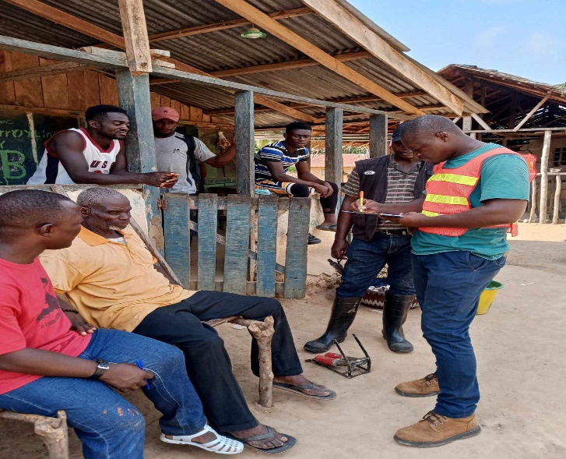

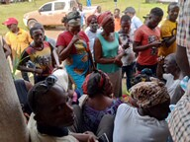

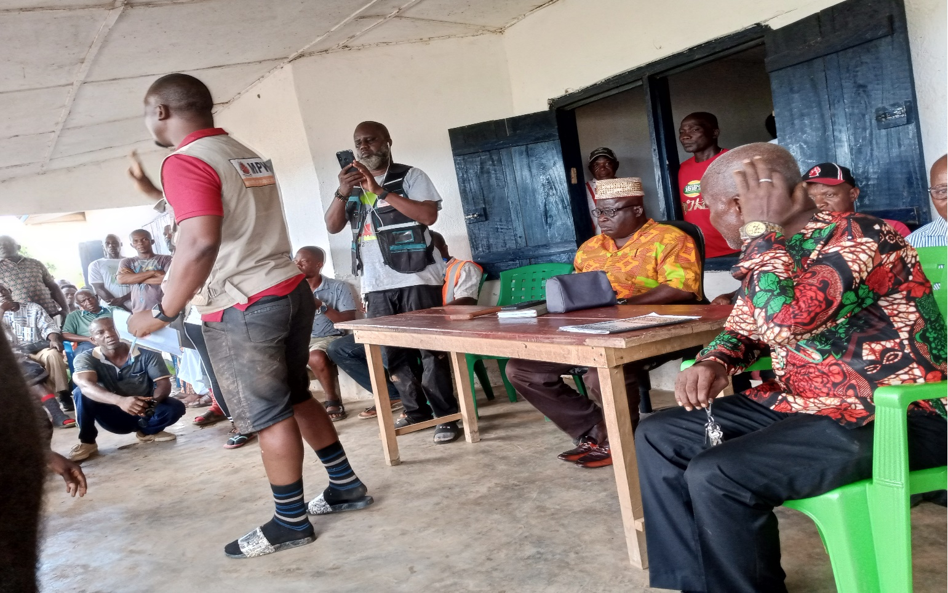

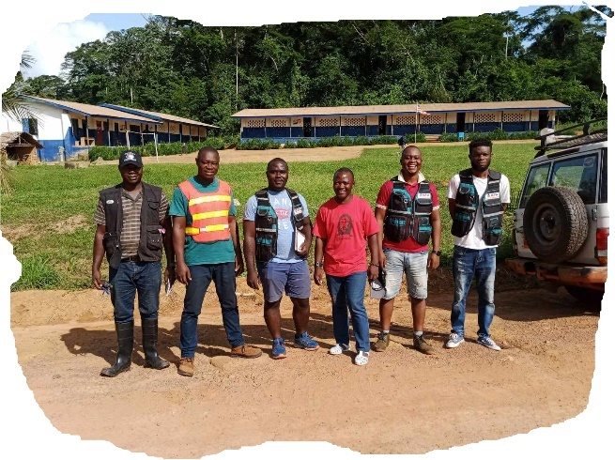
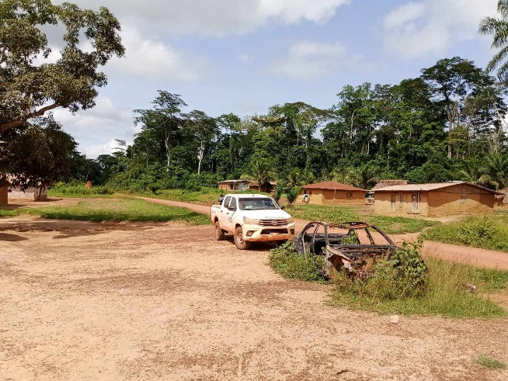

Contents
LIST OF TABLES vii
LIST OF FIGURES vii
LIST OF ACRONYMS viii
EXECUTIVE SUMMARY 1
1.0 INTRODUCTION 18
1.1 Background 18
1.2 Project Location and Area 19
1.2.1 Project Location 19
1.2.2 Project Area 22
1.3 Objective of the Resettlement Action Plan (RAP) 22
Justification for the Resettlement Action Plan (RAP) 23
1.4 Planning Principle 23
1.5 Scope of the Resettlement Action Plan 24
1.6 Approach and Methodology of the RAP 24
1.6.1 Approach 24
1.6.2 RAP Methodology 25
1.7 Report Structure 25
Characteristics of 25
2.0 REGULATORY, POLICY AND INSTITUTIONAL FRAMEWORKS 26
2.1.0 Regulatory Framework 26
2.1.1 Liberian Constitution 1986 26
2.1.2 Aborigines Law of 1956 27
2.1.3 Property Law of 1976 27
2.1.4 Revised Rules & Regulations Governing the Hinterland of Liberia (2001) 27
2.2.0 Policy Framework 27
2.2.1 Land Right Policy of Liberia (2013) 27
2.2.2 National Environmental Policy (2003) 28
2.2.3 African Development Bank Policy on Involuntary Resettlement 28
2.4 Land Tenure Systems 29
2.4.1 Customary Tenure 29
2.4.2 Freehold Tenure 29
2.4.3 Leasehold Tenure 29
2.5 Land Valuation System 29
2.6 Compensation 30
2.7 Grievance Remedial 30
2.8 Comparison of Liberian Legislations and AfDB Environmental and Social Assessment Procedures 31
In case of conflict between the Liberian regulations and the African development bank policies during the implementation of this rap, the AfDB policies will prevail 32
2.9.0 Institutional Framework 33
3.0 SOCIO-ECONOMIC 34
3.1.0 Socio-Economic Study of the Proposed Project Area 34
3.1.1 Survey Methodology and Approach 35
3.1.2 PAPs Means of Livelihood 36
3.1.3 Types and Nature of Structure own by project affected persons (PAPs) 36
3.1.4 Effect of Project on Affected Properties 38
3.1.5 Land Tenure of PAPs 38
3.1.6 Period to Relocate 40
3.1.7 PAPs Preferred Mode of Compensation 41
3.2. Socio-Economic Characteristics of Project-Affected Persons 42
3.3.0 Socio-Environment 43
3.3.1 Population 43
3.3.2 PAPs Gender 43
3.3.3 PAPs Educational Level 44
3.3.4 Main Occupation for PAPs 45
3.3.5 Marital Status of PAPs 45
3.3.6 Ethnicity of PAPs 46
3.3.7 Vulnerability of the Project Affected Persons 46
3.4 Access to Basic Facilities 47
3.5 Transportation Challenges 47
3.6 Poverty Conditions 48
3.7 Approach and Methodology 48
4.0 PROJECT IMPACTS AND MITIGATIONS 49
4.1 Types of Impacts 49
4.1.1 Positive Impacts 49
4.1.2 Negative Impacts 49
4.2 Mitigation Measures 50
5.1 Consultations with Stakeholders 51
5.1.1 Perception of PAPs 52
5.2 Future Consultation Plan 52
5.3 Resettlement Consultation 53
5.4 Disclosure of RAP Document 53
6.0 RESETTLEMENT COMPENSATION TO PROJECT AFFECTED PERSONS 54
6.1 Eligibility Criteria for Project Affected Persons as per the African Development Bank Integrated Safeguards System 54
6.2 Valuation Process/Methodology 54
6.3 Mode of Restitution 55
6.4 Compensation and Other Assistance 56
6.5 Unit Cost Per Structure 57
6.6 Compensation and Entitlement Matrix 58
7.0 RESPONSIBLE AGENCIES FOR RAP IMPLEMENTATION, MONITORING & EVALUATION 60
7.1 RAP Implementation 60
7.2 Internal Review, Monitoring & Evaluation 61
7.2.2 Reporting 62
8.0 GRIEVANCE REDRESS MECHANISM 63
8.1 GRM Overview 63
8.2 Object of the GRM 64
8.3 Main Principles of this GRM 65
8.4 Grievances Procedure 66
8.5 Estimated Budget and Workplan for Effective GRM Implementation 69
9.0 BUDGET AND SCHEDULE FOR RAP IMPLEMENTATION 71
9.1 Budget for Implementing the RAP 71
9.2 Time Schedule and Monitoring Program 72
10. CONCLUSION AND RECOMMENDATIONS 74
REFERENCES 76
APPENDICES 77
Ministry of Public Works’ Valuation Rate for Affected Structures 77
APPENDIX A: Chance Finds Procedure 77
Additional information Management options for the archaeological site 79
APPENDIX B: Minutes of Public Consultation Meetings and Survey Questionnaires in Grand Gedeh 80
APPENDIX C: Public Consultation Meeting Attendance 88
11.4 APPENDIX “D” : Photography 88
APPENDIX D: Ministry of Agriculture Price List for Affected Economic Crops 96
APPENDIX E: Ministry of Public Works’ Valuation Rate for Affected Structures 97
APPENDIX F: See Attached Spread Sheet for: 99
APPENDIX G: Photography 122

LIST OF TABLES

Table 1:Glossary of Terms x
Table 2: Summary Budget Cost for Phase Two of the RAP Implementation 16
Table 3:Comparison between Liberian Legislations and AfDB Policies 31
Table 4:Summary Table of the RAP prepared for the project 34
Table 5: Types of Structures Affected 36
Table 6: Nature of Structure 37
Table 7: Land Tenure of PAPs 39
Table 8: Time PAPs Occupy Area 40
Table 9: PAPs’ Time to Relocate 41
Table 10: Gender of the PAPs 44
Table 11: Educational Status of PAPs 44
Table 12: PAPs Marital Status 45
Table 13: PAPs Grouping 47
Table 15: Consultation in Monrovia 52
Table 16: Valuation Process 55
Table 17: Unit Rates of Structure Kinds 57
Table 18: Unit Rates for Other Structures 58
Table 19: Compensation and Entitlement Matrix for PAPs 59
Table 20: Grievance Resolution Process 67
Table 21: Grievance Implementation Work Plan 69
Table 22: Estimated Budget and Work Plan for GRM Implementation 70
Table 23: Summary Budget Cost for Phase Two of the RAP Implementation 72
Table 25: Implementation Schedule of the RAP 73

LIST OF FIGURES

Figure 1: The Political Map of Liberia showing Grand Gedeh County where the project fall 20
Figure 2: The 8 District of Grand Gedeh County showing the district where the Project fall 20
Figure 3: Map showing Project Road: John Davies Town to Zwedru (48.5km) 21
Figure 5: Graph showing structure types 37
Figure 6: Graph showing the nature of the structure Affected by the Project 38
Figure 7: Graph showing the land tenure of PAPs with Deeds and No Deeds 39
Figure 8: Graph showing the time PAPs occupied area 40
Figure 9: Graph showing the PAP's time to relocate 41
Figure 10: Graph shows the gender of PAPs 44
Figure 11: Education Status of PAPs 45
Figure 12: PAPs Marital Status 46
Figure 13: RAP implementing entities 61
Figure 14: Levels of Project GRM 64
Figure 15: GRM escalation matrix 68

LIST OF ACRONYMS

AC ......................... .... Asphalt Concrete
ADF............................African Development Fund
AfDB .......................... African Development Bank
ARAP………………. Abbreviated Resettlement Action Plan
BoQ Bill of Quantity
Db .......................... .... Decibel
E&S ....................... .... Environmental and Social
EPA ....................... .... Environmental Protection Agency
EPAA Environmental Protection Agency Act
EPML ................... .... Environmental Protection and Management Law of Liberia
EIA Environmental Impact Assessment
ESIA ...................... .... Environmental and Social Impact Assessment
ESMP .................... ....Environmental and Social Management Plan
ESAP Environmental and Social Assessment Procedures
ESO Environmental Social Officer
ESRS Environmental & Social Review Summary
FDA....................... ....Forestry Development Authority
FRAP………………. Full Resettlement Action Plan
FTHRP .................. .... Fish Town-Harper Road Project
GAC General Auditing Commission
GOL ...........................Government of Liberia
GRM ..................... .... Grievance Redress Mechanism
HIV/AIDS..............Human Immunodeficiency Virus
ISS………………..Integrated Safeguards System
IRP Involuntary Resettlement Policy
IWRMP Integrated Water Resources Management Plan
IIU Infrastructure Implementation Unit
km ......................... ....kilometer
LISGIS Liberia Institute of Statistics & Geo-Information Services
LNP Liberia National Police
LRRRC Liberian Refugee Repatriation & Resettlement Commission
LEC .......................Liberia Electricity Corporation
LWSC .................. ....Liberia Water and Sewer Corporation
m³ .......................... ....Cubic meter
MME ..........................Ministry of Mines & Energy
LLA…………………. Liberia Land Authority
MOJ…………………. Ministry of Justice
MOT .......................Ministry of Transport
mm ........................ ....millimeters
MPW ..................... ....Ministry of Agriculture
MoFDP .................. ....Ministry of Finance, Development and Planning
MoL....................... ....Ministry of Labour
MPW ..................... ....Ministry of Public Works
MRU/RDTFP ........ ....Mano River Union Road Development & Transport Facilitation Programme
NEP National Environmental Policy
NGO Non-governmental Organization
NTPS National Transport Policy & Strategy
NOx ....................... ....Nitrogen oxides
OSs .............................Operational Safeguards
OP Operational Policy
PAPs ...........................Project Affected Persons
PAHs Project Affected Households
PIU ............................Project Implementation Unit
PM .............................Particulate Matters
PPE ........................ ....Personal Protective Equipment
PPM............................Parts per million
PRS Poverty Reduction Strategy
PVO Private Volunteer Organization
RAP ............................Resettlement Action Plan
RE ..............................Resident Engineer
ROW ..........................Right of Way
SES Socio-Economic Survey
STDs Sexually Transmitted Diseases
SO₂ .............................Surfer Dioxide
TOR............................Terms of Reference
UA ..............................Unit of Account
UNEP .........................United Nations Environment Program
VRU ...........................Vulnerable Road User

Table 1:Glossary of Terms
Terms | Meaning
Business Owner | A person who owns or conducts a business within the project-affected area, the operation of which may be disrupted by the construction work under the project. S/he can be a legal owner, non-titled structure owner, or tenant and will receive different compensation and R&R packages as per the EM
Economic Displacement | Loss of income streams or means of livelihood resulting from land acquisition or obstructed access to resources (land, water, or forest) which results from the construction or operation of a project or its associated facilities
Compensation | Payment in cash or in kind to replace an asset, resource or income source which has been acquired or affected by a project for which the person affected is entitled and the amount of money required to keep a person in the same socio-economic position that he held before acquisition
Cut-off date | Date of completion of the census and assets inventory of persons affected by a project. Persons occupying the project area after the cut-off date are not eligible for compensation or resettlement assistance. The cut-off date for being eligible for compensation was June 9, 2023, which is the last day during which the socio-economic survey was completed. The cut-off date was explained and agreed with the Project Affected Persons (PAP).
Displaced persons | :In the context of involuntary resettlement, displaced persons are those who are physically displaced (relocation, loss of residential land, or loss of shelter) and/or economically displaced (loss of land, assets, access to assets, income sources, or means of livelihood) as a result of involuntary acquisition of land, or involuntary restrictions on land use or on access.
Economic Displacement | Loss of land, assets, access to assets, income sources, or means of livelihood as a result of involuntary acquisition of land, or obstructed access to resources (ii) involuntary restrictions on land use or on access to legally designated parks and protected areas.
Eligibility | The qualification criteria for receiving benefits under a resettlement program. These criteria serve as the basis for defining resettlement entitlements accrued to each eligibility category - affected residential or commercial property owners, renters, vendors, encroachers, squatters, and so on
Encroacher | Someone who has illegally expanded, or extended the outer limit of his/her private premises beyond the approved building line or agricultural land and has occupied public space beyond his/her plot or agricultural land.
Entitlement | Resettlement entitlements with respect to a particular eligibility category are the sum total of compensation and other forms of assistance provided to displaced persons in the respective eligibility category. It includes a range of measures comprising compensation, income restoration, transfer assistance, income substitution and relocation which are due to affected people, depending on the nature of their losses, to restore their economic and social base
Host Population/Community | People living in or around areas to which those physically displaced by a project will be resettled, who in turn may be affected by the resettlement. Special attention must be paid to the needs and concerns of the host population/community/hosts in a resettlement program in order to minimize social risks and avoid potential social conflicts.
Involuntary Resettlement | Resettlement is involuntary when it occurs without the consent of the PAPs or if they give their consent without having the power to refuse resettlement
Implementation Schedule | Timeframe of activities of the project
Income Restoration | Re-establishing productive livelihood of the displaced persons to enable income generation equal to or, if possible, better than that earned by the displaced persons before the resettlement.
Landowners | Owners of land with or without trees, crops, or structures affixed to the land with clear title in government records. In some exceptional cases, a person who owns land/s within the project-affected areas regardless of proof of such ownership will also be entitled, provided that such ownership is recognized under the law.
Non-Resident Land and Structure Owners | Legal landowners who do not have land either because they have rented or leased out their said land and property affixed to it, or such land has been taken possession of by any other person
Physical Displacement | Relocation, loss of residential land, or loss of shelter as a result of involuntary acquisition of land, or involuntary restrictions on land use or access.
Project Affected Person (PAP | Any person who, as a result of the implementation of CEP, etc., loses the right to own, use or otherwise benefit from a built structure, land (Residential, agricultural, commercial) annual or perennial crops, and trees, or any other fixed or movable assets, either in full or in part, permanently or temporarily
Protected Tenants | Tenants occupying a legal property, commercial, or residential and are protected under its later amendments which prevent the landowners from evicting them or increasing the rent at their own will
Relocation | A process through which physically displaced individuals or households or communities are provided with a one-time lump sum compensation payment for their existing residential structures and move from the Project Area.
Rehabilitation | Re-establishing incomes, livelihoods, living and social system
Replacement Cost | Replacement cost involves replacing an asset at a cost prevailing at the time of its acquisition. This includes fair market value, transaction costs, interest accrued, transitional and restoration costs, and any other applicable payments, if any. Depreciation of assets and structures should not be taken into account for replacement costs. Where there are no active market conditions, replacement cost is equivalent to the delivered cost of all building materials, labor cost for construction, and any transaction or relocation costs.
Resettlement effect | Loss of physical and non-physical assets, including homes, communities, productive land, income-earning assets and sources, subsistence, resources, cultural sites, social structures, networks and ties, cultural identity, and mutual help mechanisms
Vulnerable groups | Distinct groups of people might suffer disproportionately from resettlement effects, People who may by gender, ethnicity, age, physical or mental disability, economic disadvantage, or social status get more adversely affected by resettlement than others; and who may have limited ability to claim or take advantage of resettlement assistance and related development benefits
Resettlement Action Plan (RAP): | The document in which a project sponsor or other responsible entity specifies the procedures that it will follow and the actions that it will take to mitigate adverse effects, compensate losses, and provide development benefits to persons and communities affected by an investment project.
Grievance Procedures: | The processes established under law, local regulations, or administrative decisions enable property owners and other affected and/or displaced persons to redress issues related to acquisition, compensation, or other aspects of resettlement.

EXECUTIVE SUMMARY
Template: Compensation Summary Sheet
# | Variables | Data
- General
1 | Region/Province/Department … | Southeastern Liberia
2 | Municipality/District… | Grand Gedeh County Districts 1 & 2
3 | Village/Suburb …46 | - John Davies Town, (2) CVI Junction, (3) Duo Town, (4) Karlorwleh Town, (5) Wroto Village, (6) Royal Village, (7) Quiah Village, (8) Kamnyee Village, (9) Jarwleh Village, (10) Saryon Town, (11) Wilson Taye Village, (12) George Quiah Village, (13) Jaygbo Village, (14) Gbargbo Town, (15) Pellezon, (16) Polah Village, (17) Boleyville, (18) Zwedru
4 | Activity(ies) that trigger resettlement | John Davis Town to Zwedru Road Rehabilitation (48.5 KM)
5 | Project overall cost | US$46,200,000
6 | Overall resettlement cost | US$ US$1,544,520.82
7 | Applied cut-off date (s) | June 1, 2023
8 | Dates of consultation with the people affected by the project (PAP) | May 29-31, 2023
9 | Dates of the negotiations of the compensation rates / prices | May 31, 2023
 | - Specific information
10 | Number of people affected by the project (PAP) | 246
11 | Number of Physically displaced | 246
12 | Number of economically displaced | 147
13 | Number of affected households | 246
14 | Number of females affected | 101
15 | Number of vulnerable affected | 115
16 | Number of major PAP | 246
17 | Number of minor PAP | 323
18 | Number of total right-owners and beneficiaries | 246
19 | Number of households losing their shelters | 246
20 | Total area of lost arable/productive lands (ha)
21 | Number of households losing their crops and/or revenues | 20
22 | Total areas of farmlands lost (ha)
23 | Estimation of agricultural revenue lost (USD) | US$54,048.60
24 | Number of building to demolish totally | 274
25 | Number of building to demolish totally at 50% | 0
26 | Number of building to demolish totally at 25% | 0
27 | Number of tree-crops lost | 20 farms
28 | Number of commercial kiosks to demolish | 0
29 | Number of ambulant/street sailors affected | 0
30 | Number of community-level service infrastructures disrupted or dismantled | 12
31 | Number of households whose livelihood restoration is at risk | 246
…

The Resettlement Action Plan (RAP) plays a vital role in almost all development projects where people are required to be displaced due to the implementation of project activities. Project-affected persons must be resettled before the commencement of the construction activity. The RAP is an essential tool in managing the resettlement process and the potential for conflict and unrest that could have a negative impact on the successful implementation of the project. It is also an important tool in engaging affected people and communities in the project.

The Ministry of Public Works with financial assistance from the African Development Bank (AfDB) has proposed to construct a 48.5 Km of the road from John Davis Town to Zwedru City in Grand Gedeh County under the Mano River Union Road Development and Transport Facilitation Programme (MRU/RDTFP) Phase IV. Considering the Integrated Safeguards System (ISS) of the AfDB and National Regulatory requirements of the Project, Royal Environmental Group (RE-GROUP), Inc. was contracted to conduct an assessment and prepare a RAP report for the corridor. The report contains updated information on the RAP conducted and estimates gathered through a remarking and scoping assessment. The information, specific to the 48.5 km, reflects the current impact on assets, its use and restriction, tenants, vulnerable groups, and property owners along the corridor; as well as the impact from the design review and road alignment, where needed.

The project aims to reduce travel time and vehicle operating costs by improving road alignment and pavement conditions. The road project will also enhance the flow of regional and inter-regional traffic and trade, and reduce road user costs, thereby strengthening regional economic integration. The road safety measures that would be put in place will enhance safety standards on the project road. In addition, the project will also facilitate easy access by farmers and traders to social services along the corridor expected to generate more income to augment the Government’s effort in achieving economic development and poverty reduction.

The formulation of the RAP report is designed to meet the requirements of the African Development Bank’s Operational Safeguard No 2 on involuntary resettlement and the requirements of the Liberia’s legislation, policies and guidelines. The project activities under this RAP include:

- Obtaining and clearing the Right of Way

- Engagement of the Project Affected Persons (PAPs)

- Survey, Valuation and identification of Project affected Persons.

The main objectives of the RAP include the following:

- To ensure that the RAP complies with the safeguards policies of the AfDB on involuntary resettlement
- To prevent or at least mitigate the adverse impacts associated with the implementation of the road project;
- To deliver the entitlements to the Project Affected Persons (PAPs);
- To maximize the involvement of PAPs in all stages of the implementation of the RAP; and
- To ensure that the standard of living of PAPs is improved or at least restored through compensation or recommend measures.

The RAP is aimed at collecting detailed information on persons who will be directly affected by the project activities, types, and magnitude of impacts, as well as identifying options and strategies for compensating such affected persons for resettlement. To achieve these objectives, the plan provides compensation and rehabilitation measures so that the income-earnings potential of individuals is restored and their livelihoods are sustained.

The main objectives of the RAP are to ensure that project-affected persons do not lose their sources of livelihoods or assets. The ESIA of the project indicated that the current road reconstruction project will induce adverse social impacts. As required by the AfDB, the Ministry of Public Works has from the EPA the conduct of this RAP to be carried out on the proposed road corridor. The RAP includes a social-economic survey, a description of the compensation to be provided, public consultation, grievance procedures, institutional responsibility for the operations, monitoring arrangements, and a budget. The RAP was prepared following the guidelines of the African Bank’s Operational Policy (OS2). The RAP will specify all resettlement arrangements and measures for avoiding or compensating losses or other negative social impacts resulting from resettlement.

In order to ensure that the RAP complies with international best practices as regards resettlement, the implementing agency shall abide to the following guiding principles:

- Raise awareness of the project and its consequences among the public in general and those who will be directly affected by it.

- Estimate the costs necessary for resettlement/land acquisition

- Prepare a Resettlement Action Plan (RAP) that sets out strategies and schedules to mitigate adverse effects. The RAP sets the parameters and establishes entitlements for project-affected people (PAP), the institutional framework, mechanisms for consultation and grievance resolution, the schedule and budget, and the proposed monitoring and evaluation system. The agreed entitlement package includes both compensation and measures to restore the economic and social base of those affected.

- Address the requirements of the Government of Liberia, as fostered by the Environmental Protection Agency, and the African Development Bank for land acquisition and resettlement.

The goal of the project is to improve transportation, and social welfare and enhance the living standards of residents of southeastern Liberia, and all Liberians through an efficient road transport network. However, the Mano River Union Road Development and Transport Facilitation Program (MRU/RDTFP) Phase-IV: Paving of John Davies Town to Zwedru (48.5Km) of the Zwedru – Harper Section of the Ganta – Harper Road Project (510Km) link transverses through areas of diverse land uses. Therefore, its construction is expected to have a widespread positive impact on overall the socio-economic status and livelihoods of the road users, project-affected people (PAPs) as well as the economy of counties in the southeast of the country.

The construction of this corridor will improve transportation. The construction and pavement of the proposed 48.5 KM road will improve transportation in the south-eastern region of Liberia, moving from John Davis Town to Zwedru project, which is also linked to the Karloken to Harper and Harper Junction to Cavalla Customs, all three of which are currently under construction.
Advance Regional Road Network. The rehabilitation of the road will also advance the planned regional transportation network between the West African States as the Zwedru – Harper Road connects with other road networks in the country, which connect with roads in bordering countries. The 16 km Harper Junction to Cavalla Customs connects Liberia to Cote D’Ivoire.

Gender Mainstreaming. The improved road network will benefit women by reducing travel time affording them more time to participate in other productive services. The improved access to markets will not only allow women to participate more in local economic development but will lead to an increase in rural health, education, and other services. The construction and maintenance phases could lead to great job opportunities for women, empowering them to be self-sufficient. These phases could enhance women’s participation in both the skilled and unskilled labor force; ensuring equal pay is given to women and men.

There will however be some negative impacts. The construction of the project will cause people to be displaced by the road construction works. The major negative impacts include permanent losses of Residential and Domestic Structures: 199 or 100% of the structures within the 48.5-km road studied, which are solely residential or related, will be affected. The buildings are mainly constructed of mud dubbed with thatch and zinc roofs. Two hundred forty-six (246) PAPs will be affected by structures so dearly to them like churches, graves, hand pumps, well, kitchens, farmlands, tree crops, business places, and most especially their dwelling place.

The components for which land acquisition and resettlement are required are:

General road improvement will affect people who have residences or businesses located along the road right-of-way; People settled in the right-of-way which will be affected by construction works during the construction process.

In line with the Environmental Protection Agency regulatory requirements and the African Development Bank’s Integrated Safeguards System (ISS 2023), this project is classified as a Category I Project. Based on these requirements, this RAP Report was prepared in compliance with AfDB’s environmental and social assessment guidelines and procedures specifically OS2 for the project in that category and the Environmental Protection Agency (EPA) of Liberia. The RAP was undertaken with the primary aim of identifying the potential environmental and social risks associated with the project, its positive and negative impacts, and developing a sustainable Environmental and Social Management Plan (ESMP) to mitigate the negative impacts satisfactorily and at the same time, enhance the positive impacts of the proposed project. The ESMP summarizes the commitment to address and mitigate risks and impacts identified as part of the assessment through avoidance, minimization, and compensation. It also is expected to guide the decision and policymakers on the most appropriate ways to handle the relevant environmental issues that may arise during the project lifecycle. Adverse impacts ranging from the risk of disease prevalence in the project area due to labor influx, changes in cultural orientation, human displacement, and environmental pollution need to be appraised keenly to avoid where feasible and minimize the negative impacts associated with the proposed project.

To arrive at a mitigation plan, the PAPs have been involved in the decision-making process whereby they have been informed about their options and rights about resettlement namely:

- Cash for compensation

- Land or another place

- A combination of the above.

Compensation is mainly skewed towards cash compensation for structures (housing, crops, etc.) that will be affected. Cash compensation has been adopted as the mitigation measure at full replacement cost rates. And as requested by the PAPs, prompt compensation will readily enable them to relocate quicker.

All the PAPs interviewed (100%) expressed support and willingness to move to facilitate the implementation of the project although the majority about 96% wanted 90 days (3 months) for relocation upon compensation.

It is clear that there is a strong need for the project, and none of the possible alternatives are credible in a country that aims for development and prosperity. Consequently, several positive benefits of the project are identifiable. These can be summarised as follows:
- Improved access to social services, including health and educational facilities
- Reduced dust nuisance and less sediment in roadside watercourses from the current unpaved road.

As usual with the development of infrastructure, the benefits are generally focussed on the socio-economic environment, while the adverse impacts are likely to affect the bio-physical environment most. Nevertheless, as listed above, there will be some positive impacts on the bio-physical environment, and conversely, there are also potential adverse socio-economic impacts from the project.

The project covers a large area – a road corridor across (48.5 km) of rural landscape – and so can potentially cause significant damage unless care is taken. Among the many negative impacts that will occur, the following list provides a summary:

- The removal of vegetation, and the risk of serious soil erosion and sediment supply into watercourses through the quarrying of materials and construction of major earthworks;
- General degradation of the environmental resources along the road corridor – especially the forests and watercourses, and the habitats they provide – as a result of the largescale project activities;
- Pollution of soil, water, or air from the use or generation of hazardous materials;
- The danger of injury or death to both members of the public and project workers from construction activities, including traffic;
- Loss of property or livelihoods to people living close to the road; and
- Damage to social systems and community health as a result of a large transient workforce.

In the ESIA, these identified risks are disaggregated into potential impacts, against each of which a mitigation strategy is adopted. Following this, the methodology for the management of environmental and social risks and impacts is described for the project.

The process of developing a mitigation plan involved the PAPs in the decision-making process by informing the PAPs about their options and rights of resettlement; namely:

- Cash for compensation
- Land or another place
- A combination of the above

As per this developed 2023 RAP document, the preferred compensation option is mainly skewed towards cash compensation to PAPS for their affected structures (housing, land, crops affected). Cash compensation has been adopted as the mitigation measure at full replacement cost rates,and as requested by the PAPs, prompt compensation will readily enable them to relocate quicker.

The survey reported 94% of the PAPs indicated an adequate period of 3 months would be needed to relocate – this length would allow them swiftly reconstruct new structures or acquire new properties. The PAPs and affected communities expressed support and willingness for the project. Even though from a construction perspective, the construction of the average affected structure will be a little strenuous, the PAPs are willing to achieve this to facilitate the commencement of the construction works.

For each of the adverse environmental and social impacts identified, a mitigation strategy is defined and categorized as one or more of the standard practices of avoidance, prevention, reduction or minimization, restoration, and compensation. For each impact, an approach to fulfil the appropriate strategy is then identified. This is then translated into practical mitigation actions in the Environmental and Social Management Plan (ESMP).

The ESMP is the sole reference, management, and monitoring document for all project safeguards. Rather than have separate plans for managing health and safety, gender and social inclusion, biodiversity, hazardous materials, etc., the ESMP encompasses all of these aspects. The disadvantage of numerous sub-plans is the risk of contradiction, duplication, and omission where topic areas overlap. The strength of a single, encompassing plan is that actions, standards to be achieved, and responsibilities are clearly defined and can be easily monitored to ensure effectiveness.

In order to make it possible to manage the identified adverse environmental and social impacts in a structured way, they are disaggregated within areas of risk. This led to the following safeguard categories and impact mitigation headings that are used as the basis of the overall ESMP.

Overall safeguards
- General Environmental Protection
Protection of society
- Environmental Health and Safety
- Occupational Health and Safety
- Community Impacts Management
- Traffic Management
- Cultural and Archaeological Heritage Management
Pollution control
- Hazardous Materials Management (including Spill Contingency and Emergency Response)
- Construction Materials Management
- Waste Management
Environmental safeguards
- Soil Erosion Control
- Water Resources Management
- Air Emissions Management
- Ecological Management Plan
- Noise and Vibration Management

Through these categories, the ESMP lays out the management system to ensure that all of the safeguards required by the Government of Liberia and the African Development Bank are addressed to adequately defined standards and that this can be ascertained through monitoring. Most of the ESMP content is given over to practical actions in all project activities, and guidelines to support these actions in meeting national and international standards. The ESMP also cross-refers to the project’s Resettlement Action Plan, which is the equivalent working document to provide safeguards against losses of property and livelihoods.

The ESMP allows the identified potential impacts to be reduced to acceptable residual levels. Mostly they are categorized as negligible. A few are classed as minor residual impacts, where it is impossible to remove risk or restore environmental conditions completely. Examples of these are traffic safety risks and the restoration of altered landforms following quarrying. Beyond issues of this nature, the ESMP, if implemented as proposed, will provide an effective mitigation system for the project.

The social economic condition of the affected households was collected by the social assessment team during the months of May 2023. The socioeconomic household baseline assessment interviewed a total of 157 project affected households within the project corridor. In the socio-economic assessment, information on individual characteristics of household heads and other members, household characteristics (socio-demographic characteristics), household sources of income, levels of access to health services, potential impact of the planned project, land ownership and housing status, vulnerability, resettlement and relocation options of affected households. This was carried out across the 18 towns along the project corridor commencing from John Davis Town to Zwedru City (48.5km).

The RAP considers applicable existing policy, institutional and regulatory frameworks within the context of Liberian Law. Preparation of this RAP draws on the requirements of the African Development Bank’s Environmental and Social Assessment Procedures specifically the OS2 (Operational Safeguard on Involuntary Resettlement: Land Acquisition, Population Displacement and Compensation), and relevant social safeguard policies. The RAP also draws on the Liberian Constitution of 1986, the Aborigine Law of 1956, the Property Law of 1976, Revised Rules and Regulations Governing the Hinterland of Liberia (2001), the recent Land Right Policy (2013), and the 2016 Act establishing Liberia Land Authority (LLA).

The requirements to comply with environmental and social issues of infrastructure development such as roads are derived from or laid down by policy, legal and regulatory framework of the funding institution and host country. Some of the legal provisions are cross-sectoral and are only partially related to environmental and social issues. The environmental policy and environmental assessment legislation and procedures of Liberia shall be considered as the key policy of this report. The African Development Bank Operational Policies for the preparation of Environmental and Social Impact Assessment (ESIA) and Management Plans as well as the Resettlement Action Plan (RAP) shall be considered for the funding agency. This section outlines the relevant policies, legal, and administrative procedures for the project.

The National Environmental Management requirements include:

- Liberia’s National Environmental Policy
- Environmental Protection Agency Act
- Environmental Protection and Management Law
- National Biodiversity Strategy and Action Plan

The National Land, Labor, Safety and Health Requirements include:

- Lands Rights Policy
- National Environmental and Occupational Health and Safety Policy
- Public health law
- Labour Law
- National Youth Act
- National Gender Policy
- Forestry Reform Law
- National Forestry Policy and Implementation Strategy

The following African Development Bank Operational Safeguards (OS) Policies were also considered:
- Assessment and management and Social Risk and Impacts (OS 1)
- Labor and Working Conditions (OS2)
- Resources Efficiency and Pollution and Prevention and Management (OS3)
- Community Health and Safety (OS4)
- Land Acquisition, Restriction on Access to Land and Land Use, and Resettlement (OS50)
- Habitat and Biodiversity Observation and Sustainable Management of Living Natural Resources (OS6)
- Vulnerable Groups (OS7)
- Cultural Heritage (OS8)
- Financial Intermediaries (OS9)
- Stakeholder Engagement and Information Disclosure (OS 10)

All standards and Legal Framework Analysis as it relates to RAP were taken into serious account. The Ministry of Public Works through the consultant employs relevant Liberian laws and the relevant African Development safeguard guidelines and standards using the Integrated Safeguard System (ISS) to provide the basis for resettlement and compensation for all categories of Project Affected Persons (PAPs). For example, the Liberian Constitution of 1986 provides the mandate for compensation of citizens whose lands have been expropriated by the Government, while the Land Rights Act of 2018 outlines the various means for land acquisition. The AfDB E&S safeguards policies operate to prevent and mitigate potential adverse impacts associated with the Bank financed infrastructure projects. Institutional Arrangements and Coordination The institutional framework for the implementation of this RAP and subsequent RAP(s) involves government ministries and agencies as well as private institutions, but the MPW has overall responsibility. The Ministry of Public Works comprises personnel at central, and county levels, as well as staff and safeguards officers. The Senior Management Team (SMT) located at headquarters in Monrovia is the executive body of the MPW with the organized Project Implementation Unit (PIU). It is responsible for overall policy direction and implementation decisions regarding the sector and, therefore, is the main decision-making body for RAP implementation. Specifically, the MPW’s Environmental Social and Safety Division (ESAFE) works closely with the PIU which will be responsible for coordinating the implementation of all aspects of the RAP. The PIU currently has E&S Officers; that will handle all E&S issues arising from the project. Government institutions to be involved in the implementation of the RAP(s) will, among others, include the Ministry of Public Works (MPW), the Project Implementation Unit (PIU) the Environmental Protection Agency (EPA), the Liberia Land Authority (LLA), the Ministry of Internal Affairs (MIA), the Ministry of Agriculture (MOA) and Liberia Revenue Authority (LRA) etc.

The institutions that have the statutory roles in the implementation of this RAP are as follows:

- Ministry of Public Works
- Liberia Refugee Resettlement Reintegration Commission
- Ministry of Lands, Mines and Energy
- Ministry of Agriculture
- Ministry of Internal Affairs
- Environmental Protection Agency (EPA)
- Ministry of Finance (MFDP)
- General Auditing Commission (GAC)

For one to be eligible they should be considering people who will be displaced by the project and they are treated fairly, equitably, and in a socially and culturally sensitive manner. For a person to be considered a project-affected person (PAP), the property, crops or activity of the person must fall within the ROW designated for the construction of the MRU/RDTFP Phase-IV. Those eligible for compensation are occupants (tenants, land, and crop owners) of properties that will be affected, demolished, or destroyed. Vulnerable people who will be considered include PAPs as household heads who are female and 60 or more years of age that are at risk of being deprived of productive assets such as land/house and farms/crops. These persons are earmarked for vulnerability assistance, in addition to other payments or assistance.

The cut-off date was essential in the process of drawing up lists to ensure that ineligible persons do not take the opportunity to claim eligibility. The cut-off date for this project was set for June 1, 2023. The PAPs were informed that any development after this date is not entitled to compensation

Although the land belongs to the Government of Liberia, it is expected that PAPs will be entitled to compensation for the tree crops and structures in accordance with the law of Liberia.

The procedures and processes for the acquisition of the Right of Way for the proposed project corridor and assessment of compensation are guided by the laws of Liberia. In the assessment, PAPs are to relocate from the Right of Way within 90 days after compensation. For a person to be considered a project-affected person (PAP), the property, crops or activity of the person must fall within the right-of-way designated for the construction of MRU/RDTFP) Phase-IV: Paving of John Davies Town to Zwedru (48.5 km). Those eligible for compensation are occupants (tenants, land, and crop owners) of properties that will be affected, cracked, demolished, or destroyed.

Vulnerable people who will be considered include PAPs that are physically challenged or with some level of disability and also household heads who are female and 60 or more years of age that are at risk of being deprived of productive assets such as land/house and farms/crops. These persons are earmarked for vulnerability assistance, in addition to other payments or assistance. The survey recorded a total number of vulnerable people at 25, which includes older people who are either 60 or above. Among the vulnerable PAPs, the survey took note of fourteen (14) males and eleven (11) females. One of the female vulnerable persons was recorded as being physical challenged.

All the properties to be affected by the construction of the road have been valued and assessed according to the laid down procedure by the Ministry of Agriculture for affected crops, and the Ministry of Public Works for affected structures. The regulations for the valuation of real properties set by the Real Estate Division of the Ministry of Finance and best practices were used. For crops, the price list set by the Ministry of Agriculture was used while the Ministry of Public Works’ price list was used for structures.

Buildings and structures to be affected by the project were identified. A compensation valuation of all affected properties was carried out to assess commensurable values. However, only PAPs registered during the socio-economic and asset surveys were eligible for either compensation or supplementary assistance.
June 1, 2023, 2023, was the cut-off date for persons in the project area to be eligible for receipt of compensation or any assistance.

Consultations were held with a wide range of stakeholders including community leaders, household heads, business owners, landlords, and structure owners in selected towns along the John Davis Town to Zwedru Road Corridor from the 15th – 19th of May 2023. Local authorities and leaders from various administrative levels were also consulted. raised. The objectives of these consultations were:

- Dissemination of information among potentially affected communities about the intended project;
- Getting the perception of communities towards the project;
- Identification of anticipated project impacts on the socio-economic and cultural life of the community and;
- Identification of stakeholders and their roles in project activities.

The team stopped at each town along the way towards Zwedru, to direct villagers to either of three consultation meetings, depending on which one was closer to them. The John Davis Town meeting which was held on May 15th, 2023, at 9;30 a.m.; the Duo Town meeting which was held on May 15th, 2023 at 4;00 p.m. and the Zwedru meeting which was held on the May 16^{th,} 10:30 am. The people who attended the planned meetings were allowed to ask questions and contribute on areas they thought needed improvement and the RAP teams made sufficient clarifications to all matters.

Residents in the area were generally receptive to the road reconstruction. However, many PAPs expressed concerns over the loss of homes and livelihood. Most people were doubtful about receiving adequate or any compensation, thus being made worse off than they were before the project. The most important issues over which all PAP raised concerns were compensation for affected assets and financial assistance to ensure the restoration of livelihoods. Often, delayed payments of compensation have resulted in reinforced poverty due to loss of properties, land, agricultural potential, and change in the socio-economic environment. In light of these, communities would therefore appreciate potential employment opportunities and the impact of the proposed project on livelihoods. Possible solutions could include training and mobilization for women and skills development for new income-generating activities for both men and women. Furthermore, engagement with surrounding communities regarding employment opportunities should be fair, transparent, and communicated clearly to avoid disappointment.

The study attempted to identify problems concerning relationships between women and men, in particular their workloads, limited participation, and contribution to decision-making. It was observed that sociocultural attitudes and practices often result in specified gender roles and the gender division of labor, especially given the male-dominated environment, and the low position of women in the project area, and Liberia for that matter.

While there were non-existing barriers to female participation in project activities (road construction activities), men see women as being generally weak and, as a consequence recommended that women’s participation should be limited to the following activities:
- Cooking and serving meals to workers

- Hauling water for construction works

- Secretariat and clerical work in contrast, some female respondents commented that women could engage in more skilled and laborious activities than prescribed above if they were given the appropriate training. This, however, confirms the existing socio-cultural attitudes and practices regarding gender roles and the gender division of labor. As a consequence, there are inequalities between women and men concerning workloads, access to productive resources, and distribution of benefits; all of which hinder women’s participation in development activities thus constraining poverty reduction efforts. Moreover, women are often reticent to participate in project activities and decision-making. It is envisaged that even if a high amount of job positions will be created it is expected that because of the cultural setting, the isolated situation of the construction site, and the physical nature of most of the jobs, the high unskilled female population compared to men, only a few women applications for high skilled positions will be received. Therefore, women's participation has to be enhanced to overcome prejudices and avoid a bad gender impact.

A Grievance Redress Mechanism (GRM) for the project has been developed to address all project-related complaints including those that may arise from RAP implementation. It follows customary norms and fits into the statutory administrative process of the Government of Liberia. The GRM also satisfies the AfDB Integrated Safeguards System (ISS) requirements. These requirements are consistent with the Liberian laws which recognize the need for a mechanism for the PAPs to air their grievances, mainly land-related grievances in local government structures, customary authorities, and courts of law. The grievance mechanism will be another form of promoting participation and consultations.
Non-resettlement issues may include, but not be limited to, labour disputes, safety issues, and environmental issues reported will be referred to appropriate authorities for resolution. Timely response to the grievances will be ensured and records will be kept and updated for project reporting purposes. Basically, the GRM shall adhere to the following set of principles:
• Ensure social and gender equity
• Availability of key messages and documents
• Accessibility at no cost to the affected party
• Proportionality to the scale of the impact anticipated.
• Non-discrimination and equity on any grounds (gender, religious affiliation, language, economic status, etc.)
• Assurance of confidentiality where required
• Assurance against victimization for raising complaints
• Timely, efficient, relevant and transparent handling of grievance and complaints on matter within the remit of the RAP
• Cultural appropriateness in handling community concerns

Within the framework of the implementation of the MRU phase 4 project, the grievance resolution will be carried out on an amicably basis. The complaints will be handled in two stages as follows:
• 1- At the Community level: Use of traditional grievance resolution system in place with town Chiefs, Elders along with the Community Liaison Officer (CLO) for contractors and the E&S team of the PIU will at that level, start grievance resolution process following investigation and exchanges with the complainants;
- 2- At the Grievance Redress Committee (GRC) level: Implication of the Grievance redress committees that will be set up in Counties crossed by the project. The GRC is the second level of complaints and disputes resolution. It will start its action mainly when the arbitration through the traditional grievance resolution system in place failed. The GRC will also work on complex issues and complaints.
When the resolution of the grievance at the community level and the grievance redress committee failed the complainant has the right to refer to court. Proactive and continuous interactions of the Contractor CLO with surrounding communities will prevent and reduce conflicts in the area of the project.

Based on the activities identified, it is proposed that the RAP implementation will run for 7 months.

RAP Implementation Budget

The population affected by this project includes people occupying the right-of-way along (MRU/RDTFP) Phase-IV: Paving of John Davies Town to Zwedru (48.5 km). This covers the road link from John Davies Town to Zwedru in Grand Gedeh County. However, since structures and farmland within the project area were considered under MRU Phase IV, this RAP considers affected structures and farmland up to Zwedru, the capital city of Grand Gedeh County. .
the total cost for compensation and resettlement of PAPs for structures in the affected areas amounts to US$942,937.22; the cost for loss of farm/tree crops is US$54,048.60. The cost for loss of business income is US$28,585.00; and the cost for Relocation/Resettlement Assistance is US$4,200.00. The total cost for Assistance to Vulnerable Persons is US$17,250.00 and the cost for the administration, monitoring, and evaluation of the RAP is US$35,500.00. The total cost for the RAP Completion Audit is US$19,000.00; the sum of US$229,500.00 will be allocated for relocation of graves, and the GRM Implementation is US$100,000.00. There is no cost for land as no PAPs have produced a genuine deed for land. However, a cost of US$113,500.00 can be allocated for PAPs to acquire new land. Should the same be produced in the future, an amount set aside in contingency will cover this cost. Hence, the overall cost for RAP Implementation One Million Five Hundred Forty-four Thousand Five Hundred Twenty United States Dollars Eighty-two Cents (US$1,544,520.82) is required.

The total estimated cost of compensation for damages/losses to PAPs and the cost of RAP Implementation is as detailed in Table 2:

Table 2: Summary Budget Cost for Phase Two of the RAP Implementation
Summary
Number of PAPs (246)
No. | Items/Activities | Total Cost (US$)
1 | Affected Structures | 942,937.22
2 | Affected Economic Crops | 54,048.60
3 | Loss of Business Income | 28,585.00
4 | Relocation Allowances (Landlords/Tenants) | 4,200.00
6 | Vulnerable Persons | 17,250.00
7 | Allocation for Graves Relocation | 229,500.00
8 | Land Acquisition | 113,500.00
9. | Cost for the administration, monitoring, and evaluation of the RAP | 35,500.00
10. | RAP completion Audit | 19,000.00
11. | GRM Implementation | 100,000.00
TOTAL |  | 1,544,520.82

The Consultant proposed that a Monitoring and Evaluation system together with an audit should be undertaken to assess the progress and effectiveness of the RAP. The exercise should be able to determine the following:
- The effective amount of compensation paid after a given period.

- Whether the eligibility criteria complied with the RAP report.

- Checks of the compensation packages to the PAPs.

- Evidences of compensation received.

- Number of complaints recorded.

- Number of complaints addressed.

This RAP report will be disclosed in compliance with relevant Environmental Protection Agency regulations and the AfDB disclosure and access to information policy. The documents will be disclosed and will also be available to any interested persons through the media in Liberia. The RAP report will also be at the county level and Executing Agency will assist the community leadership to carry out sensitization campaigns to inform PAPs of the upcoming project and what it entails.

1.0 INTRODUCTION

1.1 Background

The Resettlement Action Plan (RAP) plays a vital role in almost all development projects where people are required to be displaced due to the implementation of project activities. Project-affected persons must be resettled before the commencement of the construction activity. The RAP is an essential tool in managing the resettlement process and the potential for conflict and unrest that could have a negative impact on the successful implementation of the project. It is also an important tool in engaging affected people and communities in the project.

The Government of Liberia is in talks with the African Development Bank (AfDB) to construct the remaining portion of Section 2 of the Ganta-Harper (510 Km) Road in Nimba, Grand Gedeh River Gee, and Maryland Counties. In keeping with the Integrated Safeguards System (ISS) of the AfDB and National Regulatory requirements, Royal Environmental Group (RE-GROUP), Inc., Inc. was contracted to prepare a Resettlement Action Plan (RAP) report for the Mano River Union Road Development and Transport Facilitation Programme (MRU/RDTFP) Phase-IV: Paving of John Davies Town to Zwedru (48.5Km). This RAP assessment and scoping exercise contain recent information on the existing road and estimates gathered through a remarking process. This recent information is specific to the 48.5 km and reflects the current impact on assets, their use and restriction, tenants, vulnerable groups, and property owners along the proposed project corridor; as well as the impact from the revised design and road alignment recommended by the Ministry of Public Works.

The project aims to reduce travel time and vehicle operating costs by improving road alignment and pavement conditions. The road project will also enhance the flow of regional and inter-regional traffic and trade, and reduce road user costs, thereby strengthening regional economic integration. The road safety measures that would be put in place will enhance safety standards on the project road. In addition, the project will also facilitate easy access by farmers and traders to social services along the corridor expected to generate more income to augment the Government’s effort in achieving economic development and poverty reduction.

It is proposed that the above-mentioned section of the road will be upgraded to improve the living condition of the people, ensure traffic safety, and accommodate evident increases in traffic flow. In addition to the construction and pavement of the road, the project will also deliver asphalt paved surfaces, new bridges of varying sizes, culverts, side drains, etc. There will also be realignments of the road at several locations along the corridor. The project aims at ensuring suitable operating conditions for safe driving on the selected routes during the entire year by providing adequate running surface and drainage systems.

Against this background, the services of Royal Environmental Group (RE-GROUP), Inc. were hired to conduct an environmental and social impact assessment of the project area and a resettlement action plan, to provide for the reconstruction and paving of the road between John Davies Town to Zwedru City (48.5Km) in Grand Gedeh County. Hence, the environmental and social impact study is intended to assess the settlements along the road, identify possible environmental causes, and human and economic impacts, which may evolve from the proposed activity, and determines the feasibility of the project. Finally, taking into consideration internationally acceptable standards, it proposes measures aimed at the mitigation or prevention of adverse outcomes.

1.2 Project Location and Area

1.2.1 Project Location

The Ganta – Harper Road network runs from Northeastern Liberia to Southeastern Liberia. Section 2 – Zwedru – Harper runs entirely in the southeastern part of Liberia. Figure 1 to Figure 4 show details about the project areas and the road section (John Davies Town-Zwedru) considered under MRU Phase IV. The proposed road project (John Davis Town to Zwedru City (48.5Km)), which is a remaining portion of Zwedru to Fish Town in Grand Gedeh and River Gee counties, is a continuation of the 510Km road development from Ganta/Nimba County to Harper/Maryland County. The entire 510 km road corridor was portioned into two (2) Sections. Section 1 is the road from Ganta, Nimba County to Zwedru, Grand Gedeh County, while Section 2 is the road from Zwedru, Grand Gedeh County to Harper and Harper Junction to Cavalla Custom in Mary Land County. Section 2 comprises the below road projects:

- Fish Town Harper Road Project Phase I: Paving of Harper to Karloken (50km) and Harper Junction to Cavalla Border (16km) - Completed
- Mano River Union Road Development and Transport Facilitation Programme (MRU/RDTFP) Phase I: Paving of Karloken to Fish Town (80km) - Ongoing
- Mano River Union Road Development and Transport Facilitation Programme (MRU/RDTFP) Phase II Lot I: Paving of Fish Town to Kelipo (20km) - Ongoing
- Fish Town Harper Road Project Phase I Extension: Paving of Kelipo to Putuken (11.5km) - Pending
- Mano River Union Road Development and Transport Facilitation Programme (MRU/RDTFP) Phase III: Paving of Putuken to John Davis Town (50km) – Pending
- Mano River Union Road Development and Transport Facilitation Programme (MRU/RDTFP) Phase IV: Paving of John Davis Town (48.5km) – Requesting approval

Figure 1: The Political Map of Liberia showing Grand Gedeh County where the project fall

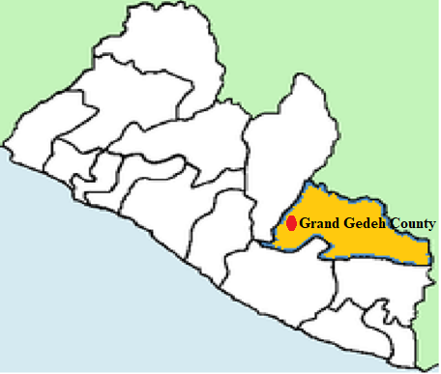

Figure 2: The 8 District of Grand Gedeh County showing the district where the Project fall

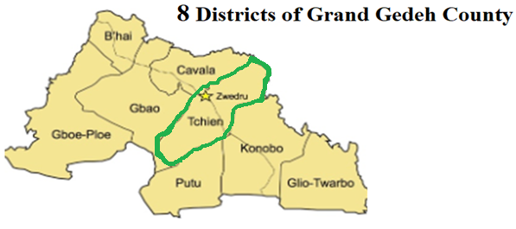

Figure 3: Map showing Project Road: John Davies Town to Zwedru (48.5km)
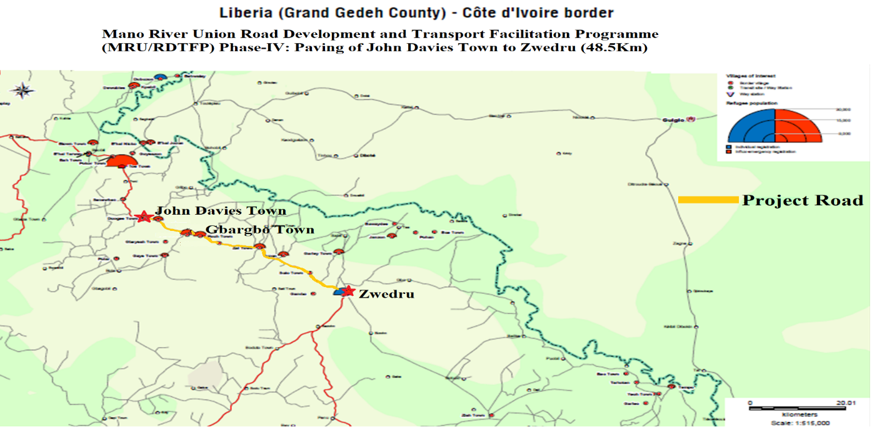
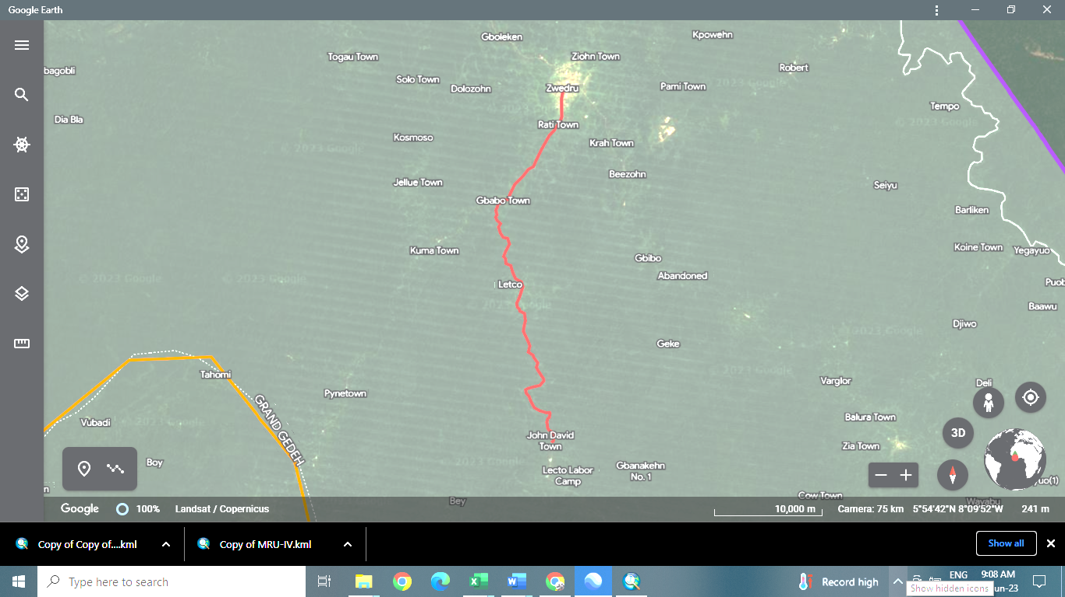

1.2.2 Project Area

The project areas comprise approximately 34 towns and villages, 3 churches, 1 clinic, 2 market buildings, a Rock Deposits/Quarry area; two campsites (Liberia Logging Company’s Camp, and unknown campsite); six (6) bridges (Neemi River Bridge, Feeley River Bridge, Jay River Bridge, Gbornee River Bridge, Dugbeh River Bridge, and unknown bridge before the City of Zwedru) along the corridor in Grand Gedeh County.

It is expected that the right-of-way along this road length from John Davis Town to Zwedru City will be affected as a result of its reconstruction. There is also going to be a slight diversion to the existing road in several places, and have other environmental and social impacts, among others. As a result of this, the project is likely to lead to environmental and involuntary resettlement issues within the right of way along the road corridor. This has therefore triggered the EPML, (2003), Section 6, and the AfDB’s Integrated Safeguards System (ISS) on the environment, which warrants the preparation of this ESIA and the RAP. Right-of-way (ROW) of 75 feet (or 22.86 m) will also be established to meet statutory and international standards,

1.3 Objective of the Resettlement Action Plan (RAP)

The RAP is aimed at collecting detailed information on persons who will be directly affected by the project activities, types, and magnitude of impacts, as well as identifying options and strategies for compensating such affected persons for resettlement. To achieve these objectives, the plan provides compensation and rehabilitation measures so that the income-earning potential of individuals is restored and sustains their livelihoods.

The Resettlement Action Plan (RAP) also provides details on:

- The likely impacts resulting from land acquisition for the rehabilitation and construction of the project road and the mitigatory measures that will be put in place to address these adverse impacts;

- The policies governing land expropriation, the range of adverse impacts and entitlements;

- Present strategy for achieving the objectives of the resettlement/ land acquisition policy;

- A framework for implementation of the stated strategies to ensure timely acquisition of assets, payment of compensation, and delivery of other benefits to project-affected persons (PAP);

- The public information, consultation and participation, and grievance redress mechanisms in project planning, design, and implementation;

- Provide identified sources and estimates of required resources for the implementation of the RAP; and

- A framework for supervision, monitoring, and evaluation of resettlement implementation.

Justification for the Resettlement Action Plan (RAP)

The main essence of the RAP is to ensure that project-affected persons do not lose their sources of livelihoods or assets. The RAP ensures the compensation and relocation of PAPs comply with the safeguards policies of the EPA and AfDB on involuntary resettlement. The RAP assists in minimizing the negative economic and social impacts that arise from either involuntary resettlement or loss of property/ livelihood for the Project Affected/ Impacted Persons. This may result in the below:
- Relocation or loss of shelter
- Loss of assets or access to assets
- Loss of income sources and livelihoods
The RAP guides how the Project Affected Persons (PAP) along the proposed project corridor will be adequately compensated and state how activities leading to compensation will be implemented in a way that is compliant with international best practices. The RAP ensures the below:

- Provides awareness of the project and its consequences among affected communities.
- Identifies the project alignment and clearly defines the Project Affected Persons that are eligible for compensation
- Sets a cut-off date for eligibility.
- Provides a socio-economic basis for identification of entitlements and strategies for minimizing the impacts on the Project Affected Persons.
- Establishes land acquisition and compensation process and establish a grievance resolution mechanism to address any grievances arising from the displacement
- Establishes rates for compensation on loss of assets and the methodology of determining the values.
- Provides proposals for resettlement options, particularly for the vulnerable PAPs.

1.4 Planning Principle

To achieve the underlying objectives of the project (i.e. the PAPs derive maximum benefit), the planning process considered public education, stakeholder sensitization, and evaluation of project impacts.

The Resettlement Action Plan should be implemented taking into consideration the below principles:

- Ensure that all people affected by the project should be compensated fully and fairly for lost assets including both permanent and temporary structures.
- Ensure that involuntary resettlement is conceived as an opportunity for improving the livelihoods of the affected persons.
- Ensure that all PAPs are consulted and involved in the resettlement planning to avoid adverse effects and enhance the benefits of resettlement.
- Ensure awareness of the project and its consequences among the public in general and those who will be directly affected by it.
- Estimate the costs necessary for resettlement/land acquisition

- Prepare a Resettlement Action Plan (RAP) that sets out strategies and schedules to mitigate adverse effects. The RAP sets the parameters and establishes entitlements for project-affected people (PAP), the institutional framework, mechanisms for consultation and grievance resolution, the schedule and budget, and the proposed monitoring and evaluation system. The agreed entitlement package includes both compensation and measures to restore the economic and social base of those affected.

- To address the requirements of the Government of Liberia, as fostered by the Environmental Protection Agency, and the African Development Bank for land acquisition and resettlement.

1.5 Scope of the Resettlement Action Plan

The scope of the RAP is in line with social safeguards guidelines of the Environmental Protection Agency along with the African Development Bank’s Policy on Involuntary Resettlement (2023). The below undertakings were carried out to ensure that the EPA and AfDB guidelines and policies were complied with,

- Secondary data information from official reports was reviewed and analyzed.
- Project Affected Persons were identified along the proposed project corridor.
- An asset inventory, which includes affected land, structures, crops, livelihood, and cultural assets, was compiled for all the identified Project Affected Persons.
- The Environmental Protection Agency of Liberia guidelines and legal provisions were reviewed and compared with the AfDB policies to identify any gaps and necessary recommendations to harmonize the two have been incorporated in resettlement planning.
- The land acquisition schedule and the resettlement plan were prepared with the necessary budget to facilitate the implementation.

1.6 Approach and Methodology of the RAP

The methodology and approach adopted in preparing the RAP are consistent with the Liberian Constitution (2006) and other Statutory Laws and Regulations among others, coupled with the African Development Bank’s ISS. A social baseline has been developed and a valuation for compensation costs prepared to maintain the livelihoods of the PAPs.

1.6.1 Approach

The approach adopted in the RAP is consistent with existing Liberian laws, the project objectives, and the policies of the African Development Bank. The Liberian Constitution recognizes the rights of individuals to property. The Constitution also considers that private property can be utilized for public use, fulfilling certain obligations. There is also a Poverty Reduction Strategy being implemented by the Government, whereby the lives of ordinary people are been improved through the reduction of poverty and ensuring sustainable economic growth.

In compiling the RAP, various steps were taken to meet the requirements of national legislation and objectives of AfDB Environmental and Social Assessment Procedures. To ensure that the concerns of major stakeholders were incorporated into the RAP, consultation meetings were held throughout the RAP preparation process and are expected to continue up to the implementation.

1.6.2 RAP Methodology

Initially, data about the project site was collected through the review of the existing data sources which included the Liberian Census 2008 Report and maps of the project area. Secondly, a reconnaissance survey was undertaken by a team of consultants comprising environmentalists to get a deeper understanding of the technological, biophysical, and socio-economic environment of the project site. Thirdly, focused group discussions were held with county and community leaders to have a feel of their desires and expectations concerning the project.

Finally, a socioeconomic survey of the project area was conducted to evaluate the socioeconomic conditions of the project-affected people (PAPs) before the project works. The understanding of critical socio-economic parameters of the PAPs, and the valuation of the properties to be lost, will enable the project proponent to address the impacts of resettlement positively.

1.7 Report Structure

This report provides the RAP for the Mano River Union Road Development and Transport Facilitation Program (MRU/RDTFP) Phase-IV: Paving of John Davies Town to Zwedru (48.5Km) of Lot 3 of the Zwedru – Harper Section of the Ganta – Harper Road Project (510Km). The report has been prepared to cover the following:

Chapter One: Introduces the Project, Location, Objectives, Justification, Scope, and
Methodology.

Chapter Two: Regulatory, Policy, Institutional Frameworks,

Chapter Three: Socio-Economic Study of the Proposed Project Area and Socio-Economic
Characteristics of Project-Affected Persons

Chapter Four: Project Impacts and Mitigations

Chapter Five: Public Participation and Consultation

Chapter Six: Resettlement Compensation to Project-Affected Persons

Chapter Seven: Responsible Agencies for RAP Implementation, Monitoring and Evaluation

Chapter Eight: Grievance Redress Mechanism

Chapter Nine: Budget and Schedule for RAP Implaementation

2.0 REGULATORY, POLICY AND INSTITUTIONAL FRAMEWORKS

The RAP considers applicable existing policy, institutional and regulatory frameworks within the context of Liberian Law. Preparation of this RAP draws on the requirements of the African Development Bank’s Environmental and Social Assessment Procedures and relevant social safeguard policies. The RAP also draws on the Liberian Constitution of 1986, the Aborigine Law of 1956, the Property Law of 1976, Revised Rules and Regulations Governing the Hinterland of Liberia (2001), and recent Land Right Policy (2013), and the 2016 Liberia Land Authority’s Act.

2.1.0 Regulatory Framework

The Liberian Constitution and other laws provide for resettlement and compensation. This section provides a detailed description of the legal framework for the implementation of involuntary resettlement projects in Liberia, considering the following applicable Liberian Laws.

2.1.1 Liberian Constitution 1986

Article 22 (a) and (b) of the Constitution gives the right to all individuals to own property, either on an individual basis or in conjunction with other individuals, as long as they are Liberian citizens. The right to ownership of property however does not extend to mineral resources on or beneath the land.

Article 24 indicates that the state guarantees the inviolability of property rights, but then provides for the expropriation of property for public purposes. It requires prompt payment of just compensation where this occurs. However, there is a lack of procedural provisions.

Articles 65 also contain a provision that the courts shall apply both statutory and customary laws in accordance with the standards enacted by the Legislature. This provides the constitutional basis for the application of the customary land tenure rules under which many rural Liberians hold their land.

2.1.2 Aborigines Law of 1956

Chapter II of this Act states that each tribe is entitled to the use of as much of the public land in the area inhabited by the tribe, as is required for farming and other enterprises essential to tribal necessities. It shall have the possession of such land as against any other person. It goes further to say that the omission of a tribe to have its territory so delimited shall not, however, affect in any way its right to the use of the land.

2.1.3 Property Law of 1976

This law established the conditions under which a Liberian can own real property and dispose of same. It states that one must hold title documents for such land and when transferring same, it shall be done by title, duly registered.

2.1.4 Revised Rules & Regulations Governing the Hinterland of Liberia (2001)

These rules are a successor to the earlier Laws and Regulations on the Hinterland. These rules apply not only to hinterland but also to land in older counties, under the customary land tenure system.

Articles 66 and 67 of the rules grant tribal people in a rural area the right to utilize land in their locale. And that any stranger wishing to utilize such land as against their usage, such stranger shall compensate for the use of the land.

2.2.0 Policy Framework

2.2.1 Land Right Policy of Liberia (2013)

The Land Right Policy of 2013 provides policy recommendations for land rights in Liberia, centered on four basic types of rights: Public Land, Government Land, Customary Land, and Private Land.

The Policy also fosters equal protection of all relative to land matters. The policy recognizes that since the founding of Liberia, the lands of customary communities have been less secure than private lands. This must end such that lands under customary practice and norms are given protection equal to that of private lands. This policy aims to give equal protection to the land rights of men and women.

2.2.2 National Environmental Policy (2003)

The National Environmental Policy aims at improving the physical environment, quality of life, and coordination between economic development, growth, and sustainable management of natural resources. Key objectives of the policy include:

- Systematic and logical framework with which to address environmental issues

- Benchmarks for addressing environmental problems in the medium- to long-term

- The context for financial/donor support to sectors and non-sector

- Means for generating information and awareness on environmental problems

- Demonstration of Liberia’s commitment to sustainable management of the environment.

2.2.3 African Development Bank Policy on Involuntary Resettlement

The AfDB Policy on Involuntary Resettlement covers economic and social impacts associated with Bank-financed projects involving involuntary acquisition of land or other assets which results in:

- Relocation or loss of shelter by the persons residing in the project area

- Loss of assets or involuntary restriction of access to assets including national parks, protected areas or natural resources; or

- Loss of income sources or means of livelihood as a result of the project, whether or not the affected persons are required to move.

Displaced persons in the following two groups are entitled to compensation for the loss of land or other assets taken for the project purposes:

- Those who have formal legal rights to land or other assets recognized under the laws of the country. This category will generally include people who are physically residing at the project site and those who will be displaced or may lose access or suffer a loss in their livelihood as a result of the project activities; and

- Those who may not have formal legal rights to land or other assets at the time of the census can prove that they have a claim such as land or assets that would be recognized under the customary laws of the country. This category may also include those people who may not be physically residing at the project site or persons who may not have any assets or direct sources of livelihood derived from the project site, but who have spiritual and/or ancestral ties with the land (e.g., graveyards, sacred forests, places of worships). This category may also include sharecroppers or tenant farmers, seasonal migrants, or nomadic families losing user rights, depending on the country’s customary land use rights. Additionally, where resettles lose access to resources such as forests, waterways, or grazing lands, they would be provided with replacements in kind.

- A third group of displaced persons are those who have no recognizable legal right or claim to the land they are occupying in the project area and who do not fall into any of the two categories described above. This category of displaced persons will be entitled to resettlement assistance instead of compensation for land to improve their former living standards (compensation for loss of livelihood activities, common property resources, structures, and crops, etc.), provided they occupied the project area before a cut-off date established by the borrower and acceptable to the Bank. At the minimum, under the Bank’s policy (with no contradiction to the borrower’s legislation), land, housing, and infrastructure should be provided to the adversely affected population, including indigenous groups, ethnic, linguistic, and religious minorities, and pastoralists who may have usufruct rights to the land or other resources taken for the project. The cut-off date must be communicated to the project-affected population. Persons who encroach on the project area after the cut-off date are not entitled to any form of resettlement assistance.

2.4 Land Tenure Systems

2.4.1 Customary Tenure

Customary tenure involves the use of land which the government has granted to people in the hinterland through customary rights. The process begins with the Town Chief, then the Clan or Paramount Chief, and finally the District Commissioner who prepares Customary Land Grant Certificates which are subsequently legalized by the President of Liberia.

2.4.2 Freehold Tenure

This involves holding land in perpetuity or for a term fixed by a condition and enables the holder to exercise, subject to the law, full powers of ownership.

2.4.3 Leasehold Tenure

This tenure is created either by contract or by operation of the law. Under the tenure, the landlord or lessor grants the tenant or lessee exclusive possession of the land, usually for a specific period in return for a rent, granting the tenant security of tenure and a proprietary interest in the land.

2.5 Land Valuation System

The Republic of Liberia is the original grantor of land and the public are all grantees. Anyone who obtains land from the State has a bona fide title and right to full possession and use of said land. However, the State has the right to revoke any previously granted title it has given. In the exercise of such power of condemnation, the State, through its institutions, is statutorily obligated to first evaluate the current market value of the property to be acquired to provide just compensation to the affected owner. Where the land to be condemned is for public use, the State has the burden of replacing it with one of commensurate value.

2.6 Compensation

The basis for one to receive compensation for acquired land is provided by Article 24 of the 1986 Liberian Constitution. The provision states that expropriation may be authorized for national security issues or where public health and safety are endangered, or for any other public purposes, provided:

- The reasons for such expropriation are given and it should be intended for public/national use;

- That there is prompt payment of just compensation;

- That such expropriation or the compensation offered may be challenged freely by the owner of the property in a court of law with no penalty for having brought such action; and

- That when property taken for public use ceases to be so used, the Republic shall accord the former owner, the right of first refusal to re-acquire the property.

This basis is also supported by the recent Land Right Policy of 2013 that lands under customary practice and norms are given protection equal to that of private lands. For customary practices, deeds are not usually issued for the transfer of land.

2.7 Grievance Remedial

The laws of Liberia provide an avenue for which an aggrieved party can seek redress. In the instance where the grievance lies against an entity of government, the first step in seeking redress is to complain to the agency, which shall then conduct an administrative hearing and decide on the matter. Such decisions are subject to appeal to a court of competent jurisdiction. An appeal may also be taken to a higher court from a lower court if the aggrieved is not satisfied with the judgment of the lower forum. An aggrieved may seek appellate review up to the Supreme Court of Liberia. The Supreme Court is the highest judicial body to which an appeal may be lodged and its decision is not appealable.

Besides the judicial system, a dispute may be resolved through mechanisms such as mediation at administrative agencies, where the aggrieved party refers the dispute to a third party for a decision binding on both parties; or arbitration, where both parties appoint a broad or arbitrators who may make a binding decision on resolution of the dispute.

2.8 Comparison of Liberian Legislations and AfDB Environmental and Social Assessment Procedures

Table 3 shows the comparison between the Liberian legislation and AfDB Assessment Procedures.
Table 3:Comparison between Liberian Legislations and AfDB Policies
Theme | Liberian Legislation | AfDB Policy | Mitigation Measures
Categories of affected individuals | There is no distinction between affected individuals. Landowners, land tenants, land users, owners of buildings, and owners of | Involuntary Resettlement should be avoided where feasible, or minimized.  • Particular attention should be | The project should be designed to distinguish between classes of affected individuals and this should be taken into consideration in awarding compensation.

 | perennial crops are all grouped and treated likewise.  There are no separate provisions, especially for vulnerable classes of people. | given to vulnerable groups  • Displaced persons should be assisted to improve their livelihoods and standards of living or at least to restore them to pre-project levels.
Impacts | Addresses only the direct physical impact of acquiring land. Socioeconomic considerations are not given priority. | Compensation should involve direct economic and social impact caused by acquisition.  It is not required to cover indirect social or economic impacts, but it is good practice for the project proponent to undertake social assessment and implementation measures to minimize adverse impacts, particularly to poor and vulnerable groups | Design a project to consider socio-economic issues in determining compensation.
Compensation & Participation | Affected persons are to be informed before the repossession of land. However, there is no provision on the notice period, and neither is there a distinction between farmed land and developed land. | Affected persons should be:  - Informed in a timely manner of their options and right pertaining to resettlement  - Offered choices among, and provided with technically and economically feasible resettlement alternatives Provided with timely and relevant information to host communities receiving re-settlers. | Adequate communication between government agencies and affected individuals well ahead of the scheduled period of repossession.
Eligibility for  compensation &  benefits | Compensation is restricted to individuals having a legal title to affected land or property | The absence of legal title to land or other assets is not a bar to compensation for lost assets or other resettlement assistance | Design project to extend compensation (social and economic) to individuals who do not have legal title to property
Monitoring & Evaluation | External evaluation is not required | Internal monitoring and external evaluation are required | Design project to involve third-party input in the assessment of compensation to be paid.
In case of conflict between the Liberian regulations and the African development bank policies during the implementation of this rap, the AfDB policies will prevail.

2.9.0 Institutional Framework

The institutions that have the statutory roles in the implementation of this RAP are as follows:

Ministry of Public Works

This ministry has the statutory responsibility to approve the design and construction of all civil works, including motor roads. Additionally, it is also responsible to carry out urban and town planning, as well as provide architectural and engineering supervision of infrastructure required for waste management.

Liberia Refugee Resettlement Reintegration Commission

This commission is clothed with the responsibility of ensuring that people affected by the civil crisis are resettled and reintegrated into society.

Ministry of Internal Affairs

The Ministry of Internal Affairs is responsible for the administration of the local government, which involved the collection of taxes, maintenance of peace and tranquility, and seeking the welfare of the people.

Ministry of Lands, Mines and Energy

This Ministry, besides its pivotal role in mineral resource development, is also in charge of administering and regulating public and private lands. This includes land tenure, land policy, land reform, land use, planning, and other aspects of land administration.

Ministry of Agriculture

The Ministry of Agriculture is the government ministry mandated to approve rates paid as compensation for economic and other crops on government projects. The MPW/PIU shall pass on the compensation of crops to the Ministry of Agriculture for approval before payments would be affected.

Environmental Protection Agency (EPA)

The EPA is responsible for monitoring, coordinating, and supervising the sustainable management of Liberia’s environment. It is mandated to ensure the conduct of environmental impact assessments for all projects and activities that are likely to have significant adverse effects on the environment.
Ministry of Finance (MFDP)

The Ministry of Finance Development and Planning is the agency of Government responsible for the allocation of funds for the RAP implementation.
General Auditing Commission (GAC)

The General Auditing Commission is the agency of the Government responsible for ensuring accountability and transparency. The entity will ensure that funds are provided and expensed for the intended purposes as stipulated in this RAP.

3.0 SOCIO-ECONOMIC

3.1.0 Socio-Economic Study of the Proposed Project Area

Table 4:Summary Table of the RAP prepared for the project
Description | Comment
Region | Southeastern, Liberia
County) | Grand Gedeh County
Type of Civil Work & Road Length | The Mano River Union Road Development and Transport Facilitation Program (MRU/RDTFP) Phase-IV: Paving of John Davies Town to Zwedru (48.5Km) of the Zwedru – Harper Section of the Ganta – Harper Road Project (510Km).
Total Number of Structures to be Affected by the Project | 286
Total Number of Graves & Cemeteries | 5 individual graves and 3 cemeteries
Total Number of Farms or Tree Crops owners to be affected | 20
Total Number of PAPs unavailable for the survey | 89
Total Number of Eligible PAPs interviewed | 157
Total Number of Males Interviewed | 94
Total Number of Females Interviewed | 63
Total Number of Affected Persons | 246
MEMBERS OF HOUSEHOLD AND VULNERABLE
Number of Affected Communities | 18  - John Davies Town, (2) CVI Junction, (3) Duo Town, (4) Karlorwleh Town, (5) Wroto Village, (6) Royal Village, (7) Quiah Village, (8) Kamnyee Village, (9) Jarwleh Village, (10) Saryon Town, (11) Wilson Taye Village, (12) George Quiah Village, (13) Jaygbo Village, (14) Gbargbo Town, (15) Pellezon, (16) Polah Village, (17) Boleyville, (18) Zwedru
Number of Affected Public Utilities (Hand Pumps and Well) | 3 hand pumps and 1 well
Church | 3
Clinic | 1
Toilet | 0
Palava Hut | 2
Market Building | 2
School | 0
Total Budget for Implementation of RAP | US$1,544,520.82

3.1.1 Survey Methodology and Approach

The socio-economic survey was conducted by qualified sociologists and asset evaluators that focused on the collection of primary data on demographic characteristics, income and livelihoods, and housing conditions. The primary data sources used to describe the existing socio-economic situation are as follows:

- Census of all project-affected people
- A household survey based on households that are to be directly affected by the project
- Public/community consultations that provide qualitative data; and
- Inventory of affected assets in the area.

Questionnaires were used to obtain census and socio-economic information about the affected people. The objective of the survey was to establish the magnitude of the project's impacts on the affected households as well as establish an inventory of assets likely to be impacted. To ensure concise responses, pre-coded multiple-choice questions were used during the interviews. The project team members held training and practical sessions focusing on interview techniques, recording responses, and standardization of assessments. The collected data were checked by supervisors, re-checked by a data analyst, and edited for consistency, error, and coding, both in the field and before data entry

3.1.2 PAPs Means of Livelihood

The majority of the PAPs are engaged in some form of activities to obtain their livelihood. Most are farmers, and miners especially those in rural communities. Few PAPs with commercial structures are involved in petty trading. Still, fewer PAPs, especially in urban areas, are employed in the public and private sectors.

3.1.3 Types and Nature of Structure own by project affected persons (PAPs)

294 structures will be affected by the project. The structures include concrete blocks building and/or porches, mud bricks buildings with zinc and thatch roofs, mud dub buildings with zinc and thatch roofs, wood frame structures with zinc and thatch roofs, graves, hand pumps, huts, clinics, market buildings, and others, which include a kiosk and a water well. Some of the PAPs own more than one structure. Table 5 and Figure 5 show the structure types in the project area.

Table 5: Types of Structures Affected
Structure Types | No. of Structure | Percentage
Mud-dubbed /Zinc | 112 | 38.10
Mud-dubbed /Thatch | 79 | 26.87
Mudbricks Zinc | 53 | 18.03
Wooden Zinc | 13 | 4.42
Graves /Cemetery | 8 | 2.72
Hand Pump | 5 | 1.70
Wooden Thatch | 4 | 1.36
Stick/Zinc | 4 | 1.36
StickThatch | 3 | 1.02
Unfinished Mud-bricks | 2 | 0.68
Container | 2 | 0.68
Wooden | 1 | 0.34
Well without Culvert | 1 | 0.34
Stick/Thatch | 1 | 0.34
Shelter | 1 | 0.34
Mud-dubbed plastered/zinc | 1 | 0.34
Mud Bricks/Latrine | 1 | 0.34
Concrete (Residential) | 1 | 0.34
Concrete (Building) | 1 | 0.34
Concrete (Clinic) | 1 | 0.34
Total | 294 | 100.0

Figure 4: Graph showing structure types

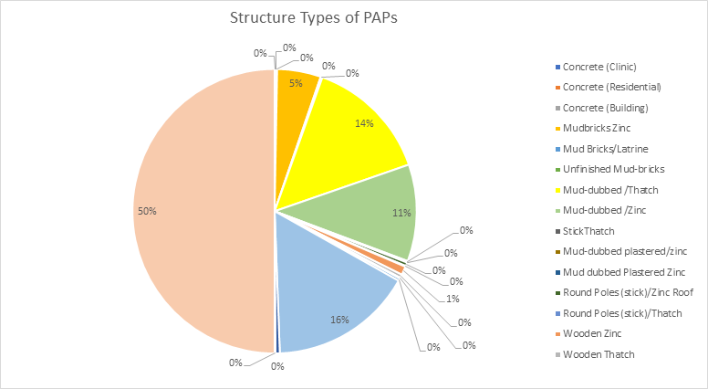

Out of the 294 structures observed during the survey, about 133 are used for residential or related purposes, 113 are used for commercial or related purposes, and 68 are used for other purposes not related to residential or commercial purposes. Table 6 and Figure 6 indicate the nature of the structures observed.

Table 6: Nature of Structure
Nature of Structure | Survey Result | Percent (%)
Commercial | 113 | 38.4
Residential | 133 | 45.2
Clinic | 1 | 0.3
Church | 3 | 1.0
Graves | 8 | 2.7
Handpump | 4 | 1.4
Kitchen | 23 | 7.8
Market Bldg. | 2 | 0.7
Palava Hut | 3 | 1.0
Shelter | 1 | 0.3
Toilet | 2 | 0.7
Well | 1 | 0.3
Total | 294 | 100.0

Figure 5: Graph showing the nature of the structure Affected by the Project
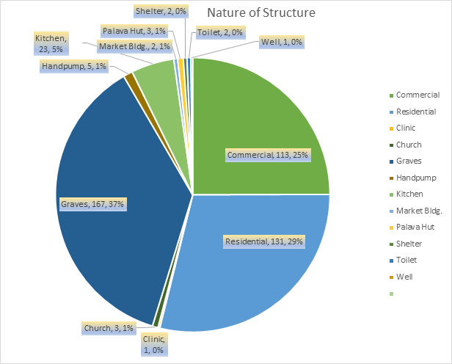

3.1.4 Effect of Project on Affected Properties

The survey shows that out of the 286 structures to be affected by the project, some will be fully affected or demolished, while others that are removable will be removed to another location. Partially affected structures include structures where only porches or fences will be affected. Other structures like kiosks, hand pumps, and graves will not be destroyed or demolished, but simply relocated to another location.

Though some structures were marked in the middle, those structures were considered as going to be fully affected since the remainder of the structures will not serve the purpose for which the entire structures served. Therefore, the survey considered such structures to receive 100% compensation.

3.1.5 Land Tenure of PAPs

During the conduct of the survey, despite being educated on tenure, some PAPs claimed to have fee simple ownership (deed) for the property they occupy, while the majority indicated that they did not have genuine deeds. To those who claimed to have a deed, when requested to exhibit the same, none was exhibited. Some claimed to have inherited the property from earlier ancestors. It can therefore be concluded that the majority of the PAHs may be considered without a genuine title. For some structure owners who were not available during the survey, his/her tenure could not be established, even though this does not change the situation in any way. Table 7 and Figure 7 present the land tenure of the PAPs as stated during the survey. Since the majority of the PAPs did not properly establish their tenure, it is necessary to confirm their tenure before and during the implementation of the RAP.

Table 7: Land Tenure of PAPs
Land tenure of PAPs | Survey Report
PAPs with Deed | 78
PAPs with No Deed | 168
 | 246

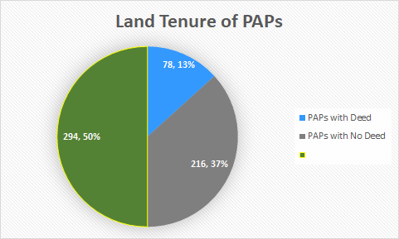
Figure 6: Graph showing the land tenure of PAPs with Deeds and No Deeds

The majority of the PAPs were born in the structures surveyed or have resided therein for more than ten (10) years. This situation exists for PAPs mainly in the rural areas, as compared to those in the urban areas who have resided in the structures for less than ten (10) years. These PAPs have moved into the area because of employment or search for jobs. However, the periods of stay at the project site, as stated by the PAPs could not be independently verified. Table 8 and Figure 8 show the length of time the PAPs who responded to this question claimed to have occupied the project area.
Table 8: Time PAPs Occupy Area
Time at the project area | Survey Report
Less than 1 year | 8 | 2.80%
1 to 5 years | 31 | 10.80%
6 to 10 years | 68 | 23.80
More than 10 years | 179 | 62.60%
Total Time PAPs Stayed in the Area | 286 | 100

Figure 7: Graph showing the time PAPs occupied area

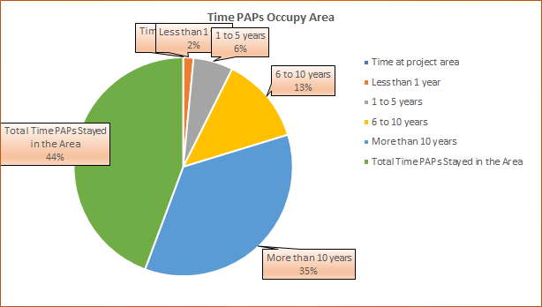

Regarding their support for the project and willingness to move to ensure its implementation, all the PAPs who responded to this question expressed positive support for the project and indicated that they are willing to move so that the project can be implemented where they are compensated.

3.1.6 Period to Relocate

A total of 157 PAPs along the road corridor were also questioned as to what period would be adequate for them to relocate from the area, after receiving compensation. 6% of the PAPs indicated that they would need up to 30 days (1 month) to relocate while 94% stated that they would need up to 3 months to relocate. Hence, a period of up to 90 days (3 months) would be reasonable for the PAPs relocation as required by EPA and AfDB. These results are presented in Table 9 and Figure 9.

Table 9: PAPs’ Time to Relocate
Land tenure of PAPs | Survey Report
1 month | 9 | 6%
3 months | 148 | 94%
Total # PAPs for Relocation Timeframe | 157 | 100%

Figure 8: Graph showing the PAP's time to relocate

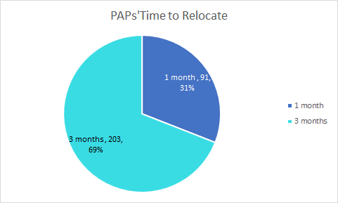

3.1.7 PAPs Preferred Mode of Compensation

The survey sought to find out preferred modes of compensation as a way of developing popular and PAPs driven compensation mechanisms. All the PAPs (100%) interviewed stated that the project was beneficiary to the community and that they would move to allow for its implementation. All the PAPs interviewed also prefer cash compensation or financial assistance so that they can seek relocation.
The choice of the mode of compensation of the PAPs in the project area is largely influenced by the fact that the nature of tenure on land is not clear for the majority of the PAPs. This makes them most likely to qualify for cash compensation for structures lost and relocation and loss of income allowance (see Table 5.0)

3.2. Socio-Economic Characteristics of Project-Affected Persons
According to the AfDB, it is recommended that where involuntary resettlement is unavoidable, either as a result of a negotiated settlement or expropriation, a census should be carried out to collect appropriate socio-economic baseline data to identify the persons who will be displaced by the project, determine who will be eligible for compensation and assistance, and discourage ineligible persons, such as opportunistic settlers, from claiming benefits. In compliance with the AfDB standard, and socioeconomic studies to guide further RAP planning and Implementation.
The project proponent ensured that a Socio-Economic Survey (SES) was conducted of the Project Affected Persons (PAPs), who are the owners and tenants of structures within the right of way of the area designated John Davies Town to Zwedru (48.5 Km). However, as the project proponent has already conducted RAPs for Lots 1 and 2, which included the Fish Town, Kelipo, Putuken to John Davies Town areas, the survey completed the remaining portion of the project corridor beginning from John Davies Town to Zwedru in Grand Gedeh County.

Most of the project-affected households (PAHs) were interviewed to gain information on their situation and present living standards. Most PAHs will lose a portion of the entire structures within the project area. Even though some indicated having a legitimate title for the land they occupy, they did not exhibit genuine deeds. Hence, the PAPs will therefore not lose land. The exercise (SES) could not cover all the possible PAPs (majority-owning graves) because few were not available when the survey was conducted.

From John Davies Town at Km 0+000 to Zwedru (48.5km), 286 structures, 5 individual graves and 3 cemeteries and 20 farms were recorded. It is anticipated that the three cemeteries may contain a total of 165 individual graves. It was observed that some PAPs own more than one structure. Hence, 157 PAPs in the project area were interviewed. 70 structure owners and 19 farm owners were unavailable for the survey. The items interviewed in the survey were basic demography, vulnerability of the people, income, household condition, preferred mode of transportation, preferred mode of resettlement, etc. The following discussion of the socio-economic characteristics of the consulted PAPs is based on a field survey conducted between May 13 and June 6, 2023. The RAP cut-off date was set as June 1, 2023.

Human settlement, commercial activities, and farming are the major undertakings in the project area. About 5 individual graves, 3 cemeteries, 20 farms and 286 structures were identified along the project road between John Davis Town to Zwedru City. The structures include concrete block buildings, mud bricks buildings with zinc and thatch roofs, mud dub buildings with zinc and thatch roofs, wood frame structures with zinc and thatch roofs, graves, hand pumps, market buildings, clinics, and others which include kiosks, fences, palava huts, toilets, and wells, etc. Some of the PAPs own more than one structure, grave, or farm and a small number of owners were unavailable during the survey.

Out of the 286 structures observed during the survey, about 133 are used for residential or related purposes, 113 are used for commercial or related purposes, and 40 are used for other purposes not related to residential or commercial purposes. As to their support for the project and willingness to move to ensure its implementation, all expressed positive support for the project and indicated that they are willing to move so that the project can be implemented. The survey sought to find out preferred modes of compensation as a way of developing popular and PAPs driven compensation mechanisms. All the PAPs interviewed (100%) stated that the project was beneficiary to the community and that they would move within the stipulated timeframe (90 days) after compensation to allow for its implementation. All the PAPs also prefer cash compensation or financial assistance so that they can seek relocation.

Acquiring Land in the project area: getting land in this region or along the proposed corridor is not as difficult as acquiring land near border corridors. Once the PAPs are compenetrated, the local authority will help them in getting ownership of new lands through local authority from their district land office.

3.3.0 Socio-Environment

3.3.1 Population

Human settlement, commercial activities, mining, and farming are the major undertakings in the project area. 246 PAPs or structure owners were identified along the project corridor. A total of 998 children/wards/elderly will also be indirectly affected by the project. This brings the total of 1,308 persons to be indirectly affected by the project. There are 286 structures, 5 individual graves, 3 cemeteries and 20 farms that are owned by people that will be affected by the project. The structures include concrete block buildings, mud brick buildings with zinc and thatch roofs, mud dub buildings with zinc and thatch roofs, wood frame structures with zinc and thatch roofs, graves, hand pumps, market buildings, clinics, and others which include kiosks, fence, palava huts, toilets, and wells, etc. Some of the PAPs own more than one structure, grave, or farm and a small number of owners were unavailable during the survey.

Out of the 286 structures observed during the survey, about 133 are used for residential or related purposes, 113 are used for commercial or related purposes, and 40 are used for other purposes not related to residential or commercial purposes.

3.3.2 PAPs Gender

Out of the one hundred fifty-seven (157) PAPs interviewed, males are in the majority comprising 94 persons, while females make up the minority of 63 persons. Out of the total number of PAPs interviewed, PAPs aged between 18- 75 years with 80% ranging from 18-40 and 20% between 50 to 75 years. The assessment observed most PAPs to be young people than older people as shown in Table 10 and Figure 10.

Table 10: Gender of the PAPs
Population by Gender | Survey Report
Male | 94 | 60%
Female | 63 | 40%
Total Male & Female | 157 | 100%
Figure 9: Graph shows the gender of PAPs

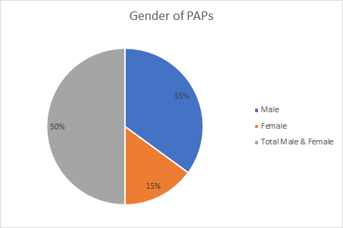

3.3.3 PAPs Educational Level

Based on the total number of PAPs interviewed, 20% have formal education, though most only completed secondary school. 42% dropped out of school at some time in primary or secondary school, and 38% never entered school. Table 11 and Figure 11 show the educational status of the PAPs interviewed

Table 11: Educational Status of PAPs
Description | Survey Report
Never Attended | 63 | 40%
Drop Out | 73 | 46.5%
Secondary & above | 21 | 13.5%
Total | 157 | 100%
Figure 10: Education Status of PAPs

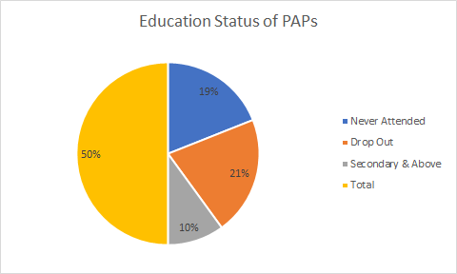

3.3.4 Main Occupation for PAPs

Based on the occupation of PAPs, most of them are engaged in mining, commercial activities, and farming, which are the major activities in the proposed project area.

3.3.5 Marital Status of PAPs

The majority of the PAPs mentioned being single although with few are married. The rest are divorced and widows as indicated in Table 12 and Figure 12.

Table 12: PAPs Marital Status
Description | Survey Report
Married | 48 | 30.5%
Divorce | 2 | 1.5%
Single | 96 | 61%
Widow | 11 | 7%
Total | 157 | 100%

Figure 11: PAPs Marital Status

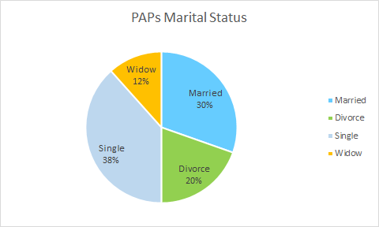

3.3.6 Ethnicity of PAPs

The majority of the people living along this corridor are from the Kran and Grobo ethnic groups. The survey recorded 80 % that speak Kran and are from Grand Gedeh, while 10% speak Grobo and are from River Gee. The remaining 10% are a few people from other ethnic groups of the 16 major ethnic groups of Liberia.

3.3.7 Vulnerability of the Project Affected Persons

Vulnerable people who will be considered include PAPs that are physically challenged or with some level of disability and also household heads who are female and 60 or more years of age that are at risk of being deprived of productive assets such as land/house and farms/crops. These persons are earmarked for vulnerability assistance, in addition to other payments or assistance. The survey recorded twenty-five (25) older people who are considered to be vulnerable because of their age of 60 and above. Among the 25 vulnerable PAPs, there are fourteen (14) males and eleven (11) females, one of the females is physically challenged which is included in the above number recorded.

The survey indicates that the majority of the PAPs are aged 18 to 79. Few PAPs were aged more than 60 and above. This group was mainly male and considered vulnerable. Female, as a disadvantaged group, was also considered vulnerable. The group of vulnerable PAPs will receive some assistance for vulnerability, along with other compensations. The total number of vulnerable PAPs was recorded in Table 13
Table 13: PAPs Grouping
Vulnerability Criteria | Gender
Older people (Above 60) | Males | Females
25 | 14 | 11

Vulnerability was examined in terms of having difficulty in seeing, hearing, and walking and possession of mental disability. Table 14 shows that all of the household heads without disabilities and blindness. the household head reported no level of mental illnesses. Other vulnerabilities observed in the project area include female households above 60 and more. Few females headed households and one household head with physically challenged conditions. In the case of equitably participation and benefiting from the proposed livelihood restoration activities leading to worsening socioeconomic conditions, the mitigation measures should therefore be designed to address the risks of the project to vulnerable groups.

3.4 Access to Basic Facilities

During the survey, it was observed that some residents access various basic facilities through various means. Through motorbikes, residents who were unable to afford the relatively high costs of the transport made their journeys by walking. For instance, nearly 27% of the sampled population (62% of which are women) walk over 4 hours to sell mostly farm products to nearby market centers or to have access to health centers. This poses a potential challenge to both men and women.

3.5 Transportation Challenges

Both men and women face similar challenges in the conduct of daily operations through transportation. For instance, fewer men (21.2%) compared to women (52.9%) mentioned unavailability of transport services as a challenge; while 29.4% (5) of women and 24.2% (8) of men are constrained by high transport costs. Poor road condition is equally a problem for both genders, but it concerns more men (12.2%) than women (11.8%). A similar situation is being experienced in petty trading and so on.

When asked what the project could do to reduce these constraints, both men and women responded that the project should consider addressing the challenges highlighted above by improving access to public transport; improving the road conditions, for both primary and feeder roads, and enhancing access to basic services. The survey showed equal interest by both genders in the use of transport opportunities to enhance public and economic activities irrespective of the prevailing differences in transport demand arrangements.

3.6 Poverty Conditions

It was observed during the field survey that livelihoods are predominantly land-based, primarily focusing on subsistence agriculture, small-scale commercial activities and supported by artisanal gold mining. The standard of living is generally relatively poor in the absence of cash-based employment opportunities as well as basic amenities such as electricity. There are, however, fewer boreholes and installed hand pumps in most of the villages within the vicinity of the project area.

3.7 Approach and Methodology

The methodology and approach adopted in preparing the RAP is consistent with The Liberian Constitution (2006) and other Statutory Laws and Regulations among others, coupled with the African Development Bank Environmental and Social Assessment Procedures. A social baseline has been developed and a valuation for compensation costs prepared to maintain the livelihoods of the PAPs.

4.0 PROJECT IMPACTS AND MITIGATIONS

4.1 Types of Impacts

The goal of the project is to improve transportation, and social welfare and enhance the living standards of residents of southeastern Liberia, and all Liberians through an efficient road transport network. However, Mano River Union Road Development and Transport Facilitation Program (MRU/RDTFP) Phase-IV: Paving of John Davies Town to Zwedru (48.5Km) of the Zwedru – Harper Section of the Ganta – Harper Road Project (510 km) links transverses through areas of diverse land uses. Therefore, its construction is expected to have a widespread positive impact on overall the socio-economic status and livelihoods of the road users, project-affected people (PAPs) as well as the economy of counties in the southeast of the country. There will however be some negative impacts. For the negative impacts, mitigation measures are presented to mitigate these impacts. The major negative impacts include permanent losses of residential and commercial structures, loss of land, loss of public facilities, and adjustment of fences and relocation of businesses.

4.1.1 Positive Impacts

- Improved Transportation - The construction and pavement of Lot-3 of the MRU/RDTFP Phase-IV link will improve transportation in southeastern Liberia, making the movement of goods and services efficient.

- Advance Regional Road Network - The rehabilitation of the road will also advance the planned regional transportation network between the West African States as the project road connects with other road networks in the country, which connect with roads in bordering countries

4.1.2 Negative Impacts

- Loss of Residential houses and other Domestic Structures - 286 of the structures within both corridors of Lot 3 of the MRU/RDTFP Phase-IV, which are solely residential or related, will be affected. The buildings are mainly constructed of mud dubbed with thatch and zinc roofs.

- Loss of Portions of Farmland or Tree Crops - About 20 farmlands or tree crops will be affected.

- Loss of shops and business places - Table 5.0 presents a summary of the loss of structures to be affected by the project. The majority of these structures are used for residential and commercial purposes. These are mostly petty trading establishments of little shops, market stalls, and kiosks.

- Displacement of People (homelessness) - About 246 persons will be displaced by road construction work. PAPs were interviewed, the majority of which are males and the majority of the affected persons are between the ages of 18 – 69 years.

The components for which land acquisition and resettlement are required are:

- General road improvement will affect people who have residences or businesses located along the road right-of-way.

- People settled in the right-of-way which will be affected by construction works during the construction process.

The cut-off date was essential in the process of drawing up lists to ensure that ineligible persons do not take the opportunity to claim eligibility. The cut-off date for this project was set June 1, 2023, after the socio-economic survey, making anyone who makes a claim for loss of land or any assets after this date to be ineligible for expropriation/compensation.

4.2 Mitigation Measures

To arrive at a mitigation plan, the PAPs have been involved in the decision-making process whereby they have been informed about their options and rights about resettlement namely:

- Cash for compensation

- Land or another place

- A combination of the above.

Compensation is mainly skewed towards cash compensation for structures (housing, crops, etc.) that will be affected. Cash compensation has been adopted as the mitigation measure at full replacement cost rates. And as requested by the PAPs, prompt compensation will readily enable them to relocate quicker.

All the PAPs interviewed (100%) expressed support and willingness to move to facilitate the implementation of the project although the majority about 96% wanted 90 days (3 months) for relocation upon compensation.

5.0 PUBLIC PARTICIPATION & CONSULTATION

During the RAP preparation process, consultations were held with a wide range of stakeholders including local authorities and leaders, community leaders, NGOs, household heads, business owners, landlords, and structure owners. The objectives of these consultations were:

- Dissemination of information among potentially affected communities about the intended project

- Getting the perception of communities toward the project

- Identification of anticipated project impacts on the socio-economic and cultural life of the community; and

- Identification of stakeholders and their roles in project activities.

5.1 Consultations with Stakeholders

Consultations were held with stakeholders in the areas affected by the project. Individuals, groups, and institutions interested in and potentially affected by the project were engaged in a stakeholders’ forum where issues relating to the project's impacts were discussed. Key stakeholders identified in the project area include:

- County leaders

- Community leaders

- Households’ heads

- Business owners; and

- Structure owners

Prior to this study and during this exercise, meetings were held with communities along the project corridor as well as the county authority, offices of the Superintendents of Grand Gedeh County as well as city officials. These meetings were intended to notify affected communities, local authorities, and leaders of the project and the likely displacement to result therefrom. It was also resolved that PAPs will be adequately informed and would be allowed to participate in the process, and just compensation will be provided.

Four (4) meetings were held with the PAPs and other stakeholders in the project area from the 13- 18 of May 2023. These meetings were held in John Davies Town, Karlorwleh Town, Gbargbo Town, and Zwedru. During the meetings, detailed information on the cut-off date for the census of affected individuals, assets, and resources was provided to the PAPs. Appendix “B” presents the minutes of the meetings stated herein and attendances thereat. Ownership of the properties was also discussed and the mode of compensation and remedy available to the PAPs. The PAPs also elected community members at each of the meetings to serve as their representatives on the Resettlement Implementation Committee. Table 15 also shows participants who attended the opening meeting with Executing Agency (Ministry of Public Works).

Table 14: Consultation in Monrovia
Location | Organization/Designation | Concern Raised
Monrovia | Ministry of Public Works  Project Implementation Unit, Project Coordinator  Environmental Officer  Director  ESAFE/MPW  RE GROUP Inc. | -Make sure you submit a good quality report at the earliest possible time  -Ensure that environmental and social impacts are accurately assessed under natural, physical, and social settings.  -Liaise with the Ministry of Public Works ESAFE Division,  -Liberia Revenue Authority and the  -Ministry of Agricultural to get accurate rates in the preparation of RAP Use a ROW of 52. km for the project corridor and settlements for accessing the RAP.

5.1.1 Perception of PAPs

Residents in the area were generally receptive to the road reconstruction. However, many PAPs expressed concerns over the loss of homes and livelihood. Most people were doubtful about receiving adequate or any compensation, thus being made worse off than they were before the project. The most important issues over which all PAP raised concerns were compensation for affected assets and financial assistance to ensure the restoration of livelihoods.

5.2 Future Consultation Plan

PIU/MPW has the responsibility for conducting future public consultation and disclosure plans. The goal of the plan will be to improve decision-making through dialogue with individuals, groups, and organizations having a legitimate interest in the project. These will be held before the payment of compensations to the individual PAPs. They will be notified about compensations due them and where to collect the compensation. They will also be notified of the start date of civil works.

5.3 Resettlement Consultation

PIU/MPW will be responsible to undertake a comprehensive and formal negotiation process with the PAPs and other stakeholders to determine mutually agreed compensation procedures and rates. The negotiation process should be complemented by a series of consultation and disclosure activities. The activities will involve formal and informal dialogue with stakeholders and relevant agencies on the implementation process. This process will involve:

The formation of a Resettlement Implementation Committee, involving all stakeholders;
Collaboration between stakeholder groups at the Resettlement Implementation Committee;
An agreement on the compensation procedures and rates describes in this document;
Alleviating pressures, fears, and anxieties of both impacted persons/households and PIU/MPW promoting broad community support for the Project.

5.4 Disclosure of RAP Document

The Resettlement Action Plan for The Mano River Union Road Development and Transport Facilitation Program MRU/RDTFP Phase-IV: Paving of John Davies Town to Zwedru (48.5Km) of Lot 3 of the Zwedru – Harper Section of the Ganta – Harper Road Project (510Km) will be disclosed in Liberia by the Ministry of Public Works, through its Project Implementation Unit (PIU) and the Environmental Protection Agency (EPA) Liberia. A summary of the RAP will be hosted in the affected areas. Copies will also be disclosed at the Administrative Buildings in major communities of the project area in Grand Gedeh County.

6.0 RESETTLEMENT COMPENSATION TO PROJECT AFFECTED PERSONS

6.1 Eligibility Criteria for Project Affected Persons as per the African Development Bank Integrated Safeguards System

Operational Safeguard 2 (OS 2) Involuntary Resettlement: Land Acquisition, Population Displacement, and Compensation:

For one to be eligible they should be considering people who will be displaced by the project and they are treated fairly, equitably, and in a socially and culturally sensitive manner. For a person to be considered a project-affected person (PAP), the property, crops or activity of the person must fall within the ROW designated for the construction of the MRU/RDTFP Phase-IV. Those eligible for compensation are occupants (tenants, land, and crop owners) of properties that will be affected, demolished, or destroyed. Vulnerable people who will be considered include PAPs as household heads who are female and 60 or more years of age that are at risk of being deprived of productive assets such as land/house and farms/crops. These persons are earmarked for vulnerability assistance, in addition to other payments or assistance.

All the properties to be affected by the construction of the road have been valued and assessed according to the laid down procedure. The regulations for the valuation of real properties set by the MPW and the Real Estate Division of the Ministry of Finance and best practices were used. For crops, the price list set by the Ministry of Agriculture was used. Details of compensation due PAPs for affected properties and crops are provided in the annexures.

Buildings and structures to be affected by the project were identified. A compensation valuation of all affected properties was carried out to assess commensurable values. However, only PAPs registered during the socio-economic and asset surveys were eligible for either compensation or supplementary assistance.

6.2 Valuation Process/Methodology

Valuation of lost assets has been made at their Replacement Cost. This is in line with the provisions of the ESAP of the AfDB for preparing a resettlement action plan, which requires that PAPs should be assisted to improve their living conditions or at least to be restored to their PR displacement levels.

Some of the affected households and landholders lack legal claims for land ownership. In the valuation process, the element of land value has been omitted for such PAPs, and the individual structure values are given in isolation. However, top-up on their compensation will be included in their payment to enable PAPs to acquire new lands for relocation.
This is shown in Table 16.

Table 15: Valuation Process
Assets | Process
Structures | Steps  - A detailed inventory of all persons, possession, assets, and stock requiring resettlement is made;  - Accurate and real valuation of structures is undertaken;  - Determination of compensation package according to valuation carried out.  Recommendation:  - GOL/MPW to provide compensation for affected structures.
Loss of Farm/Tree Crops | - A detailed inventory of all farms/tree crops.  - Accurate and real valuation of crops is undertaken.  - Determination of compensation package according to valuation carried out.  Recommendation:  - GOL/MPW to provide compensation for affected crops
Loss of land and earning | - Compensation is to be paid on the loss of land and income during the period of relocation or disturbance to the structure.  Recommendation:  - GOL/MPW to aid with relocation and disturbance. However, the Compensation package should include payments for acquiring new lands/

6.3 Mode of Restitution

Owners of structures and crops whose properties are affected by the project are protected by law and would receive adequate compensation for their properties. All affected properties will be compensated at the present market value or replacement cost. And if the property owner is not satisfied with the offer of GOL/MPW, he/she has the option of requesting a private valuer of his/her choice to reassess the property and submit the same to GOL/MPW for consideration and final determination of the value of the property. The determined figure will be considered.

However, in the situation where the affected person is still not satisfied with the amount of compensation payable to him/her, he/she is at liberty to seek redress at the courts. However, the property cannot be demolished until the issue is resolved.

6.4 Compensation and Other Assistance

Land taking or property demolition typically entails compensation for land, houses, crops, and other structures on that land, as well as other assistance to mitigate the adverse consequences that affect people and communities when they give up property for the public good. The form of resettlement agreeable to the PAPs for land, structures, and crops is monetary compensation to enable them to relocate. The method of valuation of the structures is that set by MPW and the Real Estate Division of the MFDP and that of tree crops is that set by the MOA. Title deeds of affected land will be verified through the Liberia Land Authority, and the Ministry of Mines and Energy to ascertain land ownership.

This RAP intended compensation according to the following three options:

- Cash compensation
- Alternative land, or
- Combination of both.

However, as deduced from the survey, nearly all the PAPs prefer cash compensation. Cash compensation will do for the below categories:

(a) Loss of structures

For compensation, the squatters are to be compensated at full replacement value for structures. There will also be payment for transportation, disturbance allowance, and vulnerability. The majority of PAPs fall under this category. They will receive the same treatment as the private property owners as regards compensation, except for payment for land.

(b) Loss of perennial and annual crops

All PAPs with cash crops or trees will be compensated for the said crops/trees as per the price listing of the Ministry of Agriculture, presented in Appendix “D”.

(c) Loss of livelihood or business income

All PAPs with businesses to be relocated with receive assistance for loss of income during the relocation process before the ninety (90) days for evacuation.
(d) Vulnerable groups

This group includes household or business heads who are female and 70 years of age or above. In addition to other compensation that will be due to them, they will receive some special assistance to help them. They will be given first preference in processing their documents, they will not have to stand in line or any long queue.

6.5 Unit Cost Per Structure

For the survey, several structure types were categorized. Values of affected structures were determined by the prevailing market price of materials used including labor cost necessary for construction. This methodology is supported by the Regulation of the Real Estate Division of the Ministry of Finance, Development & Planning, and the Ministry of Public Works to determine structure value. The regulation is reviewed and revised periodically based on prevailing market value and labor cost. Therefore, the prevailing rates per area of structure kind based on the materials of construction, as published in the regulation, were used to determine the rates of structure kinds for the RAP.

Eight (8) main structure kinds were identified during the survey. The unit rates of each kind are shown in Table 17.

Table 16: Unit Rates of Structure Kinds
Structure Kinds | Roof | Wall | Floor | Storey | Unit Cost US$/m | Average Range/m
Concrete Flat | Zinc | Concrete | Concrete | Single | 35.00 | 30.00 – 40.00
Mud Bricks | Zinc | Mud Bricks | Concrete | Single | 6.00 | 4.00 – 8.00
Mud Dub | Zinc | Mud Dub | none/soil | Single | 4.25 | 4.00 – 4.50
Mud Dub | Thatch | Mud Dub | none/soil | Single | 3.50 | 3.00 – 4.00
Round Poles | Zinc | Round Pole | none/soil | Single | 3.50 | 3.00 - 400
Round Poles | Thatch | Round Pole | none/soil | Single | 2.50 | 2.00 – 3.00
Zinc Round | Thatch | Zinc | none/soil | Single | 4.25 | 4.00 – 4.50
Wooden | Zinc | Wood | none/soil | Single | 3.00 | 2.50 – 3.50

Other structures such as fences, handpumps, and water wells including labor costs necessary for construction were also studied to estimate unit cost based on prevailing market value. The results of the specific rates are listed in Table 18.

Table 17: Unit Rates for Other Structures
Structure Kinds | Unit Cost US$/m
Fence | 1.50
Hand Pump | 3,600/pump
Well | 300 per well
Grave | 1,350 per grave

6.6 Compensation and Entitlement Matrix

The provision of an adequate right-of-way for the John Davies Town to Zwedru road will adversely affect the livelihood of persons who live, work, or earn their livelihood within the right-of-way that will be acquired for the project. Before the commencement of the project, there needs to be in place a mechanism for compensation of Project Affected Persons (PAPs) to avoid household economic difficulties that will result due to the loss of residential houses, businesses, or farm profits derived from occupying within the affected area.

For this report, the affected persons can be adequately defined as follows:

- Persons who have a right in structures (owners of buildings)

- Persons who own cash/tree crops in the project area. (Owners of crops)

- Persons who use the structures or persons whose businesses, occupations, or habitat are adversely affected; or

- Persons whose standards of living are adversely affected because of resettlement activities.

Therefore, all those persons who are affected regardless of their legal status concerning the affected area should be considered as Project Affected Persons (PAPs). Table 19 shows the Compensation and Entitlement Matrix for PAPs.

Table 18: Compensation and Entitlement Matrix for PAPs
Category of PAPs | Entitlement /  Type of Loss | Compensation
 |  | Compensation for loss of structure/ land or crops | Compensation for loss of Accommodation/income | Payment Regime
Owner of structure | Loss of structure | Replacement value | Relocation and transportation assistance | Lump sum of total
Owner of crops | Loss of crops | Stipulated  Compensation | N/A | Lump sum of total
Owner of land | Loss of land | Replacement value | N/A | Lump sum of total
Business owners | Loss of income | N/A | Assistance for loss of business income and Relocation Assistance | Lump sum payment
Vulnerable Persons | Loss of accommodation | Special assistance | Relocation and disturbance assistance | Lump sum payment

Listings of compensation of affected persons are presented in Appendix “E”: Ministry of Public Works ‘Valuation Rate for Affected Structures.
structures and Appendix.

7.0 RESPONSIBLE AGENCIES FOR RAP IMPLEMENTATION, MONITORING & EVALUATION

7.1 RAP Implementation
Implementation of the RAP will involve relevant institutions with experience in displacement and resettlement programs. These institutions, as shown in Figure 14.0, will include (1) the Ministry of Public Works/Environmental Social Safeguards Division (MPW/ESAFE) (2) the Project Implementation Unit (PIU), (3) the National Road Fund (NRF), (4) General Auditing Commission (GAC), (5) Liberia Refugee Repatriation and Resettlement Commission (LRRRC), (6) Liberia Land Authority (LLA), (7) The Ministry of Mines & Energy (MME) (8) Ministry of Finance, Development & Planning (MFDP); and (9) Environmental Protection Agency (EPA). (10) Ministry of Agriculture. The respective roles of the institutions involved in the implementation of the RAP are as follows:

Ministry of Public Works/Environmental Social Safeguards Division (MPW/ESAFE): as a supervisory entity to ensure the reconstruction of the John Davies Town to Zwedru Highway will coordinate and supervise the activities of the Committee

Project Implementation Unit (PIU) The Project Implementation Unit will monitor and verify all RAP activities

National Road Fund (NRF): This institution in collaboration with MFDP will generate and provide funding for the RAP implementation

Ministry of Finance, Development & Planning (MFDP): This institution will provide the funding for the implementation of the RAP

General Auditing Commission (GAC): This institution will be responsible to ensure that there is transparency and accountability on funds provided for the RAP implementation

Liberia Refugee Repatriation and Resettlement Commission (LRRRC): This institution will assist with the resettlement of all PAPs

Ministry of Mines & Energy (MME): This ministry will verify the demarcation of all disputed land boundaries

Environmental Protection Agency (EPA): The EPA will be responsible to assess the environmental suitability of proposed actions including the choice of resettlement areas

Liberia Land Authority (LLA): This institution will resolve all land cases or grievances arising from RAP Implementation.

MPW/PIU
MFDP
NRF
MME
GAC
LLA
EPA
LRRRC
MPW/ESAFE
MoJ
Figure 12: RAP implementing entities

7.2 Internal Review, Monitoring & Evaluation

Some of the risks that will be associated with resettlement, in this case, are wrongful payment of compensation, deletion of rightful PAPs from the process, impoverishment, and destitution caused by inappropriate spending of compensation money by some heads of households. This practice of profligate spending of compensation money by the head of households, at the detriment of other members of the household, is common practice and should be expected in this resettlement plan. Other risks involve the breaking up of social cohesion and loss of access to community facilities.

Hence, there will first be an internal review process to be conducted by the Projected Implantation Unit (PIU) to ensure that all those listed on the compensation listing are qualified and certified. It is to these PAPs that payment will be made. Further, an external monitor should be selected to conduct the external monitoring and evaluation stage to strengthen consistency and follow-up of the whole project process. Earth Environmental Consultancy will work in an advisory role for the implementation committee and report accordingly.

Continuous evaluation is necessary for the identification of problems and difficulties occurring after the process of implementation. Monitoring and evaluation will pay special attention to vulnerable groups, such as the aged family heads. Baseline data from the socio-economic survey and census of the PAPs will be used as the control data measuring improvements or deterioration of the PAPs relocation, after displacement.

Monitoring will focus on:
- Information about PAPs post compensation and entitlement spending

- Relevance of relocation RAP implementation timetable to what took place moving out of the site.

- Content of grievances, efficiency of procedures, and accountability in handling the grievance; and

- Use of compensation money for those who “invested” it in profit-making enterprises.

7.2.1 Performance Monitoring Indicators

These indicators measure inputs, outputs, and outcomes relative to the resettlement activities. The indicators shall include:

- The number and categories of affected people compensated

- Number of owners of structures compensated

- The number of owners of cash crops compensated.

- Number of owners of land compensated

- Adherence to schedules for compensation

- Resolved cases of complaints and grievances
- Accuracy of payment records

7.2.2 Reporting

The independent monitoring reports will be prepared by the Implementation Committee, and the final report to follow at the end of the resettlement process.

8.0 GRIEVANCE REDRESS MECHANISM

8.1 GRM Overview

A Grievance Redress Mechanism (GRM) for the project has been developed to address all project-related complaints including those that may arise from RAP implementation. It follows customary norms and fits into the statutory administrative process of the Government of Liberia. The GRM also satisfies the ISS requirements of the Bank. The GRM’s basis is described in the ESIA and the practical implementation of it is also given in the ESMP. Cash compensation will be paid to all PAPs whose structures, crops, and/or land are to be demolished or cleared to allow for the implementation of the project.

Each PAP has the right to refuse the compensation rate proposed if he/she finds the compensation to be inadequate and unfair under replacement cost. The PAP is at liberty to seek redress at the courts. The proposed process requires the PAP to first seek recourse through the Committee set up for that purpose to implement the RAP. The PAP can engage his/her valuer to determine the compensation due. The evaluator and the Grievance Committee together with the relevant valuation will negotiate a settlement. If the PAP is still not convinced with what has been proposed, as stated above, he/she can take the case to the court for redress and the property cannot be demolished until the issue is resolved.

There is a procedure set to receive grievances from local people, in case of noise, dangerous driving behavior, destruction of any crops, or related to any aspects for resettlement. The levels of the Grievance Redress Mechanism present the various stages at which concerned stakeholders are to be involved during the grievance resolution and/or redress process. The grievance mechanism will be widely advertised to the stakeholders so that they are aware of the process, know they have the right to submit a grievance and understand how the mechanism will work and how their grievance will be addressed. The process of information dissemination will be part of the Stakeholder Engagement Plan that will be primarily carried out through community visits and distributing flyers. Figure 15 depicts the GRM handling processes by various stakeholders.

Figure 13: Levels of Project GRM
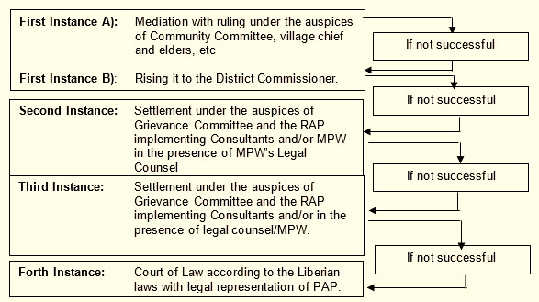
The Instances of Grievance Redress are as follows:

The Instances of Grievance Redress are as follows:

8.2 Object of the GRM

The prime objective of establishing the GRM is to resolve problems in an efficient, timely, and cost-effective manner in a cordial environment with the participation of all stakeholders including affected parties. Under the GRM, it shall describe the options available to the project for grievance redress. Any environmental or social impacts (other than issues of valuation and compensation) that would be adversely affecting the general public in the project area should be resolved by the GRC. The GRM is also part and parcel of the machinery of any project. No project can claim to be accountable, responsive, and user-friendly unless it has established an efficient and effective grievance redress mechanism. The grievance redress mechanism of this project (John Davies Town to Zwedru (48.5 km) Road) is an instrument to measure its efficiency and effectiveness as it provides important feedback on the working of the project.

The John Davies Town to Zwedru (48.5Km) Road project is a category “A” Project hence, required the Grievance Redress Mechanism (GRM) to address issues raised by the public about the project implementation since a GRM provides a predictable, transparent, and credible process to all parties, resulting in outcomes that are seen as fair, effective, and lasting. Subsequently, the Grievance Redress Committees (GRC) is been set up to handle all matters arising from the project. The social structure of the project implementing area is to some extent affected by the project. This caused several adverse social and cultural impacts on the community. As a result, it could be identified that several psychosocial issues have taken place. On these grounds, more attention must be paid to the community for the successful implementation and sustainability of the project. Also, the implementation of the GRM is required to follow the gender policy of the GOL and the African Development Bank (AfDB). Accordingly, there should be equal opportunities for men and women to be given at any stage of the GRM and to encourage women’s participation in the decision-making process in development activities.

The following objectives provide benefits to both the project and the affected persons:
- Establish a prompt, easy-to-understand, consistent, and respectful mechanism to support the receiving, investigating, and responding to complaints or grievances from community stakeholders;
- Ensure proper documentation of complaints or grievances and any corrective actions taken;
- Contribute to continuous improvement in the performance of the John Davies Town to Zwedru (48.5 km) Road Project through the analysis of trends and lessons learned.
- Provide a forum for redressing grievances and disputes at the lowest level;
- Create effective communication between the project and affected persons;
- Build up a productive relationship among all stakeholders including affected persons;
- Provide access to affected persons to negotiate and influence the decisions and policies of the project which might be adversely affected them;
- Mitigates, avoid, or prevents adverse impacts of the project on communities and produces appropriate corrective or preventive action;
- Harmonize both projects and affected persons' activities.

Grievance Redress Mechanism is part and parcel of the machinery of any project. No project can claim to be accountable, responsive, and user-friendly unless it has established an efficient and effective grievance redress mechanism. The grievance redress mechanism of this project (John Davies Town to Zwedru (48.5 km) Road) is an instrument to measure its efficiency and effectiveness as it provides important feedback on the working of the project.

8.3 Main Principles of this GRM

- A Grievance Redress Mechanism (GRM) is proposed to address any complaints and grievances arising during the project. Members of the public may perceive risks to themselves or their property or have concerns about the environmental performance of the project. Any concerns or grievances should be addressed quickly and transparently, and without reprisal to the affected person (AP) or Complainant;
- The primary principles are that all complaints and grievances are resolved as quickly as possible. It, therefore, follows that the resolution of complaints and grievances should be at the lowest possible level for resolution;
- All minor land or property-related complaints that can be resolved, should be resolved immediately on the site. The focus of the GRM is to resolve issues in a customarily appropriate fashion at the community level and record details of the complaint, the complainant, and the resolution;
- All grievances from the public should be considered with equal relevance to avoid conflict of interest. Any complaints from institutions within the project area should also be treated equally as individual complaints passing through the same system and treated equally;
- Decisions that will be taken earlier are reiterated without subjecting the cases to independent examination. There is inertia to review decisions taken by down-the-line functionaries. In many cases, the CLO justifies the delay if any, and continues with the inability to take decisions by putting the onus on another petitioner. Many times, the actual cause of grievance lay in the internal inefficiency of the system and failure to identify simple systemic solutions;
- There is no doubt that grievances will continue to arise because of a high systemic tolerance for delay, work quality, and non-accountability in the daily performance of functions. Failure to review archaic, redundant, and incongruous rules, policies, and procedures and to initiate simple, workable systemic changes is another cause for grievance generation. However, the committee set at the local level and the Offices of the CLO will work with policies and procedures on a day-to-day basis, developing the ability to continually look 'within' and identify deficiencies.

8.4 Grievances Procedure

The grievance resolution process includes four key stages – (i) Receive; (ii) Investigate/Enquire; (iii) Respond and Resolve; and (iv) Follow up/Close Out.
The intention is to resolve a complaint as quickly and at as low a level as possible to avoid a minor issue becoming a significant grievance. Unresolved complaints may be treated as grievances only if, in the opinion of the GRC Chairman that they fall within the definition of grievance under the project.
Irrespective of the stage of the process, a complainant can pursue the grievance through the court as is his or her legal right. Table 20 shows the process through which a grievance can be resolved, while Figure 16 displays the escalation matrix.

Table 19: Grievance Resolution Process
Allotted Timeframe Stage
Within 1 day | • | Grievance reported to Contractor through nominated person either CLO by Complainant or community representative.
 | • | A contractor with the support of a Supervision Consultant prepares Grievance Report Form providing full details of the alleged grievance.
Within 2 days | • | CLO investigates and confirms details of the grievance and ensures that details are entered into the Grievance Report Form.
 | • | CLO confirms subject of the complaint is still relevant and contacts management.
 | • | CLO sends Grievance Report Form to management.
 | • | The CLO will log the grievance into the GRM register.
Within 7 days | • | CLO informs GRC Chairman and confirms who will have delegated authority to resolve the grievance.
 | • | GRC delegate and CLO or PIU representative meet with relevant parties, village leaders, etc.
 | • | Depending on the nature or severity of the grievance GR delegate and PIU representative attempt to identify acceptable resolutions.
 | • | Confirm resolution with Affected Party (  representative) and seek their approval or confirmation that the grievance is resolved.
 | • | Grievance closed out by the GRC Chairman in writing informed management.
30 days | • | If unresolved then the Grievance including an update of actions to date is referred to management for further action.
 | • | Database updated by CLO.
As soon thereafter as possible | • • | Management undertakes further action.  If the grievance remains unresolved the grievance can b closed out by management on behalf of the project, and if there exists no way out, Complainant may initiate a leg process through the courts
 | • | Database updated by CLO.

Figure 14: GRM escalation matrix
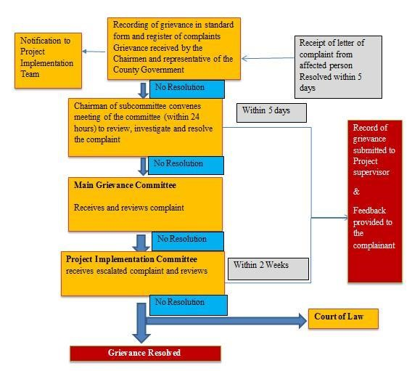

8.5 Estimated Budget and Workplan for Effective GRM Implementation

The budget (Table 21 and Table 22) will allow the GRMC to implement the activities set out in this work plan. Depending on the complaints and reconsideration requests received (which are unpredictable), the budget may need to be supplemented during the year. Both the work plan and budget assume that the project will continue at varying levels during its implementation.

Work Plan for the Implementation of the GRM

Table 20: Grievance Implementation Work Plan
No | Items | Activities | frequency
1 | Disclosure of the GRM | Gathering of all community dwellers and local authority to disclose the GRM and properly explain the complaint procedure to them | Once
2 | Establishment of the GMC | The PIU to create awareness and bring communities together by mapping out communities’ leaders to form part of each committee | Once
3 | Implementation of the GRM | The PIU Social Safeguard Officer to make regular follow up and resolve all RAP related grievance | Throughout the project cycle
4 | Monthly field visits to the project | The Social Safeguard Office should Visit all communities along the project to follow up with complaints and have them resolve | Monthly
5 | Special Sitting with committee member | The Social Safeguard Officer of the PIU should organize emergency sitting for some committee members and with the involvement of local authority from the county or district level to solve some complicated cases | If applicable

Table 21: Estimated Budget and Work Plan for GRM Implementation
GRM Implementation Cost
 | Work Plan | Duration | Cost | Source
 | Communication and awareness raising on the GRM | Throughout project implementation | $20,000.00 | MPW/PIU
 | Cost-associated establishment of the various GRM bodies |  | $10,000.00
 | Transport and communication costs associated with GRM  operation |  | $20,000.00
 | Training of the Grievance  Redress Committee  members |  | $15,000.00
 | Cost for purchasing and operating equipment for GRM implementation |  | $5,000.00
 | GRM monitoring and  reporting |  | $10,000.00
 | GRM committees Sitting (this includes local level sitting) |  | $10,000.00
 | Professional Services including Case Management System including Travel associated with complaints/requests |  | $10,000.00
Total |  |  | $100,000.00 | Project

9.0 BUDGET AND SCHEDULE FOR RAP IMPLEMENTATION

9.1 Budget for Implementing the RAP

The population affected by this project includes people occupying the right-of-way along Mano River Union Road Development and Transport Facilitation Program (MRU/RDTFP) Phase-IV: Paving of John Davies Town to Zwedru (48.5Km) of Lot 3 of the Zwedru – Harper Section of the Ganta – Harper Road Project (510Km). However, since structures and farmland within the project area were considered under the proposed corridor, this RAP considers affected structures and farmland up to Zwedru. Some of these PAPs are legitimate structures owners and will therefore receive full replacement costs for their property. Some do not have legitimate titles and are not entitled to compensation for loss of land under the AfDB policy. However, they are entitled to compensation for any improvement made to the land as well as to resettlement assistance if they occupied the project area before the established cutoff date. Vulnerable persons will also receive some form of assistance.

The values presented assume a standard permanent house, even when it is temporary, to comply with the requirement of the provision of AfDB policy for preparing a resettlement action plan, which outlines that PAPs should be assisted to improve their standards of living or at least to restore them to their pre-displacement levels.

The total cost for compensation and resettlement of PAPs for structures in the affected areas amounts to US$942,937.22; the cost for loss of farm/tree crops is US$54,048.60. The cost for loss of business income is US$28,585.00. And the cost for Relocation/Resettlement Assistance is US$4,200.00. The total cost for Assistance to Vulnerable Persons is US$17,250.00 and the cost for the administration, monitoring, and evaluation of the RAP is US$35,500.00. The total cost for the RAP completion Audit is US$19,000.00; the sum of US$229,500.00 will be allocated for graves, and the GRM Implementation is US$100,000.00. There is no cost for land as no PAPs have produced a genuine deed for land. However, a cost of US$113,500.00 can be allocated for PAPs to acquire new land. Should the same be produced in the future, an amount set aside in contingency will cover this cost. Hence, the overall cost for RAP Implementation One Million Five Hundred Forty-four Thousand Five Hundred Twenty United States Dollars Eighty-two Cents (US$1,544,520.82) is required.

The total estimated cost of compensation for damages/losses to PAPs and the cost of RAP Implementation is as detailed in Table 23:

Table 22: Summary Budget Cost for Phase Two of the RAP Implementation
Summary
Number of PAPs (246)
No. | Items/Activities | Total Cost (US$)
1 | Affected Structures | 942,937.22
2 | Affected Economic Crops | 54,048.60
3 | Loss of Business Income | 28,585.00
4 | Relocation Allowances (Landlords/Tenants) | 4,200.00
6 | Vulnerable Persons | 17,250.00
7 | Allocation for Graves Relocation | 229,500.00
8 | Land Acquisition | 113,500.00
9. | Cost for the administration, monitoring, and evaluation of the RAP | 35,500.00
10. | RAP completion Audit | 19,000.00
11. | GRM Implementation | 100,000.00
TOTAL |  | 1,544,520.82

Implementation of this RAP will be financed by the Government of Liberia, through MPW/PIU. Compensation will be paid directly to the affected parties by the RAP Implementation Committee comprising MPW/ESAFE, MFDP, NRF, GAC. Appropriate mechanisms will be put in place to ensure the timely flow of funds for the RAP activities.

9.2 Time Schedule and Monitoring Program

The period for the implementation of the RAP process is estimated to take seven (7) months from January 2024 to July 2024. This considers important variables such as RAP Reverification, resolution of conflicts and grievances, and cash flow from GOL/MPW/PIU to the consultant monitoring of the resettlement process. The schedule and summary of activities are presented in Table 25.

Activities to be carried out for the eight months will include but not be limited to:
- Reverification of PAPs, their structures, or crops.
- Compensation of PAPs
- Follow up on PAPs with the bank
- Follow up on PAPs for GRM-related matters.

Table 23: Implementation Schedule of the RAP

Activities | Jan 2024 |  |  |  |  | Feb 2024 |  |  |  | March 2024 |  |  |  | April 2024 |  |  |  |  | May 2024 |  |  |  | June 2024 |  |  |  | July 2024
 | W  1 | W  2 | W  3 | W  4 | W  5 | W  1 | W  2 | W  3 | W  4 | W  1 | W  2 | W  3 | W  4 | W  1 | W  2 | W  3 | W  4 | W  5 | W  1 | W  2 | W  3 | W  4 | W  1 | W  2 | W  3 | W  4 | W  1 | W  2 | W  3 | W  4 | W  5
Meetings with PAPs
Establishment of Compensation Team
Deposit of list of PAPs and verification
Provision of a compensation package
Issue of Notice of Eviction to
PAPs, accompanied by payment
Resolution of conflicts and grievances
Relocation of PAPs
Monitoring
Progress and final report

10. CONCLUSION AND RECOMMENDATIONS

The Ministry of Public Works aims at constructing a portion of Fish Town to Zwedru City (48.5km) in Grand Gedeh County to benefit the people, mainly in the southeastern region of Liberia. The completion of this road will not only provide economic benefits to Liberia but as well as its neighboring countries.
The Potential environmental and social impacts associated with the implementation of the project activities of the project have been assessed and analyzed carefully and the necessary mitigation measures formulated. The impacts include soil erosion, generation of dust, land degradation due to excavation work, noise disturbance, and destruction of natural habitat for fauna and flora species that occur in these areas. All those impacts are restricted to construction sites and periods and can be mitigated through good engineering practice. Required mitigation measures and the monitoring plans are provided in the ESMP which stands as a separate document for this report.
The most significant negative social-economic impact of the project activity will be the probable displacement of people and loss of properties and crops within the proposed corridor of the road from John Davis Town to Zwedru City (48.5 Km) in Grand Gedeh County. Due to the rather small footprint of the project, the number of directly affected people is limited (246 PAPs) and the economic loss can be compensated.

The overall benefit of the project for Liberia outweighs the rather small negative impact by far. The project will have a long-term beneficial effect on the environment since high-cost vehicle maintenance, transportation cost, poor health and security, deplorable road, poor communication, etc. will reduce greatly as well as reduce travel time, promote and increase trade within the subregions.
However, the following is still required:
- RAP Implementation: This should commence as soon as possible, establishing institutional arrangements and commencing compensation activities as soon as possible.
- Management measures: This RAP Report recommended a series of management measures, mitigation strategies, and actions for the various environmental and social impacts created by the Project. These measures will be actively implemented and with committed intent to ensure that environmental and social impacts are managed appropriately under the national environmental laws, the AfDB’s Safeguards Standards, and international best practices (IBP).
- Management Plans: The key commitments to environmental and social impact management and mitigation are set out in the RAP. Prior to Project development, these plans will need to be reviewed and updated to reflect specific development consent conditions and management details.
- That this road project be implemented and that the proposed mitigation and monitoring measures are enforced;
- A monitoring program should be adhered to by the supervising Engineers and MPW/PIU during the operation of the road;
- MPW/PIU should liaise with other entities/organizations having utilities on the road to ensure that they only use the edges of the road reserve to avoid future costs of relocation of service and inconvenience;

REFERENCES

Ministry of Public Works | Socio-economic Survey Report of Lot 2 of the
. | Zwedru – Harper Road Project (May – June 2013).
Liberia Institute of | Republic of Liberia – 2008 National Population
Statistics & Geo-Infor- | & Housing Census Final Results
motion Services (LISGIS) | Monrovia, Liberia; May 2009
Ministry of Finance, Development & Planning | Lift Liberia Poverty Reduction Strategy - Final Report: A Results-Focused Assessment - (June 2008 – December 2011);
Stanley Consultants Inc. | Resettlement Action Plan (RAP) – Feasibility Studies and Detailed Engineering Designs for Upgrading a Section (Section 2) of the Ganta to Herpar Road Corridor between Zwedru – Harper City (225km) and Harper Junction – Cavalla Customs (16km) – November 2013
GEO Taxon Consultant Ltd & Uganda Railways Corporation | R esettlement – Keyengera Meter Guage Railway Lines (Action Plan (RAP) Vol. I for the Proposed Rehabilitation of the Kampala – Malaba, Kampala – Nalukolongo – Kyengera Metre Guage Railway Lines (Between Kampala – Tororo Districts, May 2022
Aduljebain Engineering Consultant Office (AECO) | Gbarnga – Voinjama – Mendikoma Road Lot 2 (Konia -Voinjama – Mendikoma (144) Rasettlement Action Plan Final Report – October 2020
The African Development Bank | Environmental and Social Assessment Procedures – For African Development Bank’s Public Sector Operations © June 2001.
The African Development Bank  Geographic Maps of Liberia | Involuntary Resettlement Policy | © November 2003.

APPENDICES

 | Appendices
APPENDIX “A”: | Chance Finds Procedure
APPENDIX “B”: | Minutes of Public Consultation Meetings and Survey Questionnaires in Grand Gedeh
APPENDIX “C”: | Public Consultation Meeting Attendance
APPENDIX “D”: | Ministry of Agriculture Price List
APPENDIX “E”: | Ministry of Public Works’ Valuation Rate for Affected Structures
APPENDIX “F” | See attached Spread Sheet:  - Compensation/Replacement Payment to Owners of Affected Structures;  - Relocation Assistance to PAPs of Residential Structures;  - Loss of Income & Relocation Assistance to PAPs of Commercial Structures and Assistance to Vulnerable PAPs on the Mano River Union Road Development and Transport Facilitation Program MRU/RDTFP Phase-IV: Paving of John Davies Town to Zwedru (48.5Km) of Lot 3 of the Zwedru – Harper Section of the Ganta – Harper Road Project (510Km) Corridor.
APPENDIX “G” | Photography

APPENDIX A: Chance Finds Procedure

The chance find procedure is a project-specific procedure that outlines actions required if previously unknown heritage resources, particularly archaeological resources, are encountered during project construction or operation. A Chance Find Procedure is a process that prevents chance finds from being disturbed until an assessment by a competent specialist is made and actions consistent with the requirements are implemented. Scope of the chance find procedure This procedure applies to all activities conducted by the personnel, including contractors, that have the potential to uncover a heritage item/site. The procedure details the actions to be taken when a previously unidentified and potential heritage item/site is found during construction activities. The procedure outlines the roles and responsibilities and the response times required from both project staff, and any relevant heritage authority. Induction/Training All personnel, especially those working on earth movements and excavations, are to be inducted on the identification of potential heritage items/sites and the relevant actions for them with regards to this procedure during the Project induction and regular toolbox talks. A chance find procedure If any person discovers a physical cultural resource, such as (but not limited to) archaeological sites, historical sites, remains and objects, or a cemetery and/or individual graves during excavation or construction, the following steps shall be taken:
- Stop all works in the vicinity of the find, until a solution is found for the preservation of these artifacts or advice from the relevant authorities is obtained

- Immediately notify a foreman. The foreman will then notify the Construction Manager and the Environment Officer (EO)/Environmental Manager (EM)

- Record details in the Incident Report and take photos of the find.

- Delineate the discovered site or area; secure the site to prevent any damage or loss of removable objects. In cases of removable antiquities or sensitive remains, a night guard shall be arranged until the responsible local authorities take over.

- Preliminary evaluation of the findings by archaeologists. The archaeologist must make a rapid assessment of the site or find to determine its importance. Based on this assessment the appropriate strategy can be implemented. The significance and importance of the findings should be assessed according to the various criteria relevant to cultural heritage such as aesthetic, historic, scientific or research, and social and economic values of the find.

Sites of minor significance (such as isolated or unclear features, and isolated finds) should be recorded immediately by the archaeologist, thus causing a minimum disruption to the work.

- Schedule of the Contractor - The results of all archaeological work must be reported to the Ministry/Agency, once completed.
- In case of a significant find the MPW, Ministry of Internal Affairs, EPA, or Ministry of Information, Culture and Tourism (hereinafter referred to as Heritage team) should be informed immediately and in writing within 7 days from the find;
- The onsite archaeologist provides the Heritage team with photos, and other information as relevant for identification and assessment of the significance of heritage items. The Ministry must investigate the fact within 2 weeks from the date of notification and respond in writing. 9. Decisions on how to handle the finding shall be taken by the responsible authorities. This could include changes in the layout (such as when finding an irremovable remain of cultural or archaeological importance) conservation, preservation, restoration, and salvage;
- Construction works could resume only after permission is granted from the responsible authorities.
- In case no response is received within the 2 weeks mentioned above, this is considered as authorization to proceed with suspended construction works. One of the main requirements of the procedure is record keeping. All finds must be registered. Photolog, copies of communication with decision-making authorities, conclusions and recommendations/guidance, implementation reports – kept.

Additional information Management options for the archaeological site

- Site avoidance: If the boundaries of the site have been delineated attempt must be made to redesign the proposed development to avoid the site. (The fastest and most cost-effective management option)
- Mitigation: If it is not feasible to avoid the site through redesign, it will be necessary to sample it using a data collection program before its loss. This could include surface collection and/or excavation. (The most expensive and time-consuming management option.)
- Site Protection: It may be possible to protect the site through the installation of barriers during the time of the development and/or possibly for a longer term. This could include the erection of high-visibility fencing around the site or covering the site area with a geotextile and then capping it with fill. The exact prescription would be site-specific. Management of replicable and non-replicable heritage Different approaches for the finds apply to replicable and nonreplicable heritage. Replicable heritage Where tangible cultural heritage that is replicable and not critical is encountered, mitigation measures will be applied. The mitigation hierarchy is as follows:

Avoidance;
- Minimization of adverse impacts and implementation of restoration measures, in situ;
- Restoration of the functionality of the cultural heritage, in a different location;
- Permanent removal of historical and archaeological artifacts and structures;
- Compensation of loss where minimization of adverse impacts and restoration is not feasible. Non-replicable heritage Most cultural heritage is best protected by in situ preservation since removal is likely to result in irreparable damage or even destruction of the cultural heritage. Replicable cultural heritage is defined as tangible forms of cultural heritage that can themselves be moved to another location or that can be replaced by a similar structure or natural features to which the cultural values can be transferred by appropriate measures. Archaeological or historical sites may be considered replicable where the particular eras and cultural values they represent are well represented by other sites and/or structures;
- The overall benefits of the project conclusively outweigh the anticipated cultural heritage loss from removal, and Any removal of cultural heritage must be conducted using the best available technique advised by the relevant authority and supervised by an archaeologist or the PIU EO. Human Remains Management Options The handling of human remains believed to be archaeological requires communication according to the same procedure described above. There are two possible courses of action:
- Avoid: The development project is redesigned to completely avoid the found remains. An assessment should be made as to whether the remains may be affected by residual or accumulative impacts associated with the development, and properly addressed by a comprehensive management plan, and
- Exhumation: Exhumation of the remains in a manner considered appropriate by decision-makers. This will involve the predetermination of a site suitable for the reburial of the remains. Certain ceremonies or procedures may need to be followed before development activities can recommence in the area of the discovery.

APPENDIX B: Minutes of Public Consultation Meetings and Survey Questionnaires in Grand Gedeh

Public Consultation Meetings ‘Minutes in John Davies Town, Karlorwleh Town, Gbargbo Town and Zwedru, Grand Gedeh County

Date | Location Meeting | of | Number of  Participants | Topics/Matters discussed
May 29, 2023 | John Davies Town |  | 29 | - Introduction of the team;  - Introduction of the Project;  - Emphasized the essence of the ESIA and RAP process.  - Provided a detailed explanation of the new design.  - Encouraging the Participants to be open and feel free in expressing their opinions.  - Presentation of the road project (including brief history and overview of the formalities leading to the proposed construction of the 48.5 km road, John Davies Town to Zwedru).  - Significant of the proposed project.  - Short presentation on the EPML and AfDB’s Policy.  - Detailed discussion on the GRM;  - Explanation and detailed information about the RAP, RAP Cut Off Date, Compensation, Relocation, Timeframe (90 days) for Relocation and Demolition.  - Eligibility Criteria;  - Information on the Evaluation Process for both structures and economic crops;  - Information on the Government’s institution involved in the RAP process.  - Information on the structures/economic crops within RoW;  - Discussion on Land Acquisition.  - Information on Wildlife including fishes.  - Information on Hiring/Employment for the proposed project road.  - Archaeological, cultural heritage, chance finds procedural;  - Public facilities  - Access Roads.  - The main issues were access to the road, loss of property,  - change in route design between the preparation of RAP,  - AOB
May 30, 2023 | Karlorwleh Town |  | 27 | - Introduction of the team;  - Introduction of the Project;  - Emphasized the essence of the ESIA and RAP process.  - Provided a detailed explanation of the new design.  - Encouraging the Participants to be open and feel free in expressing their opinions.  - Presentation of the road project (including brief history and overview of the formalities leading to the proposed construction of the 48.5 km road, John Davies Town to Zwedru).  - Significant of the proposed project.  - Short presentation on the EPML and AfDB’s Policy.  - Detailed discussion on the GRM;  - Explanation and detailed information about the RAP, RAP Cut Off Date, Compensation, Relocation, Timeframe (90 days) for Relocation and Demolition.  - Eligibility Criteria;  - Information on the Evaluation Process for both structures and economic crops;  - Information on the Government’s institution involved in the RAP process.  - Information on the structures/economic crops within RoW;  - Discussion on Land Acquisition.  - Information on Wildlife including fishes.  - Information on Hiring/Employment for the proposed project road.  - Archaeological, cultural heritage, chance finds procedural;  - Public facilities  - Access Roads.  - The main issues were access to the road, loss of property,  - change in route design between the preparation of RAP,  - AOB
Women Focus Group Discussion

Date | Location Meeting | of | Number of  Participants | Topics/Matters discussed
May 31, 2023 | Gbargbo Town |  | 24 | - Introduction of the team;  - Introduction of the Project;  - Emphasized the essence of the ESIA and RAP process.  - Provided a detailed explanation of the new design.  - Encouraging the Participants to be open and feel free in expressing their opinions.  - Presentation of the road project (including brief history and overview of the formalities leading to the proposed construction of the 48.5 km road, John Davies Town to Zwedru).  - Significant of the proposed project.  - Short presentation on the EPML and AfDB’s Policy.  - Detailed discussion on the GRM;  - Explanation and detailed information about the RAP, RAP Cut Off Date, Compensation, Relocation, Timeframe (90 days) for Relocation and Demolition.  - Eligibility Criteria;  - Information on the Evaluation Process for both structures and economic crops;  - Information on the Government’s institution involved in the RAP process.  - Information on the structures/economic crops within RoW;  - Discussion on Land Acquisition.  - Information on Wildlife including fishes.  - Information on Hiring/Employment for the proposed project road.  - Archaeological, cultural heritage, chance finds procedural;  - Public facilities  - Access Roads.  - The main issues were access to the road, loss of property,  - change in route design between the preparation of RAP,  AOB
Date | Location Meeting | of | Number of  Participants | Topics/Matters discussed
June 1, 2023 | Zwedru City |  | 38 | - Introduction of the team;  - Introduction of the Project;  - Emphasized the essence of the ESIA and RAP process.  - Provided a detailed explanation of the new design.  - Encouraging the Participants to be open and feel free in expressing their opinions.  - Presentation of the road project (including brief history and overview of the formalities leading to the proposed construction of the 48.5 km road, John Davies Town to Zwedru).  - Significant of the proposed project.  - Short presentation on the EPML and AfDB’s Policy.  - Detailed discussion on the GRM;  - Explanation and detailed information about the RAP, RAP Cut Off Date, Compensation, Relocation, Timeframe (90 days) for Relocation and Demolition.  - Eligibility Criteria;  - Information on the Evaluation Process for both structures and economic crops;  - Information on the Government’s institution involved in the RAP process.  - Information on the structures/economic crops within RoW;  - Discussion on Land Acquisition.  - Information on Wildlife including fishes.  - Information on Hiring/Employment for the proposed project road.  - Archaeological, cultural heritage, chance finds procedural;  - Public facilities  - Access Roads.  - The main issues were access to the road, loss of property,  - change in route design between the preparation of RAP,  - AOB

Survey Questions and Answers
Some Questions the RAP Team asked the people | People’s responses/comments
What is the main source of water for general domestic use? | Residents said that they obtained water from the following sources:  Hand pumps, wells, and the main creeks since most hand pumps are not functioning.
Whether their main source of water is the same during the dry and wet seasons | Most of them said no.  According to them, the quality of the water is sometimes clean and sometimes dirty and they experience difficulties in getting water during the dry season months, and during this tense stage of the dry season, most of the water is undrinkable.
Whether they find the project construction of the road useful, and its benefits after upgrading it to the proposed standard ac road | All of them agreed that the project will be useful in terms of:  - Increase productivity, market, farming, etc.;  - Increased wealth creation owing to the influx of investors coming to exploit the increased business potential due to a good road network;  - Savings arising from reduced transportation costs and time spent traveling or commuting;  - Increase in the government revenue generation;  - Creation of employment during the construction and operation phases of the project; and  - Boost the business of construction materials and consumables, especially during the construction phase.
Whether they are willing to give land for contractor and engineer camps | The people willingly requested the team for the project to be established in their communities. They are willing to give their land for camps construction;
Disadvantages of the project | The people fear that they will lose properties, farms, and there will be no employment for them  - Change of socio-cultural setup of their community;  - That there will be Vibration/Water/Air/Noise pollution;  - Fear of erosion or the discharge of runoff into their homes.  - Vibration due to quarry rock blasting, and excavation during road work;  - Fear of Road accidents, etc.
Asked what were some of their major concerns regarding the proposed road project. | - Employment  - Drainage and erosion concerns  - The road should be constructed to standard so that it can last longer;  - Disruption of services;  - Health and safety standards should be followed;  - Pollution;  - Incidences of accidents may increase;
Asked about their traditional practices, worship centers, culture, sacred places/trees, etc. | Communities along the project corridor informed the meeting that there are no sacred places except for the people of Karlorwleh Town, the Town Chief (Decontee Saywon Tele. #: (+231881130873) told the meeting that her town women often have their meetings under the Mango Tree that fall directly in the RoW. She appeals that the project builds them a town hall since they do not have any.


APPENDIX C: Public Consultation Meeting Attendance

11.4 APPENDIX “D” : Photography

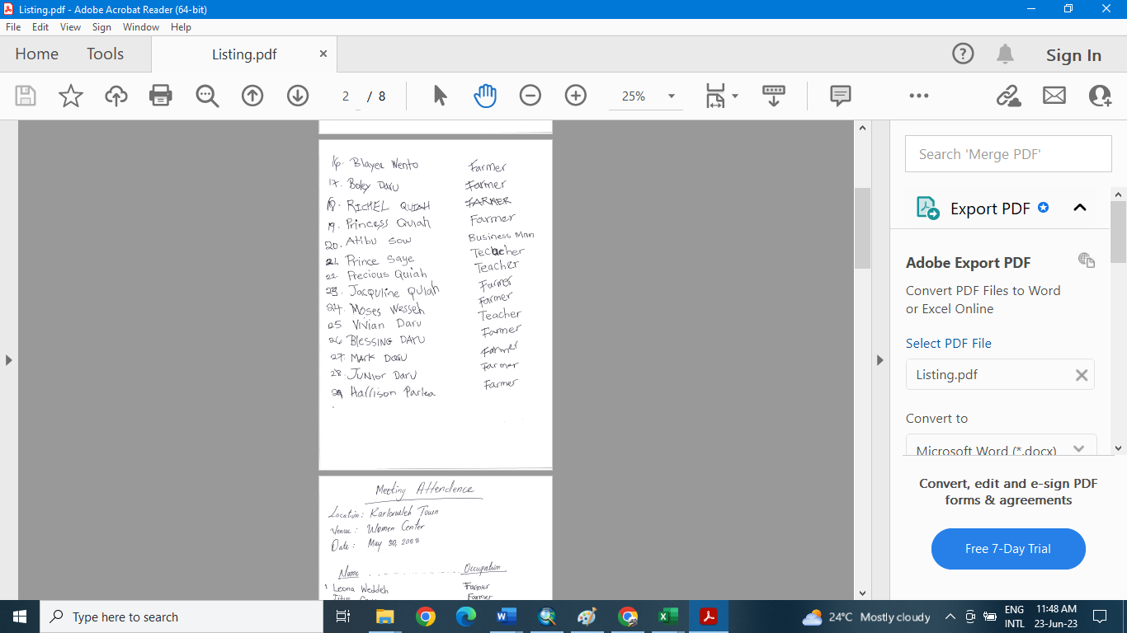

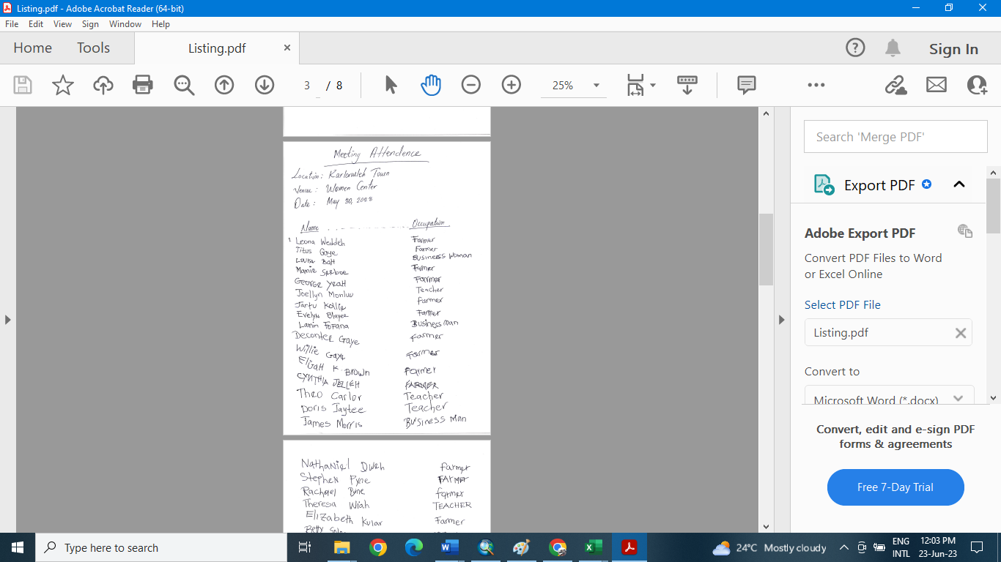

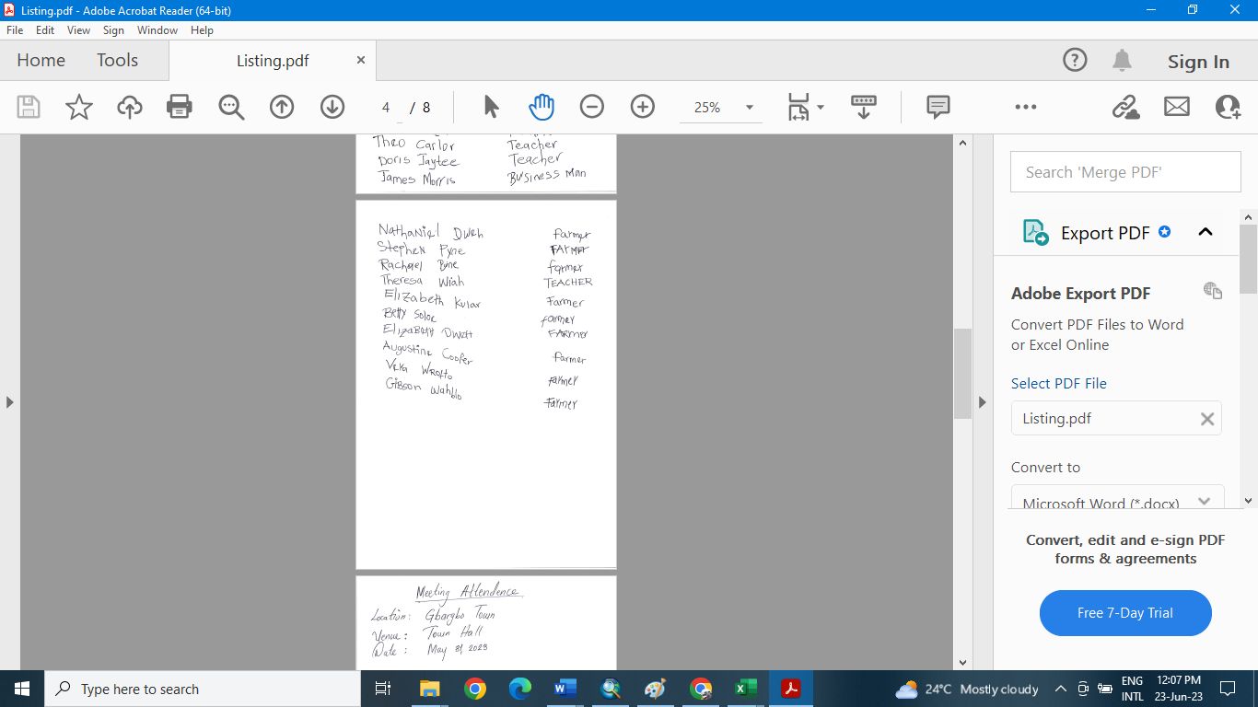

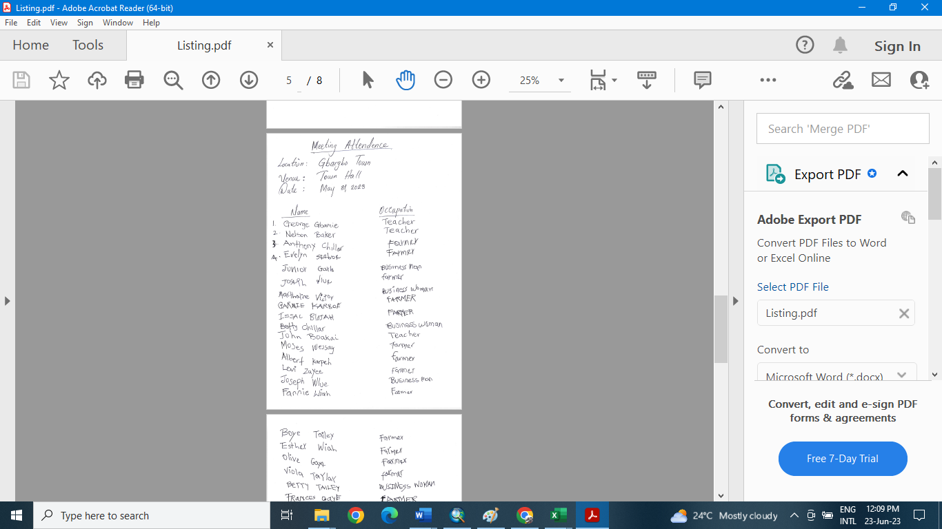



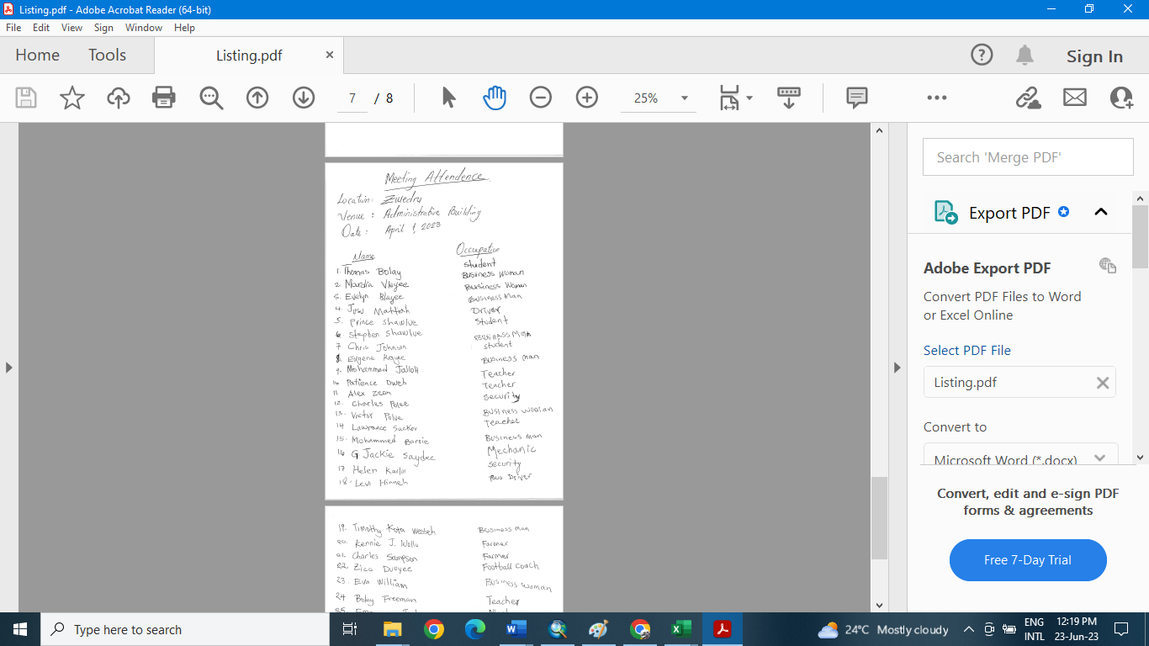

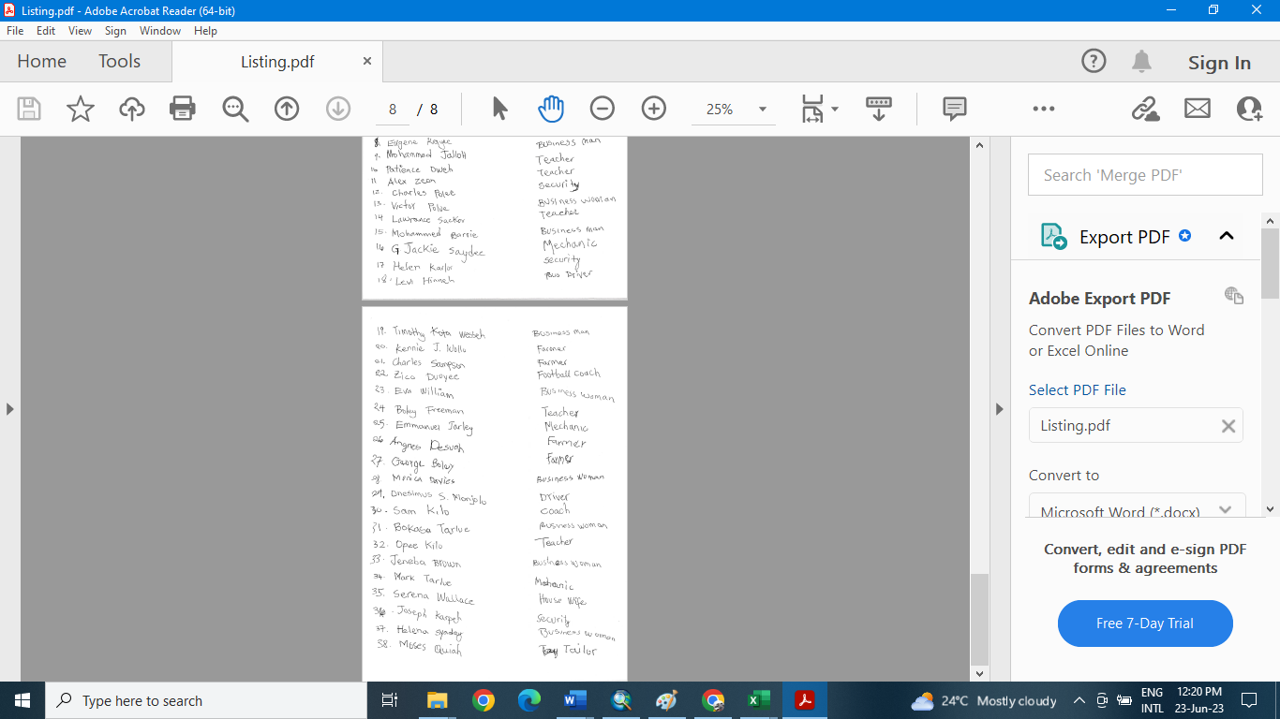

APPENDIX D: Ministry of Agriculture Price List for Affected Economic Crops

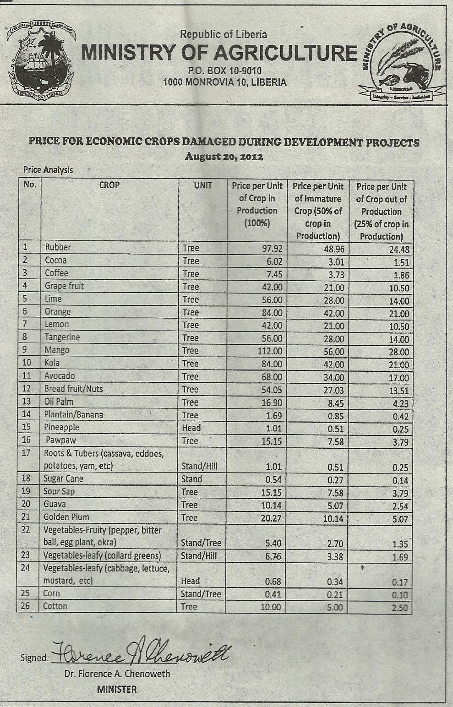

Figure 15.0: Ministry of Agriculture Price List for Affected Economic Crops

APPENDIX E: Ministry of Public Works’ Valuation Rate for Affected Structures

ID No | Structure Type | Main  Outer  Wall | Main Roofing Material | Main Window  Material | Main Floor Material | Ceiling Type | Door  Type
1 | Residential/ Commercial | Concrete Wall | Decra/Onduline/ Aluminum/ 28-guage channeled zinc/ concrete | Aluminum Framed/glass | Ceramic  Tiles/ Marble | plywood | panel/ steel | $  35.00
2 | Residential/ Commercial | Concrete Wall | Decra/Onduline/ Aluminum/ 28-guage channeled zinc/ concrete | Aluminum Framed/glass | Terrazo/  Vinyl Tiles | plywood | panel/ steel | $  34.00
3 | Residential/ Commercial | Concrete Wall | Metal Sheet/zinc | Jalousie  Window/ Wood/  Decorative  Blocks | Concrete/  Terrazo/ vinyl  Tiles | plywood/ mat | plywood/ Panel | $  29.00
4 | Residential/ Commercial | Concrete Wall | Metal Sheet/zinc | Jalousie  Window/ Wood/  Decorative  Blocks | Ceramic  Tiles/ marbles | plywood | plywood/ Panel | $  30.00
5 | Residential/ Commercial | Wood | Metal Sheet/zinc | Jalousie  Window/ Wood/  Decorative  Blocks | Ceramic  Tiles/  Marbles | mat/ plywood | plywood/ Panel | $  21.75
6 | Residential/ Commercial | Wood | Metal Sheet/zinc | Jalousie  Window/ Wood/  Decorative  Blocks | Concrete/  Terrazo/  Vinyl Tiles/  Wood | mat/ plywood | plywood/ Panel | $  20.76
7 | Residential/ Commercial | Dirt Brick  &  Concrete | Metal Sheet/zinc | Jalousie  Window/ Wood/  Decorative  Blocks | Concrete/  Terrazo /  Vinyl Tiles | plywood/ mat | Wood/ plywood | $  16.77
8 | Residential/ Commercial | Dirt Brick | Metal Sheet/zinc | Wood/  Decorative  Blocks | Concrete/ Vinyl Tiles | plywood/ mat | Wood/ plywood | $  9.87
9 | Residential/ Commercial | Dirt Brick | Metal Sheet/zinc | Wood/ Zinc | Plastic Vinyl/ Concrete | mat/none | Wood/ plywood | $  9.44
10 | Residential/ Commercial | Dubbed Mud | Metal Sheet/zinc | Wood/ Zinc | Mud/Concrete | None/mat | Wood/ plywood | $  6.50
11 | Residential/ Commercial | Dubbed Mud | Thatch | Wood/ Zinc | Mud/Concrete | None/mat | Wood/ plywood | $  5.00
12 | Residential/ Commercial | Zinc |  |  |  |  |  | $  11.15
13 | Shed | Channeled zinc roof, Ceramic Tile floor with sides close to concrete block |  |  |  |  |  | $  17.00
14 |  | Channeled zinc roof, concrete floor with sides close to concrete block |  |  |  |  |  | $  15.00
15 |  | Channeled zinc roof, concrete floor with sides close to a wood |  |  |  |  |  | $  10.00

ID No | Structure Type | Main  Outer  Wall | Main Roofing Material | Main Window  Material | Main Floor Material | Ceiling Type | Door  Type
16 |  | Channeled zinc roof, concrete or laterite floor with open sides |  |  |  |  |  | $  3.50
17 |  | Thatch roof, concrete, or laterite floor with open sides |  |  |  |  |  | $  2.00
18 | Warehouse | Reinforced concrete framed structure, usually with cast roof and concrete floor |  |  |  |  |  | $  25.00
19 |  | Concrete blocks structure with zinc roof and concrete floor |  |  |  |  |  | $  20.00
20 |  | Dirt Brick and concrete and concrete |  |  |  |  |  | $  17.00
21 |  | Concrete foundation with prefab structures and roof or zinc. |  |  |  |  |  | $  10.00
22 | Foundation |  |  |  |  |  |  | $  15.00
23 | Concrete  Block Fence |  | Less than 5 Rows (Courses) | Plastered |  |  |  | $  70.00
24 | Concrete  Block Fence |  | Less than 5 Rows (Courses) | Not Plastered |  |  |  | $  55.00
25 | Concrete  Block Fence |  | 5 to 10 Rows  (courses) | Plastered |  |  |  | $  85.00
26 | Concrete  Block Fence |  | 6 to 10 Rows  (courses) | Not Plastered |  |  |  | $  70.00
27 | Concrete  Block Fence |  | More than 10 Courses | Plastered |  |  |  | $  100.00
28 | Concrete  Block Fence |  | More than 10 Courses | Not Plastered |  |  |  | $  85.00
29 | Wooden  Fence |  |  |  |  |  |  | $  30.00
30 | Zinc Fence |  |  |  |  |  |  | $  15.00
31 | Handpump |  |  |  |  |  |  | $  3,600.00
32 | Well |  |  |  |  |  |  | $  2,000.00
33 | Grave/ Concrete |  |  |  |  |  |  | $  800.00
34 | Grave/ Earth |  |  |  |  |  |  | $  500.00
35 | Grave/ Tiles |  |  |  |  |  |  | $  1,200.00
ID No | Structure Type | Main  Outer  Wall | Main Roofing Material | Main Window  Material | Main Floor Material | Ceiling Type | Door  Type
36 | Monument no engravement |  |  |  |  |  |  | $  250.00
37 | Monument engravement |  |  |  |  |  |  | $  500.00
38 | Monument |  |  |  |  |  |  | $  350.00

APPENDIX F: See Attached Spread Sheet for:

- Compensation/Replacement Payment to Owners of Affected Structures;

- Relocation Assistance to PAPs of Residential Structures;

- Loss of Income & Relocation Assistance to PAPs of Commercial Structures and Assistance to Vulnerable PAPs on the Mano River Union Road Development and Transport Facilitation Program MRU/RDTFP Phase-IV: Paving of John Davies Town to Zwedru (48.5Km) of Lot 3 of the Zwedru – Harper Section of the Ganta – Harper Road Project (510Km) Corridor

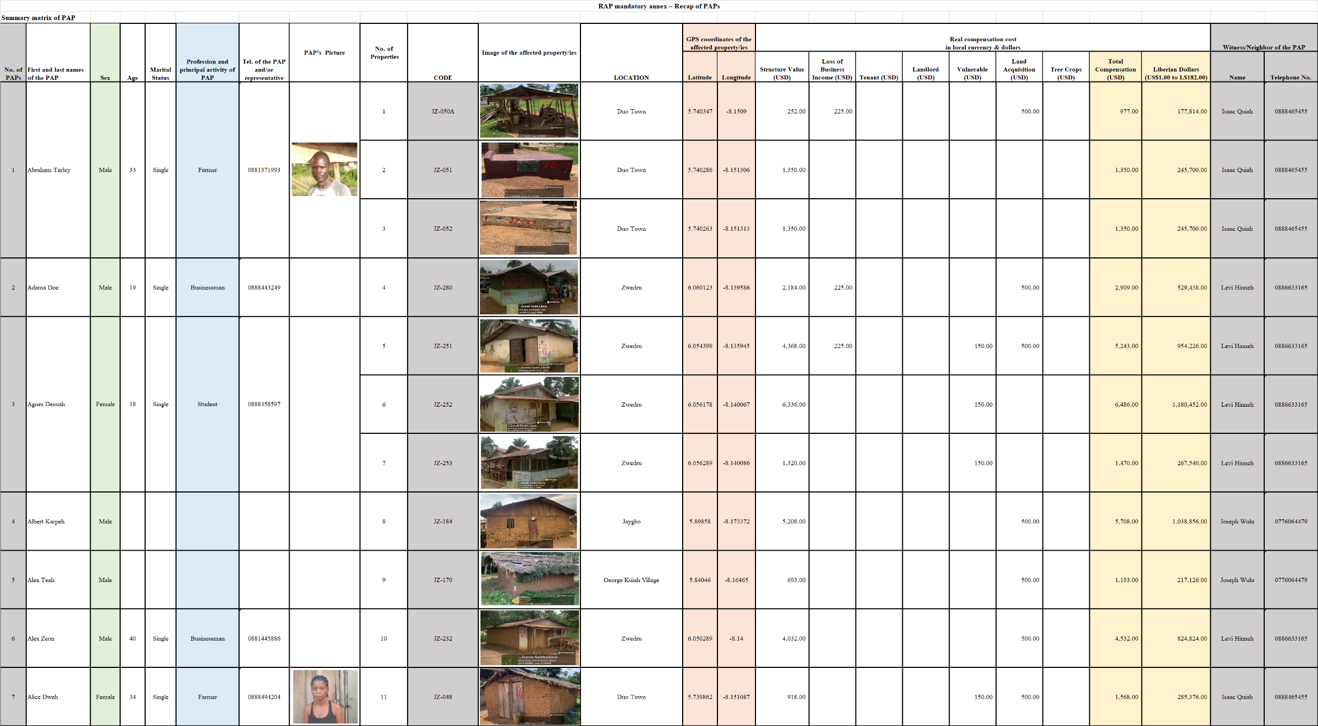

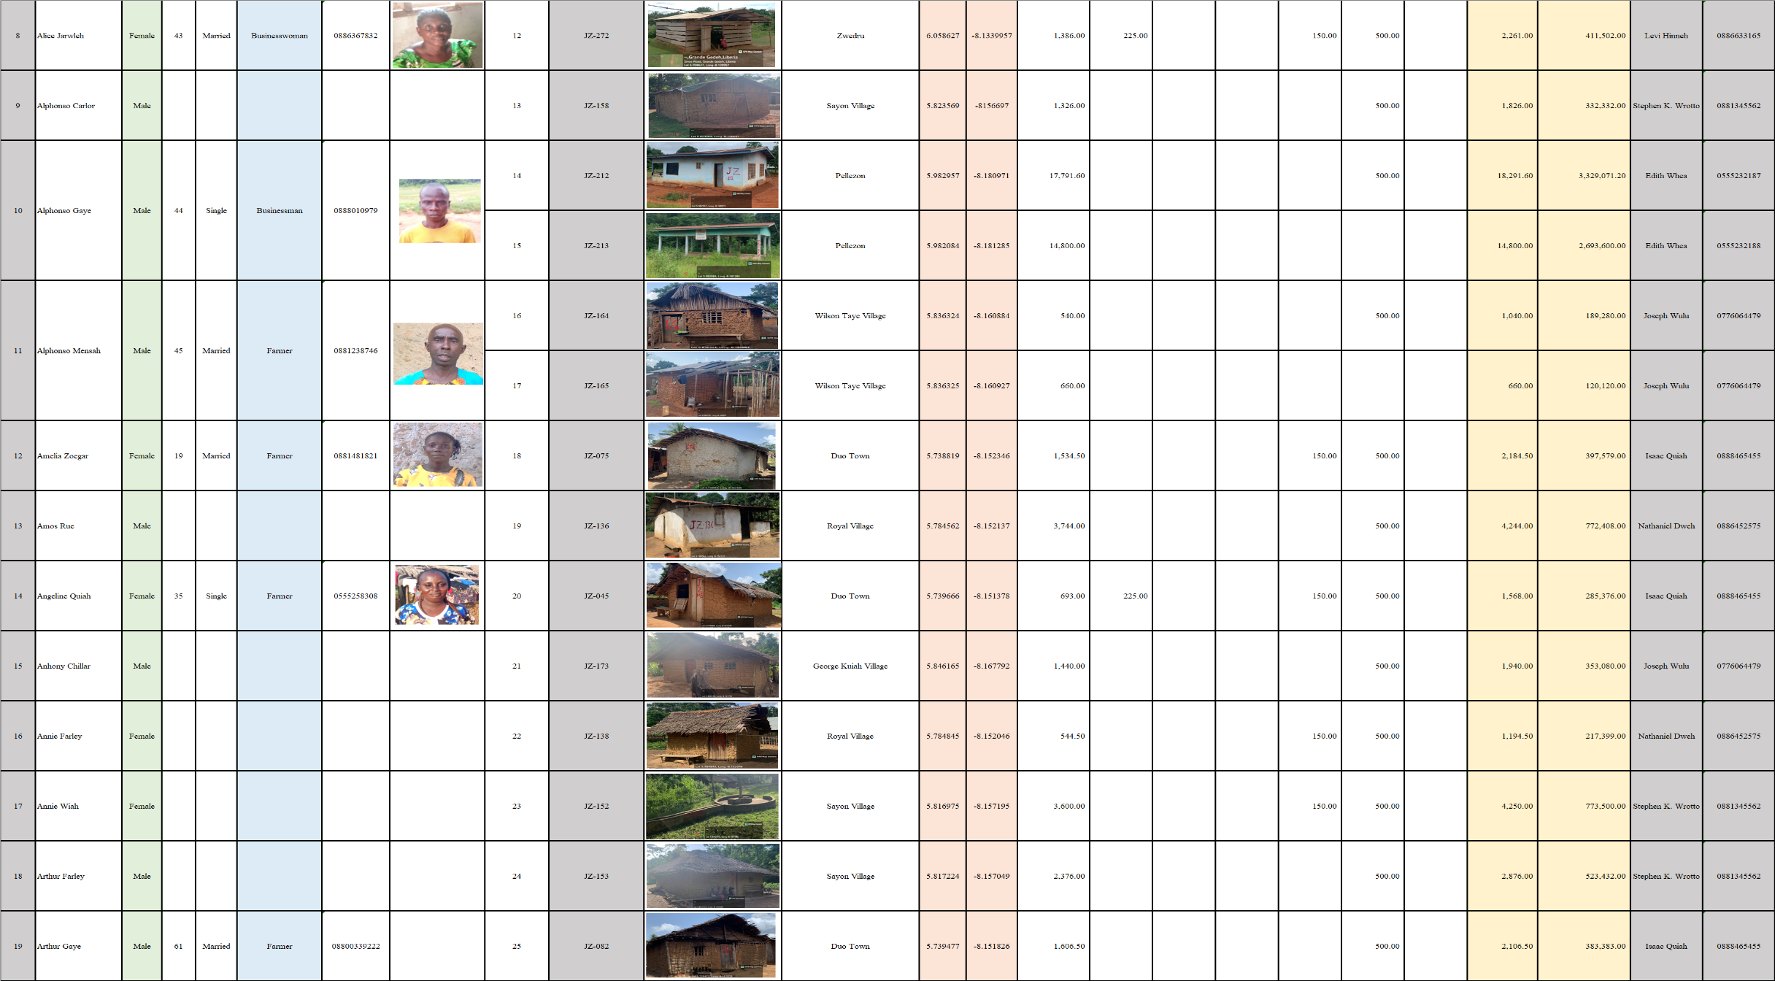

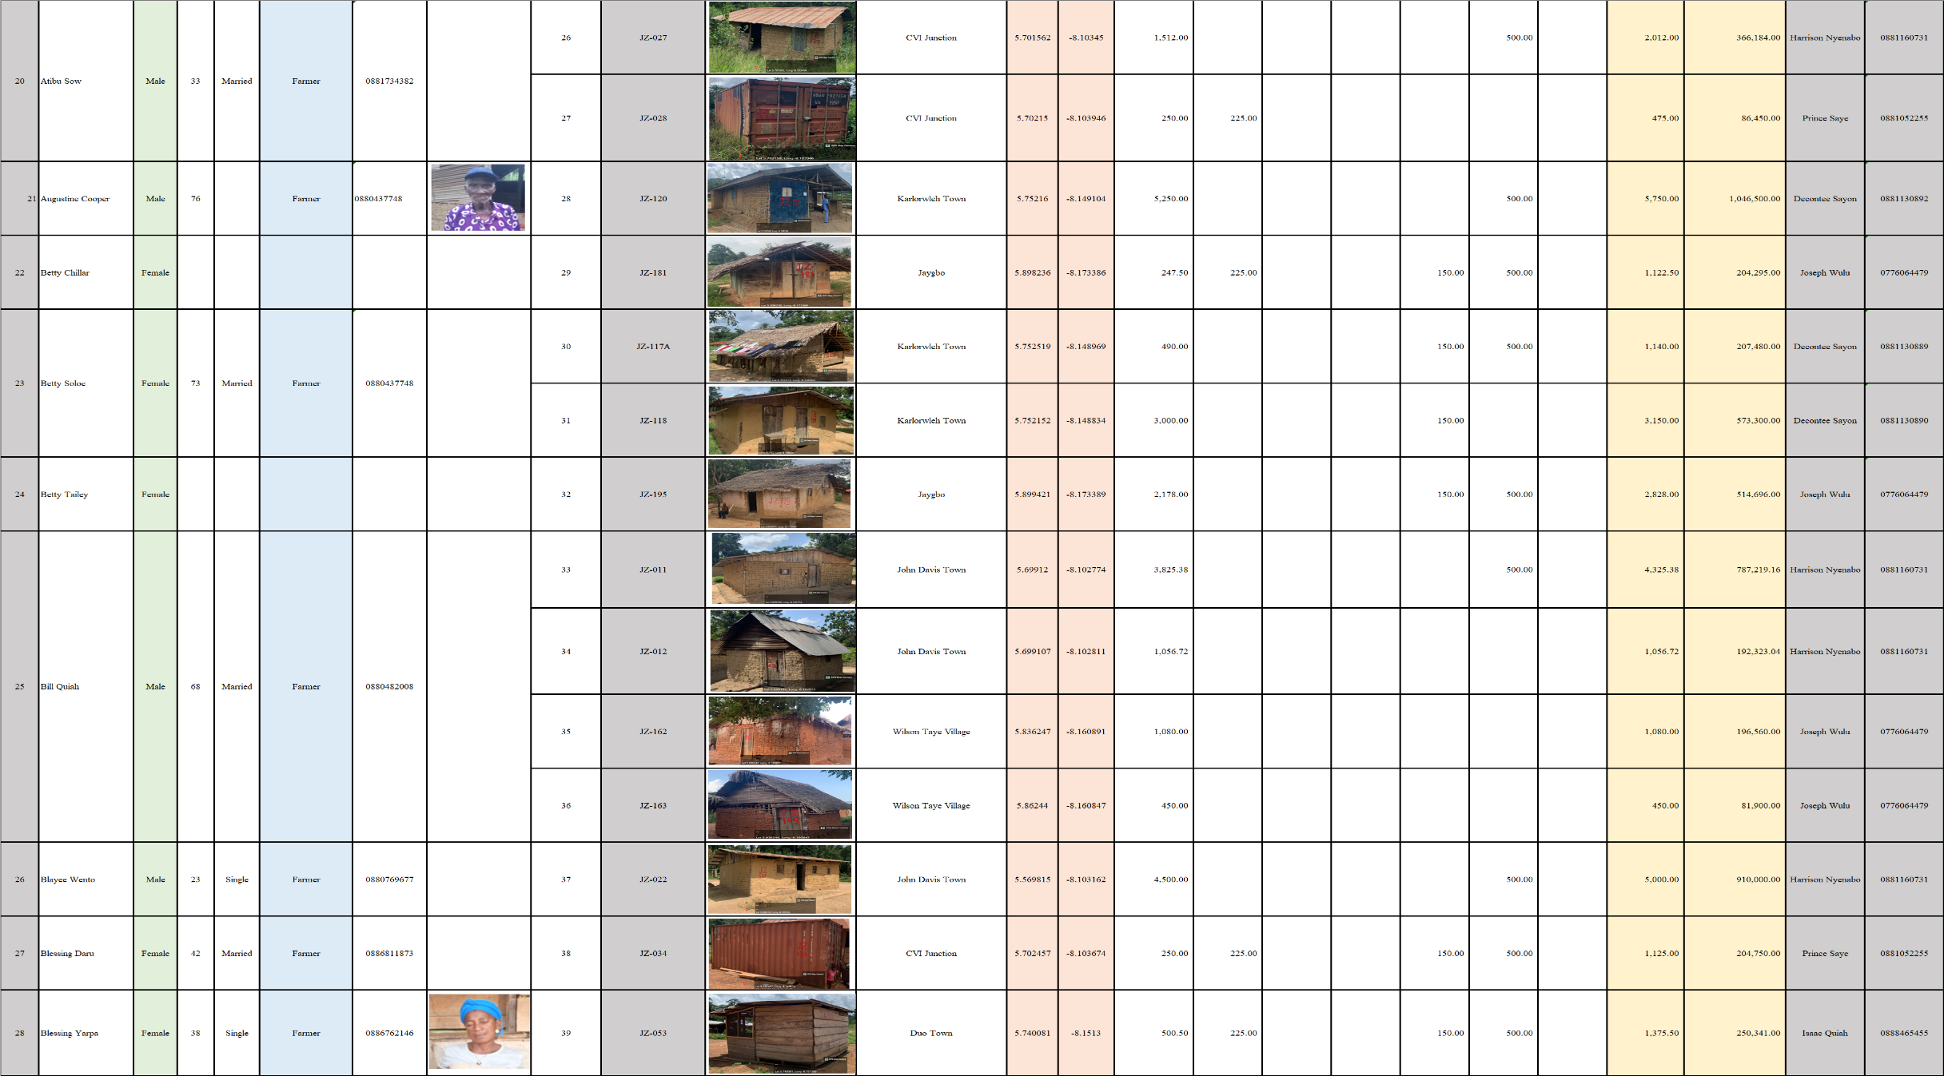

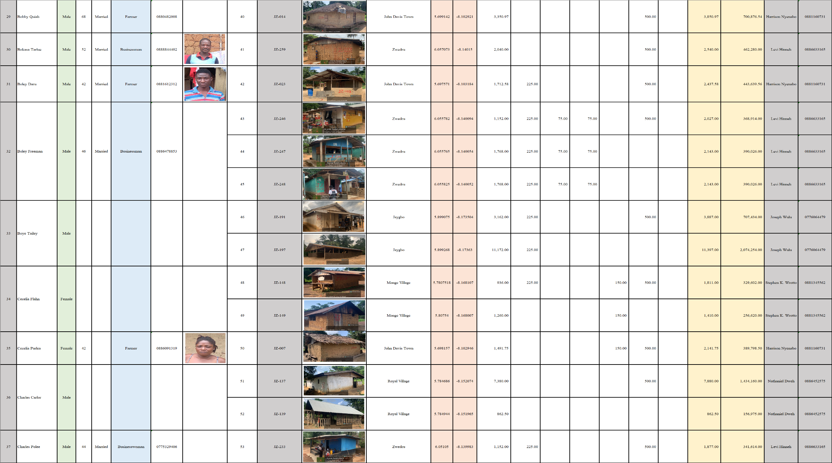

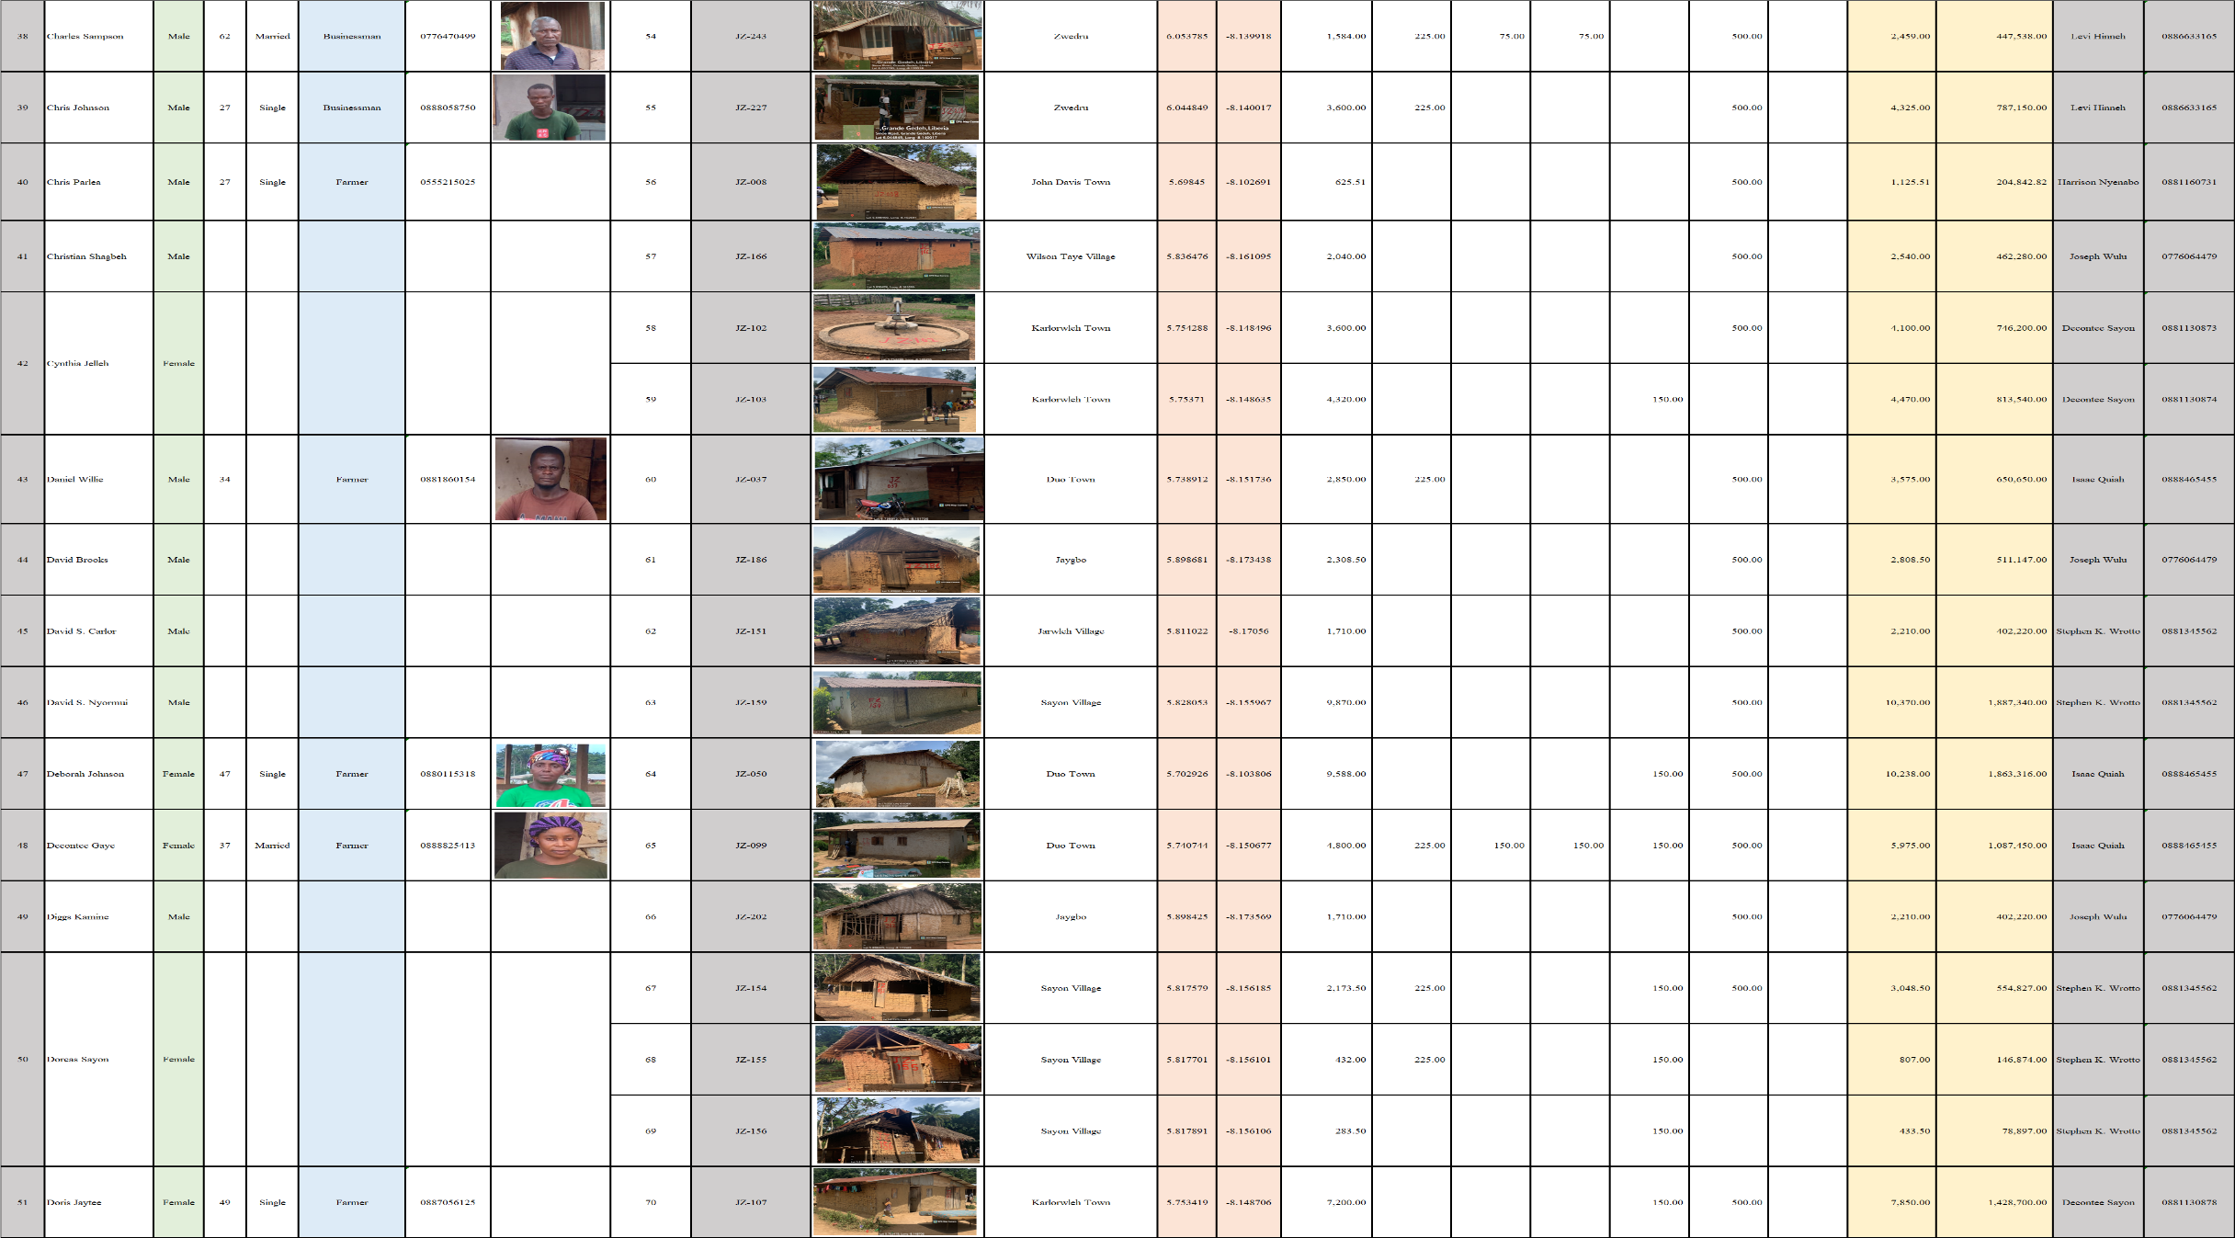

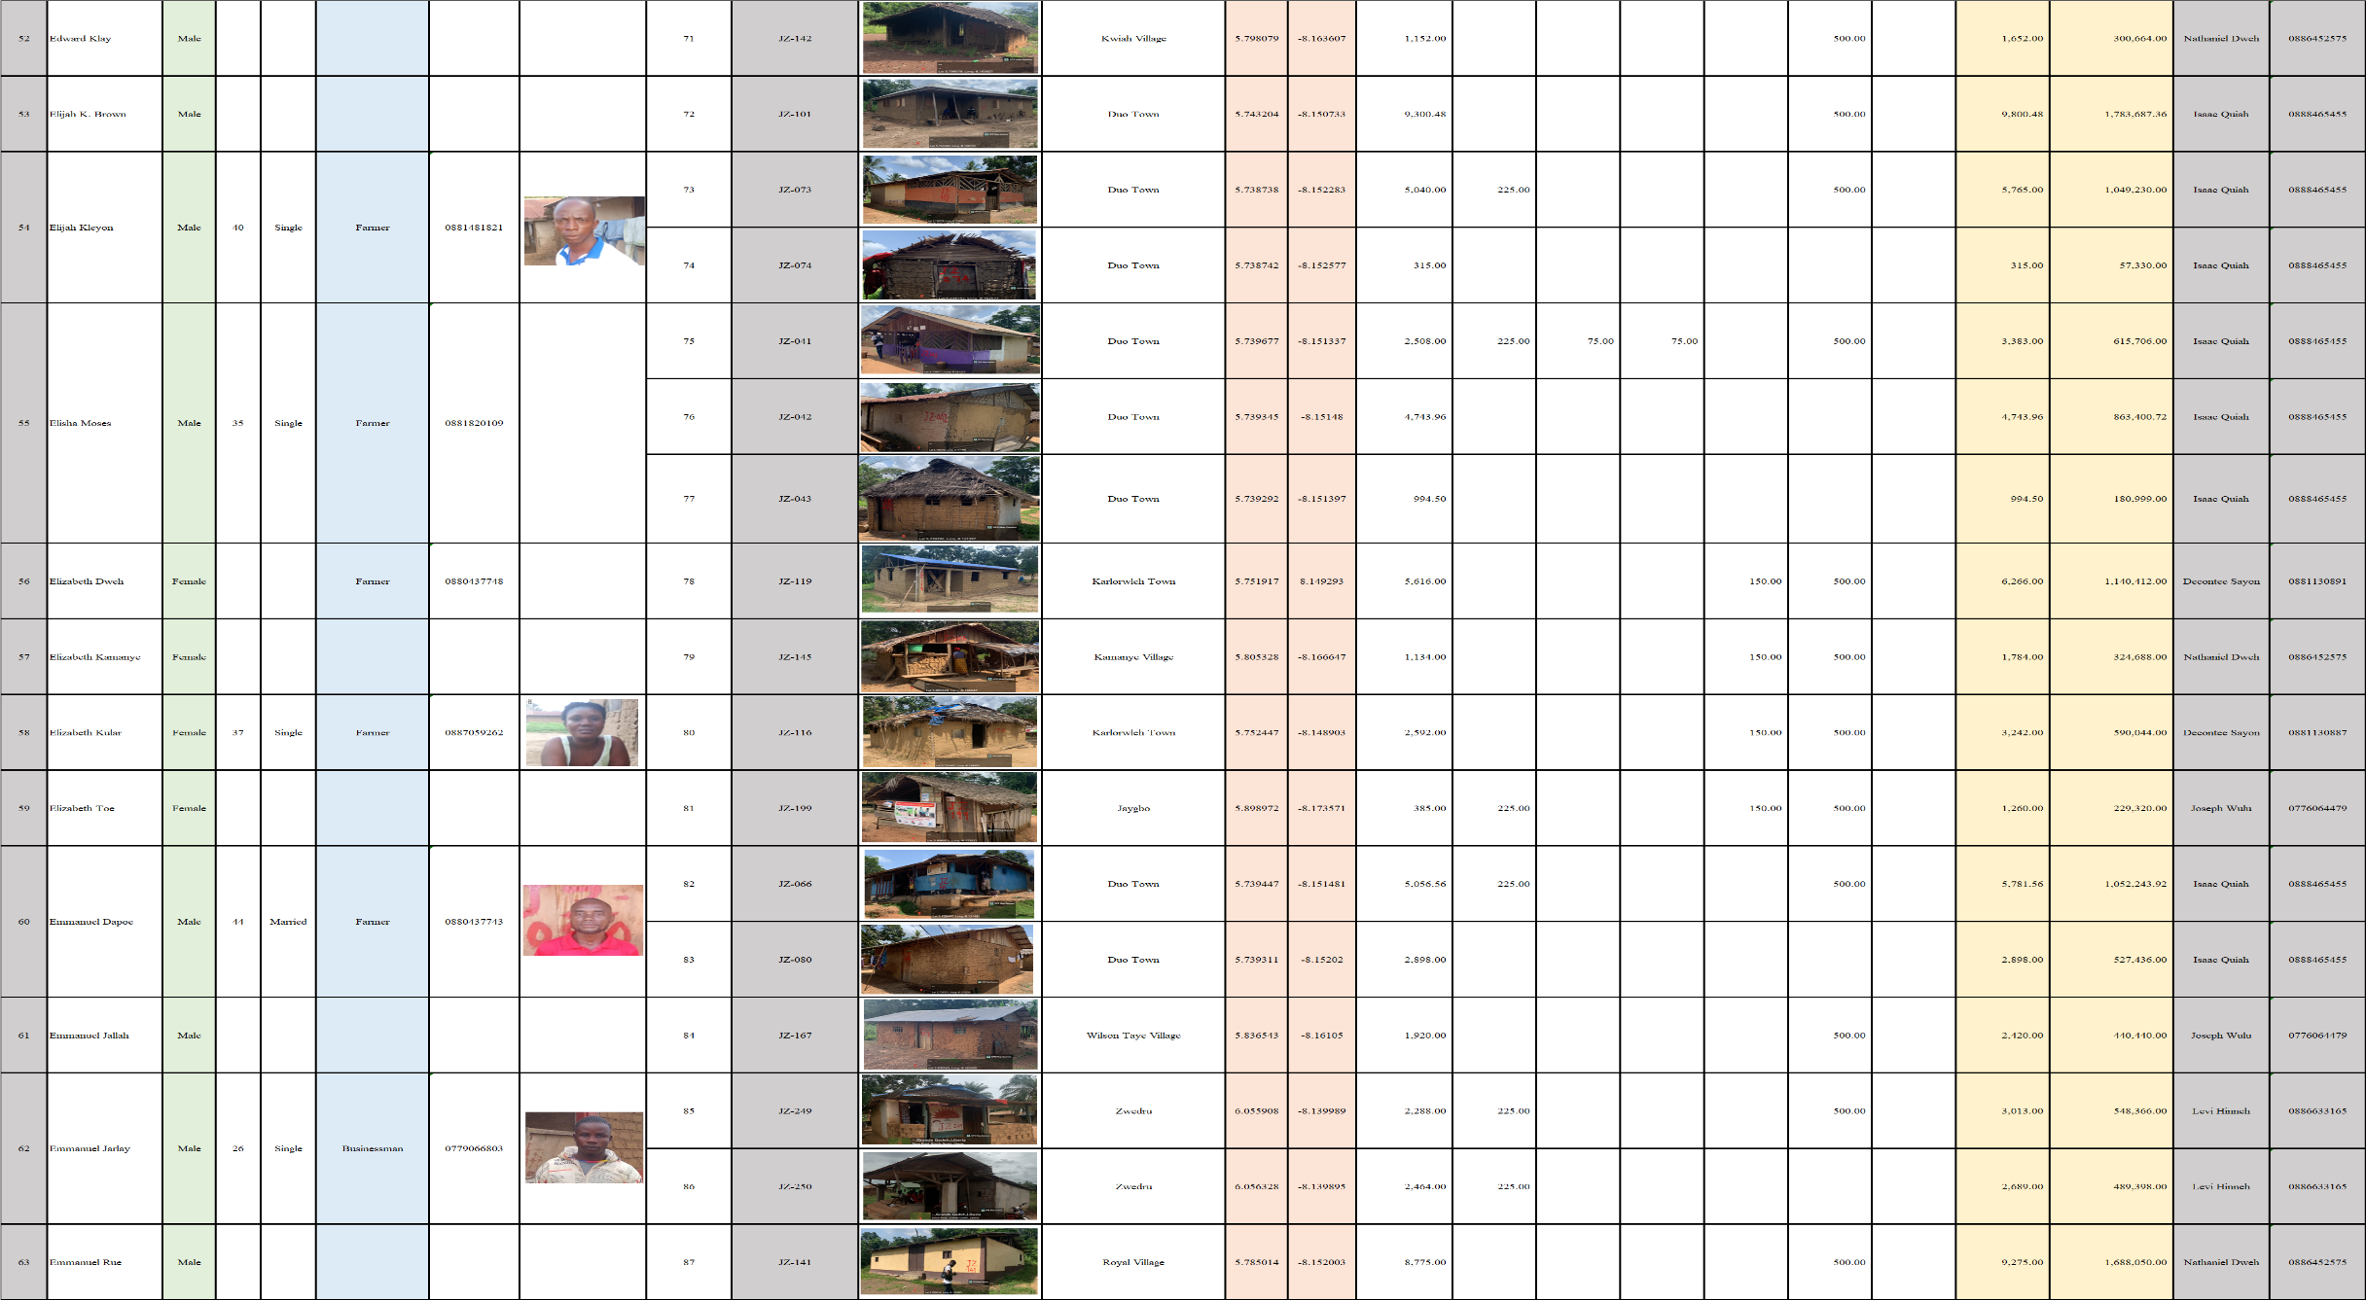

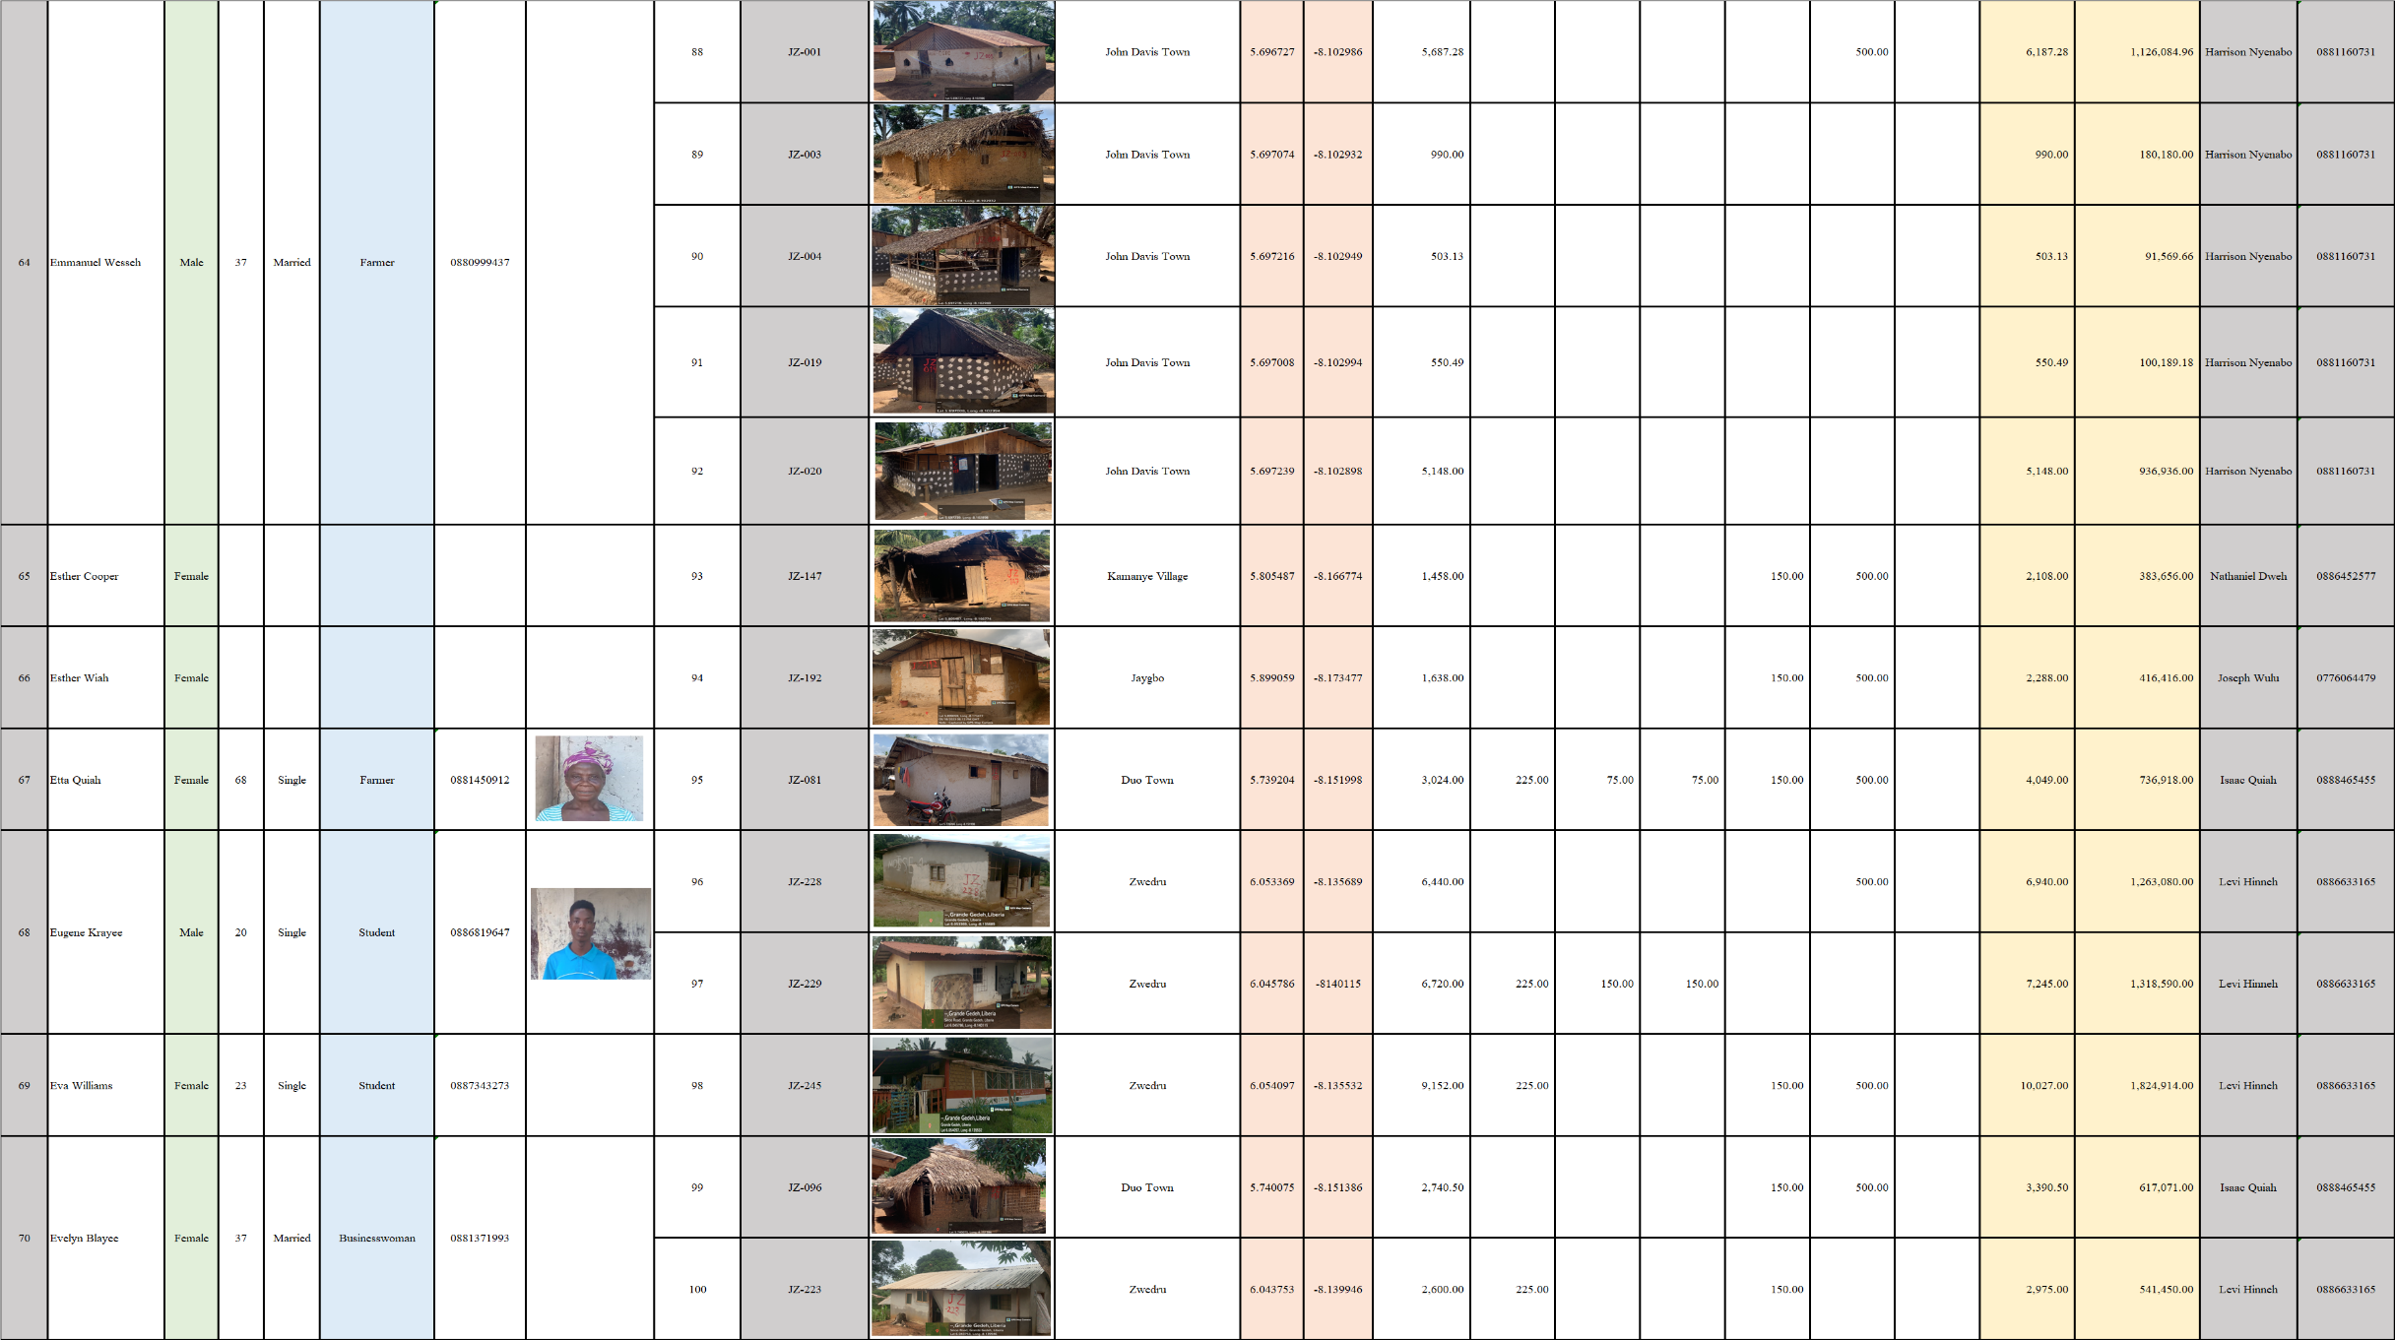

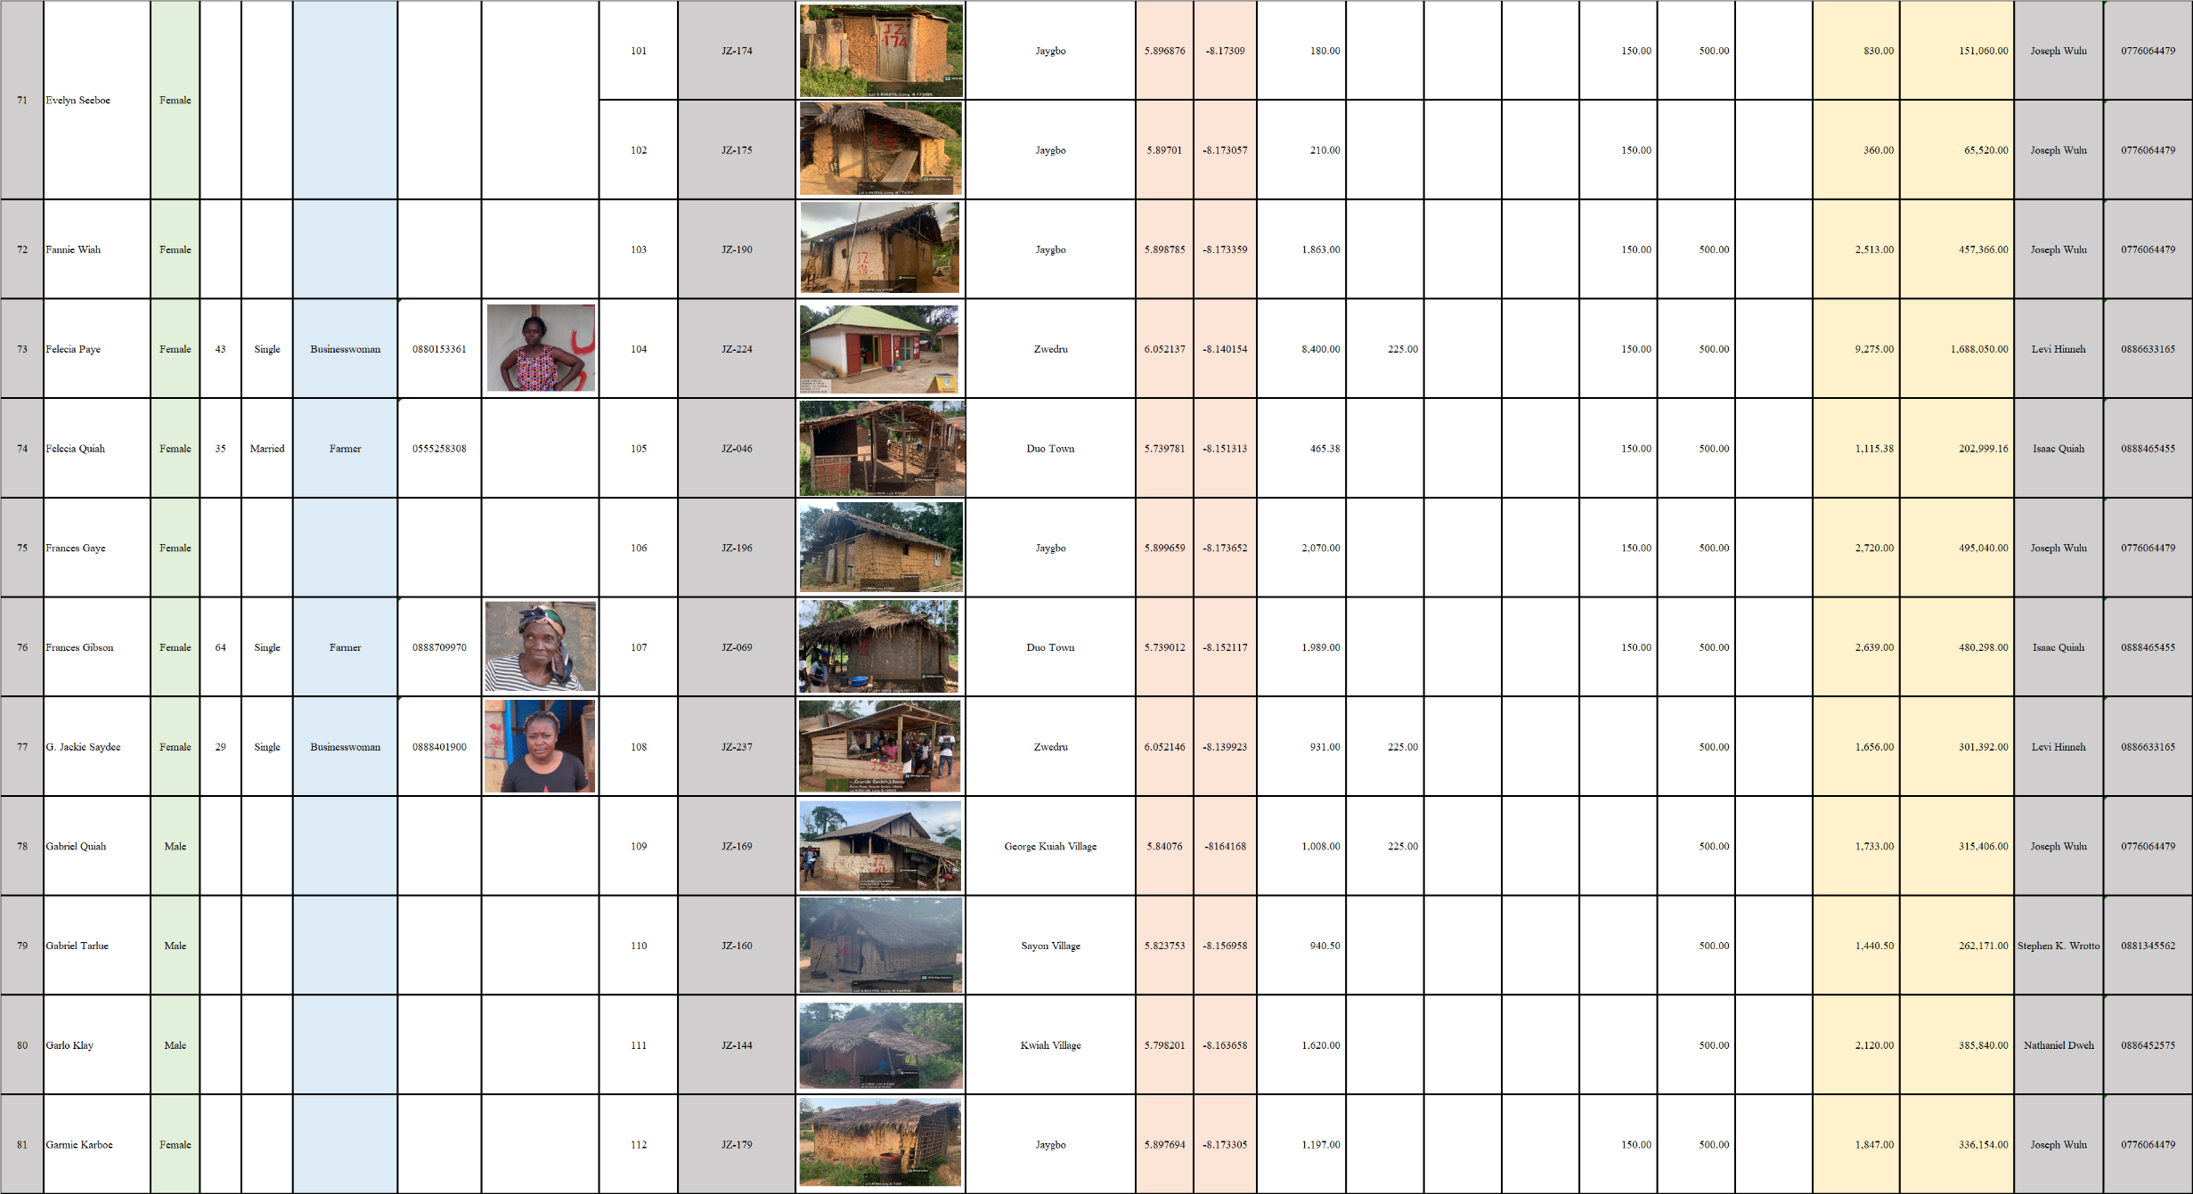

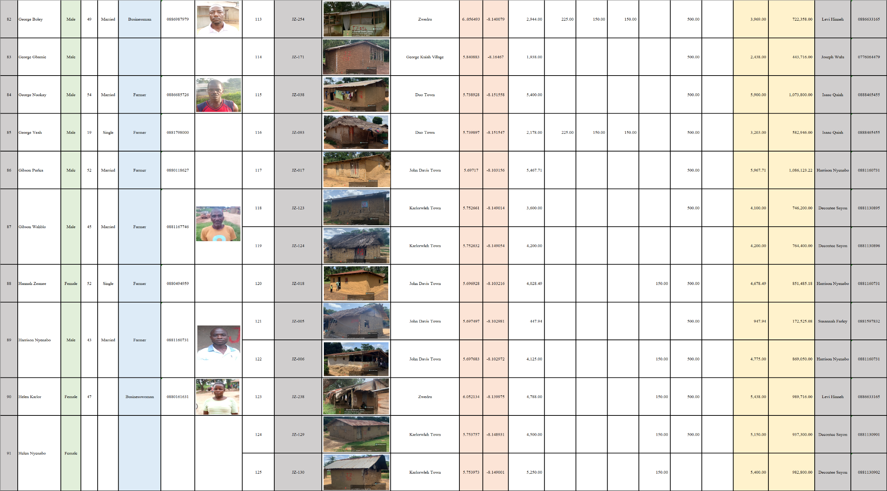

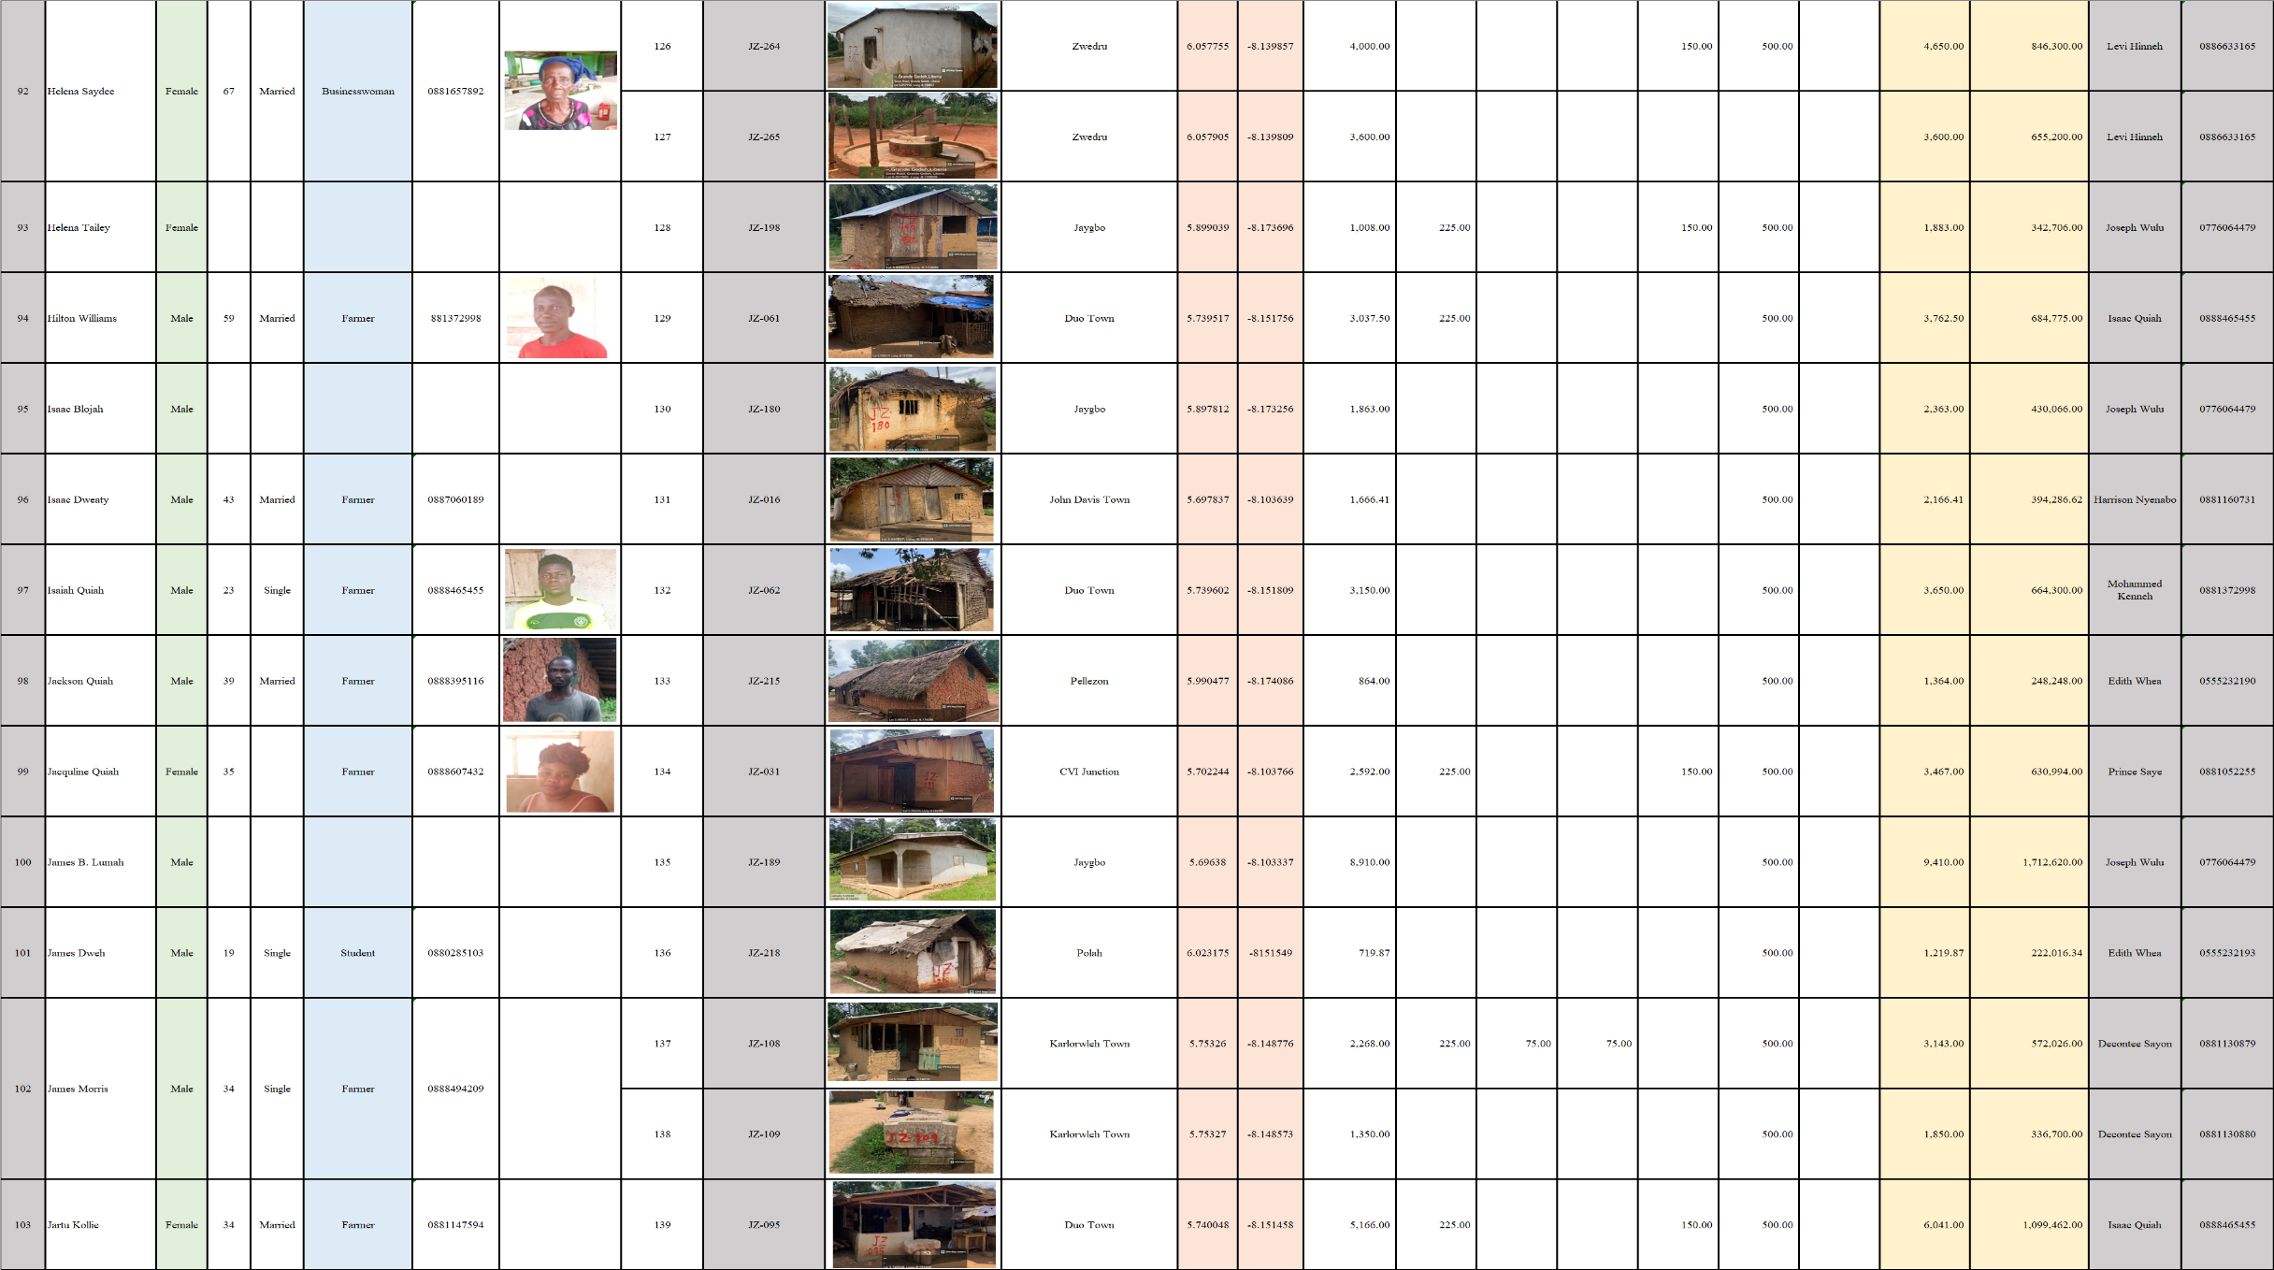

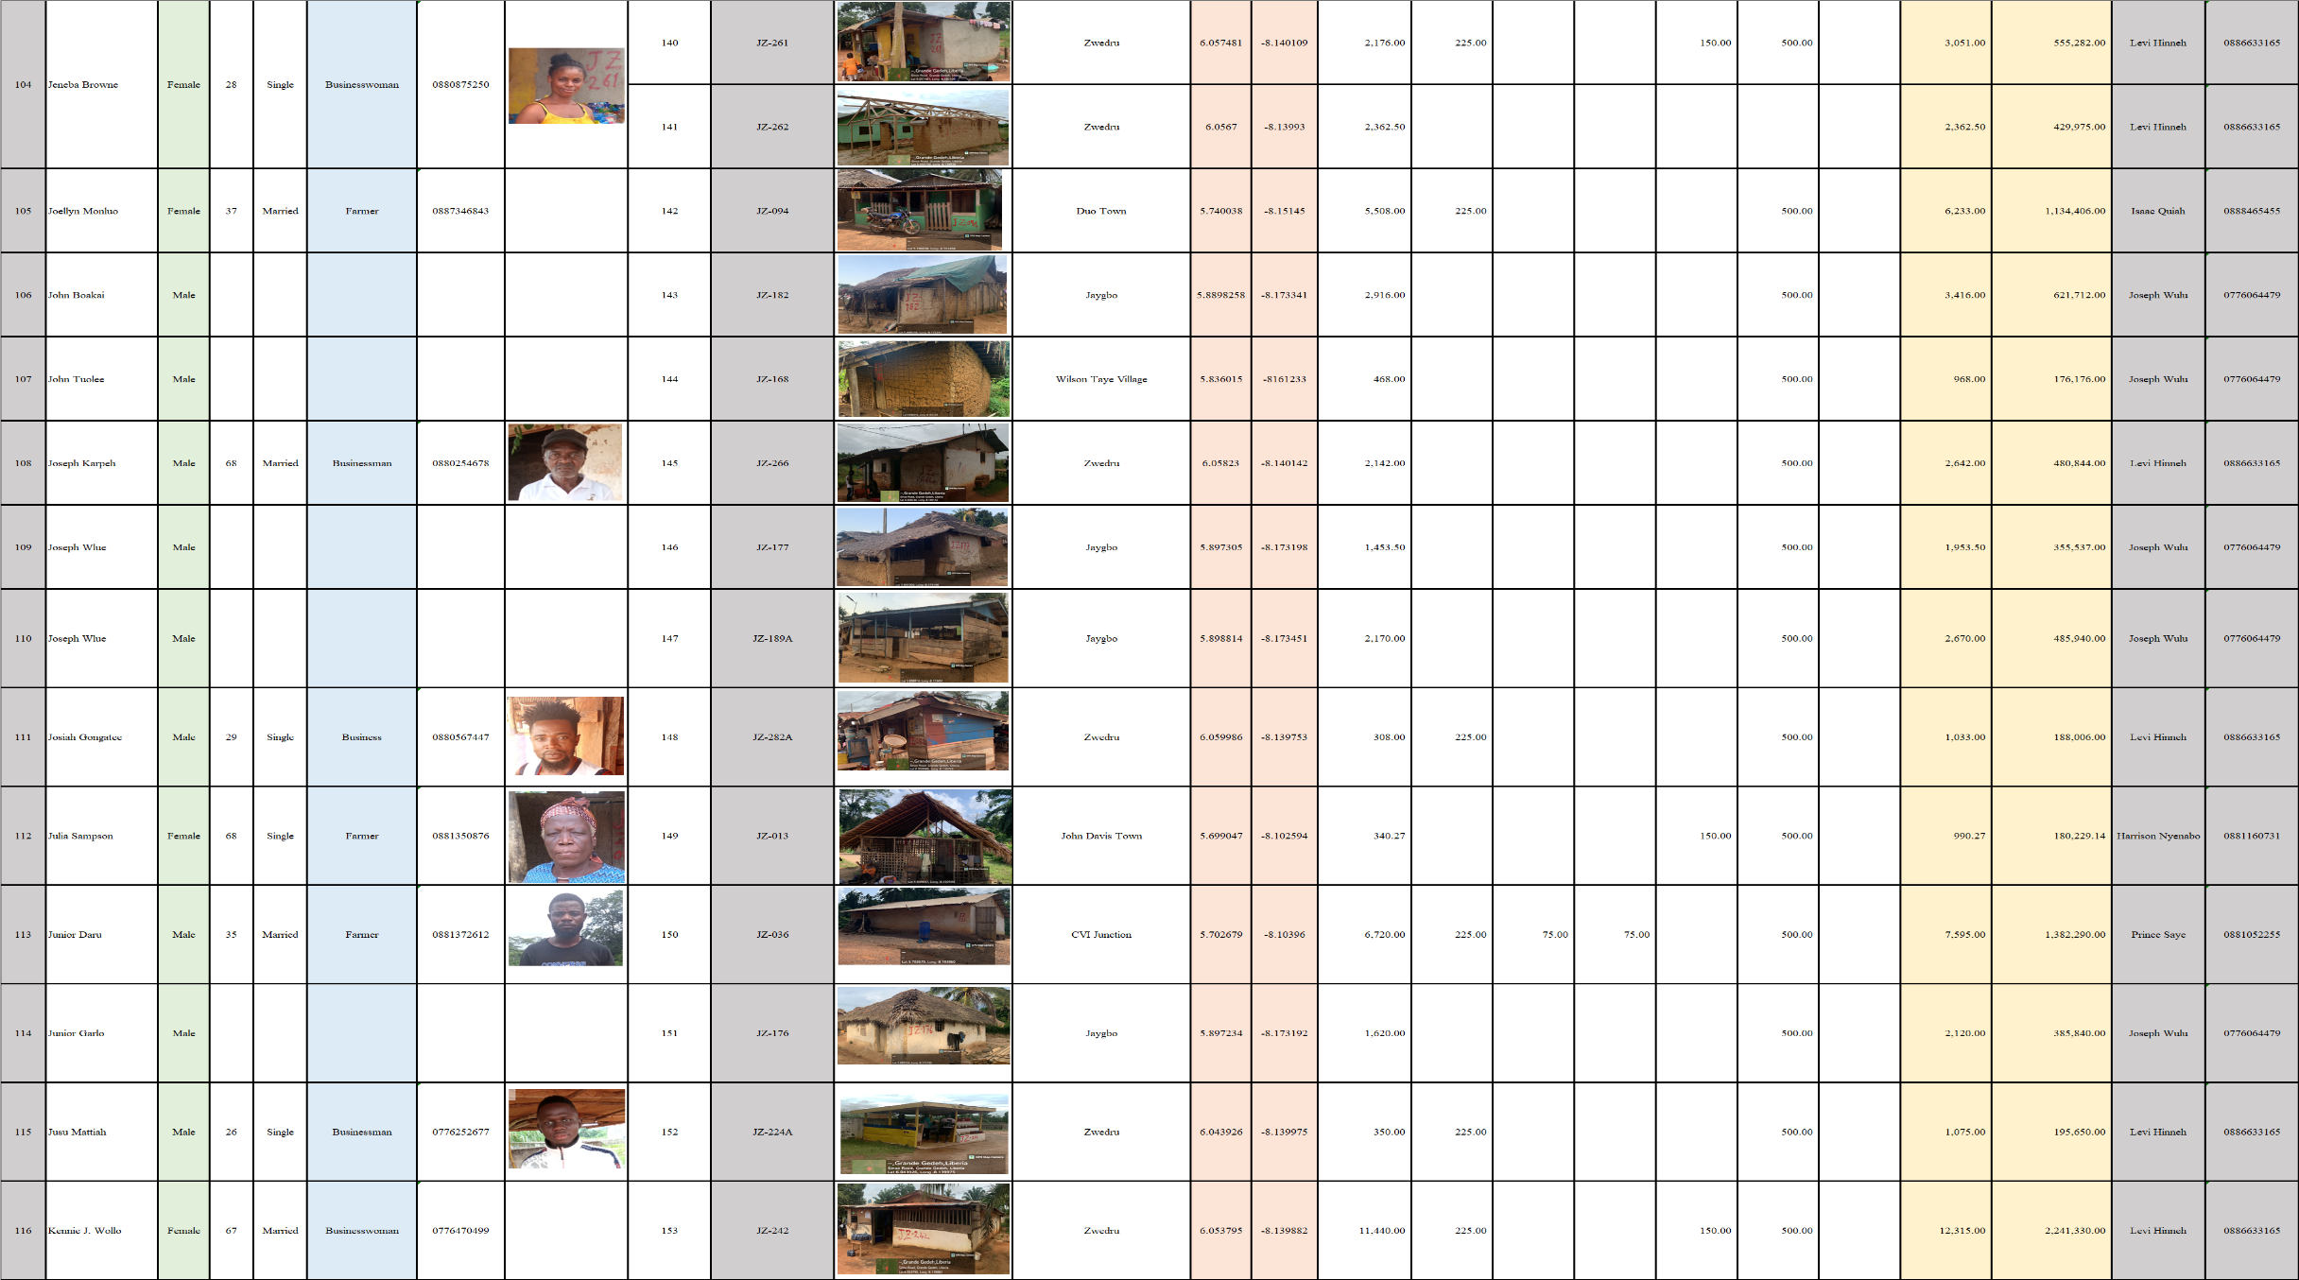

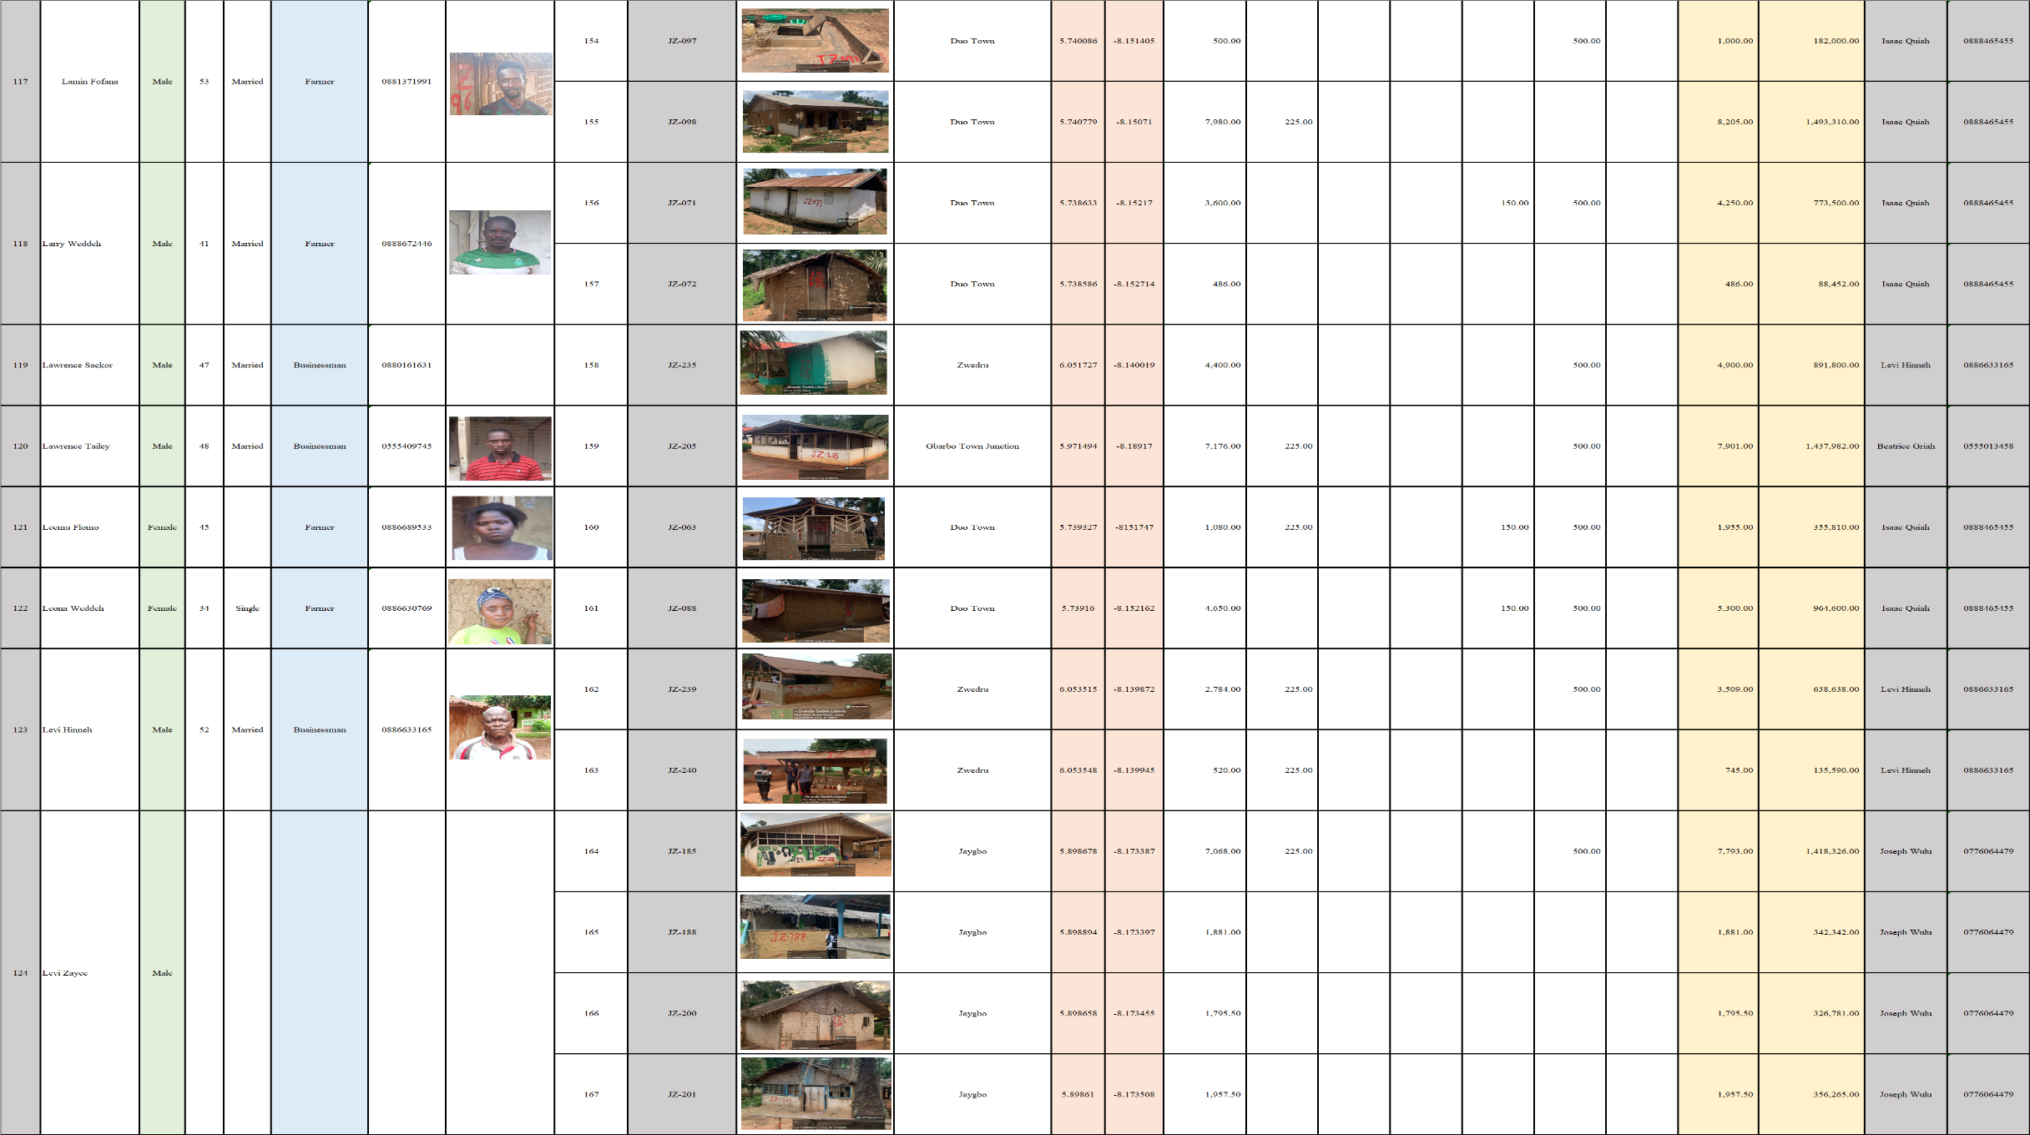

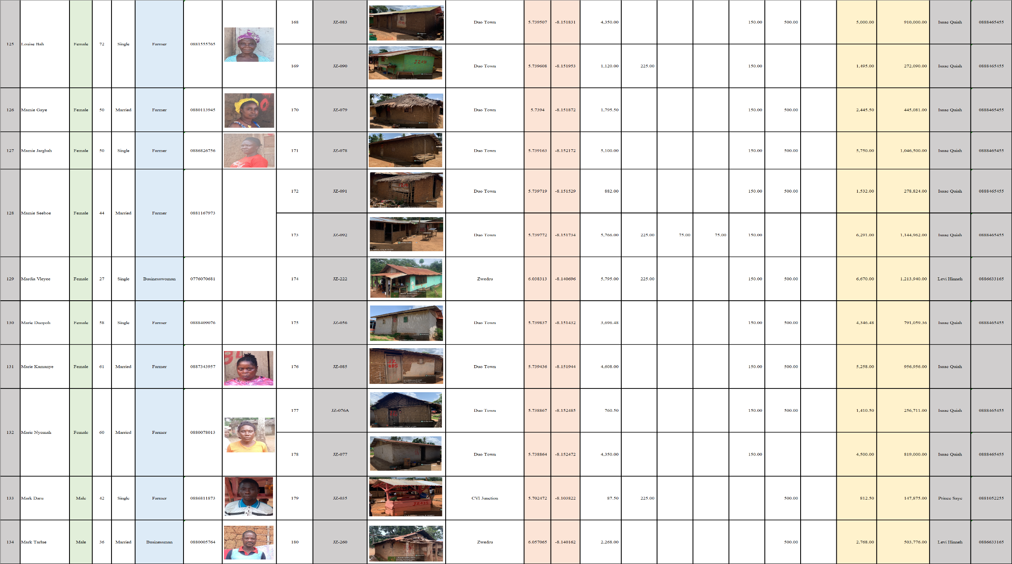

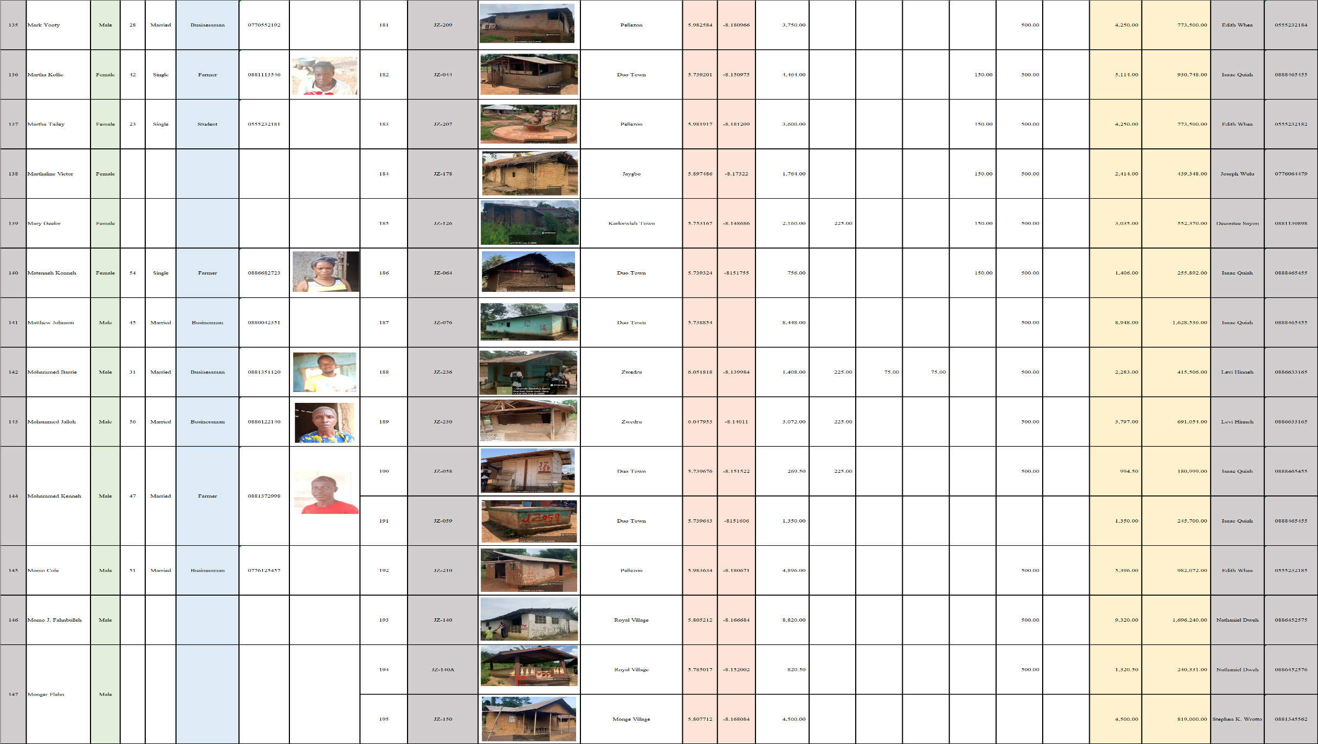

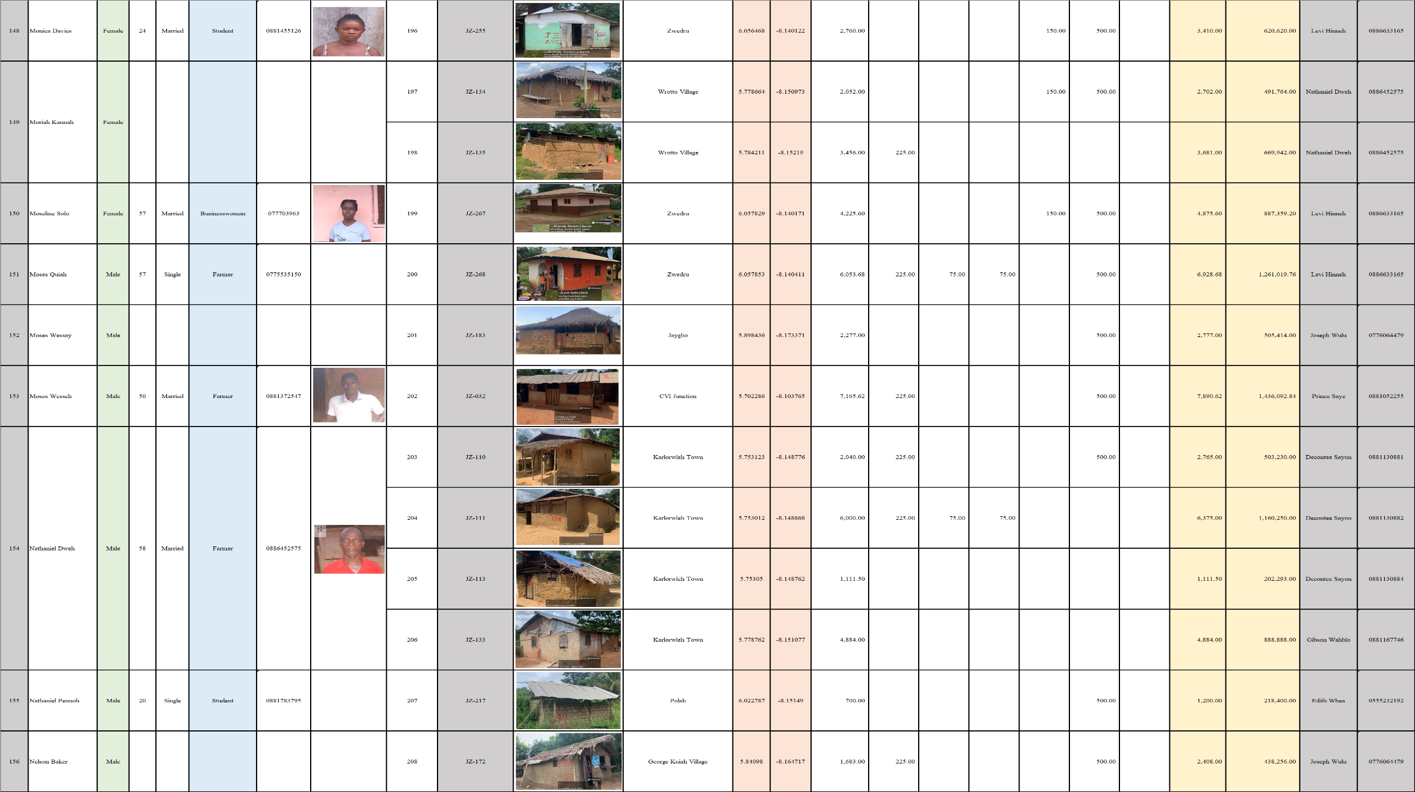

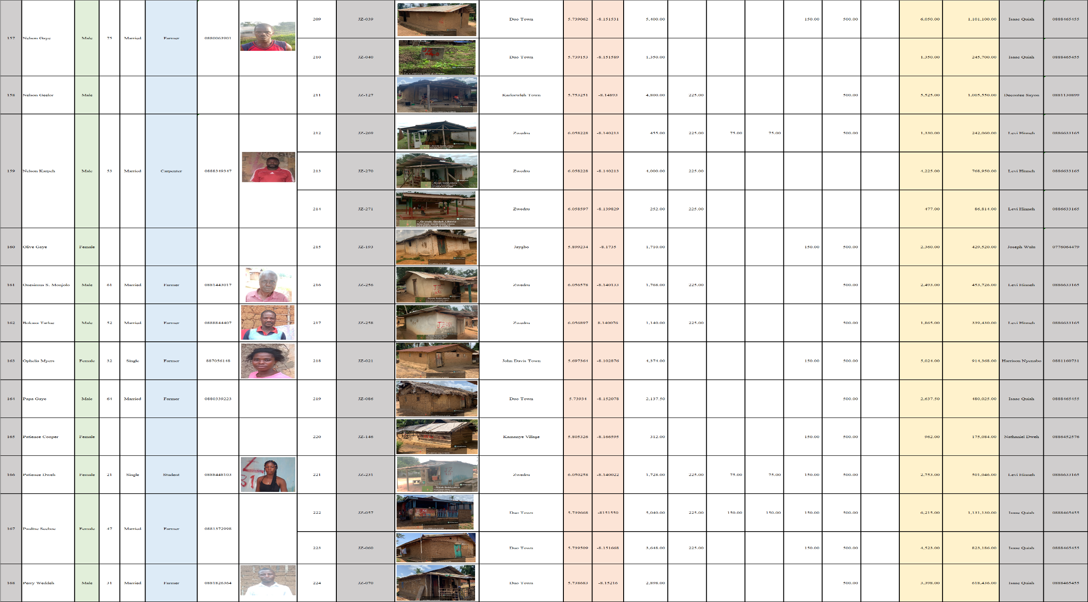

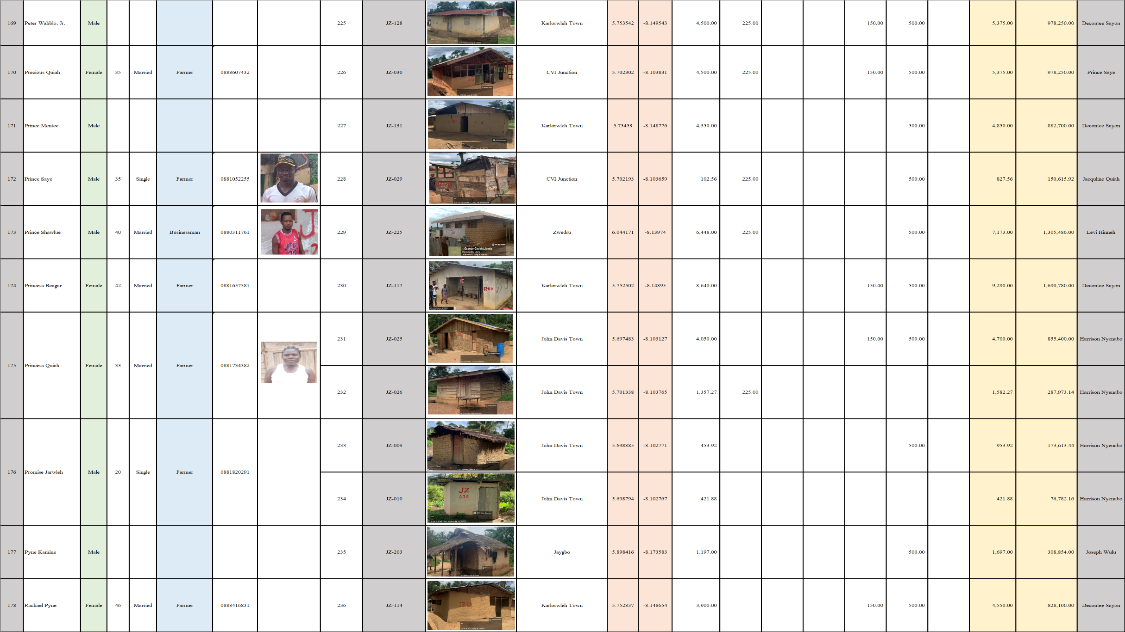

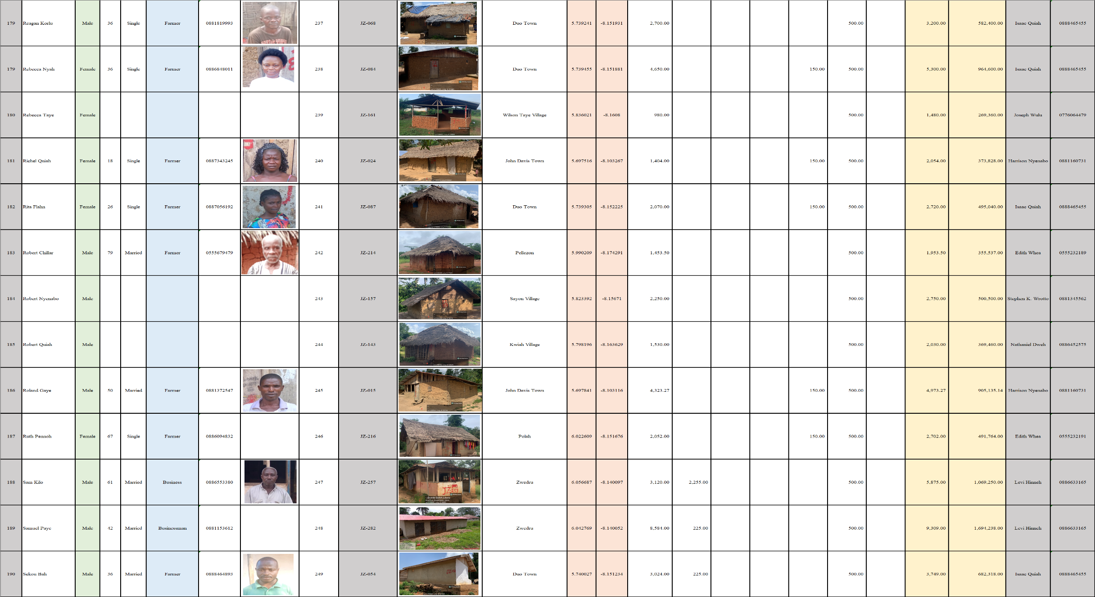

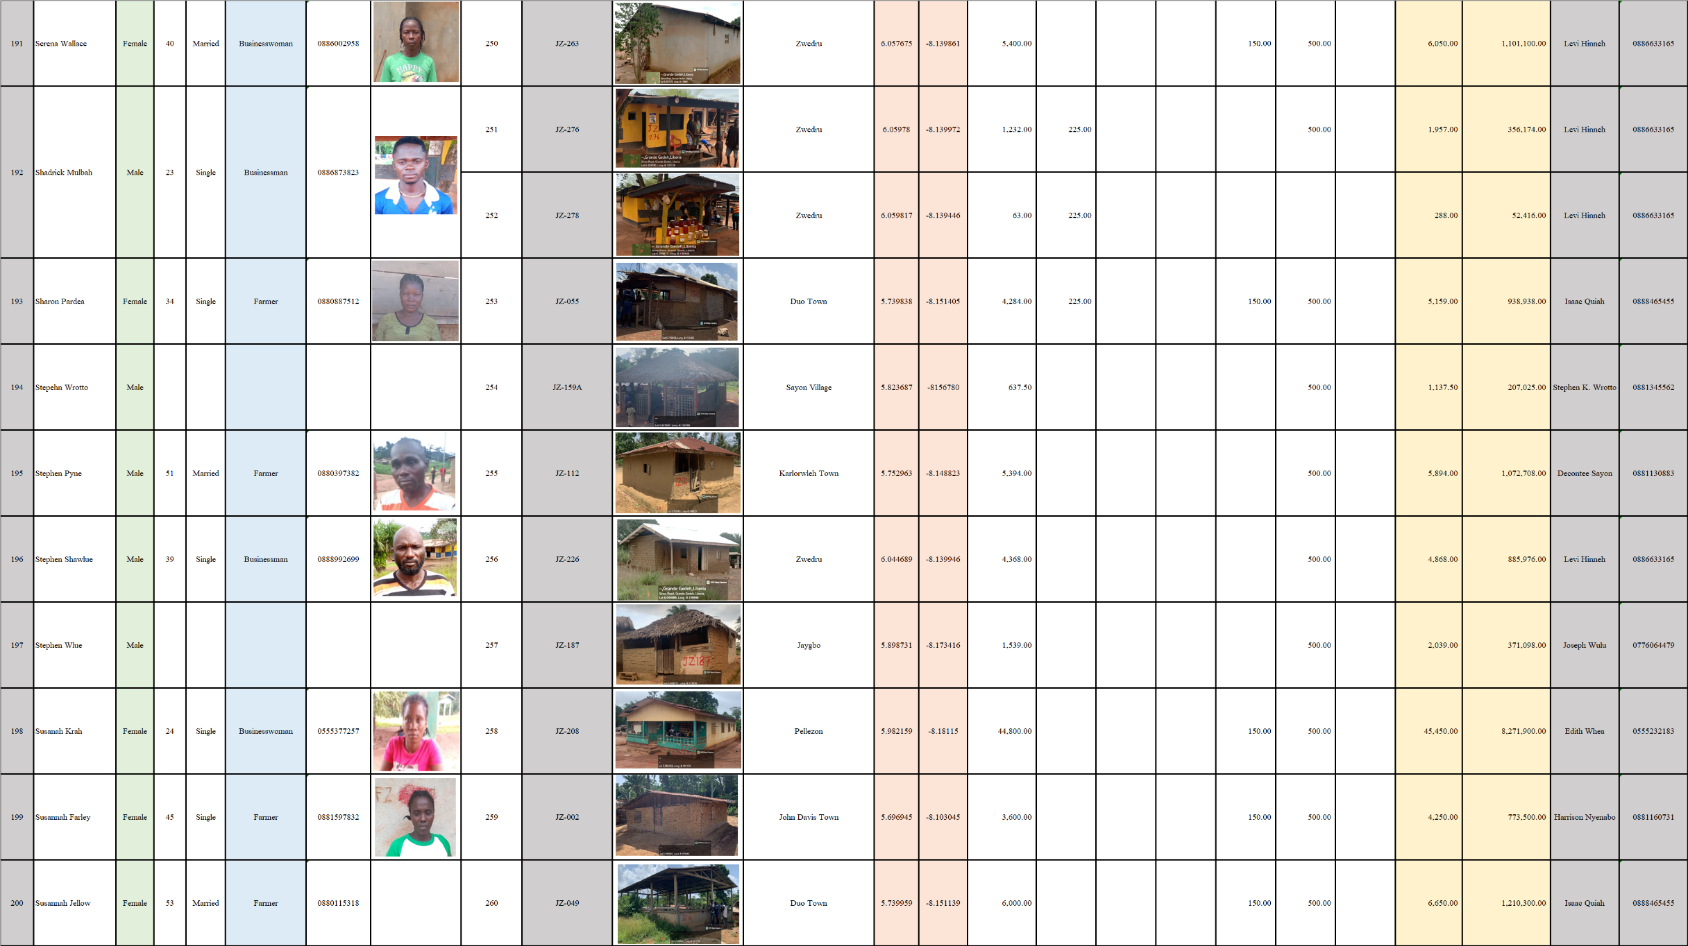

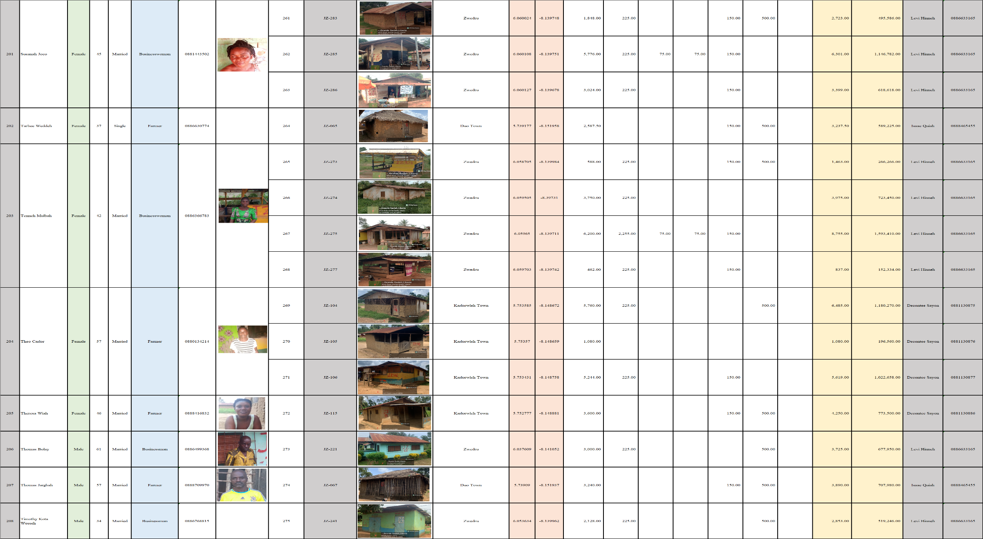

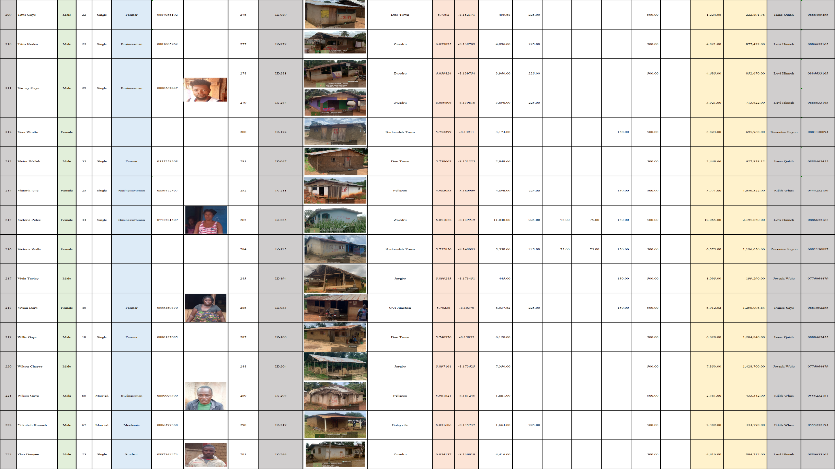



APPENDIX G: Photography
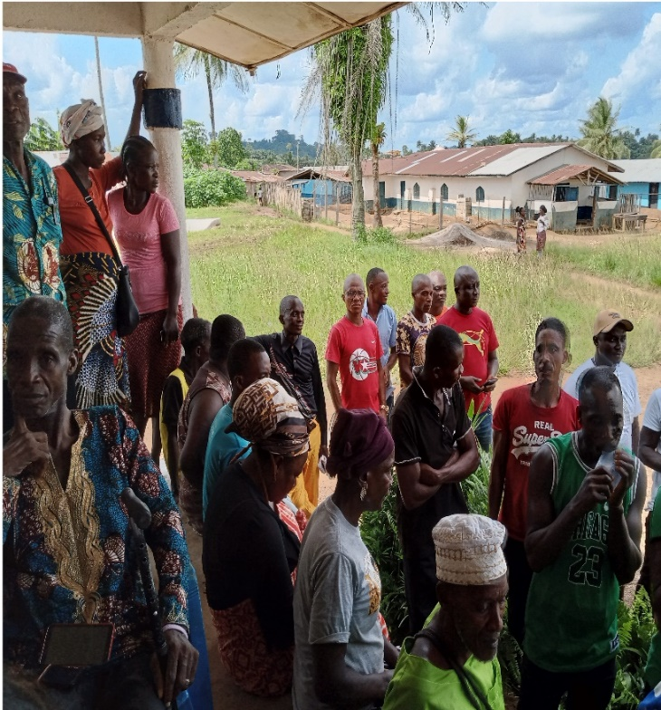
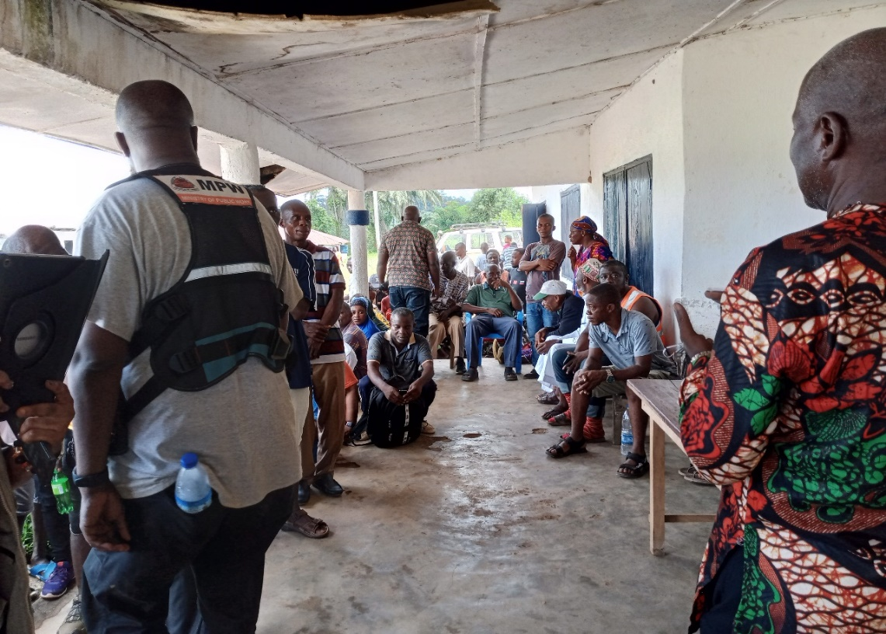
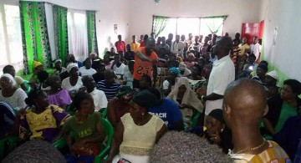
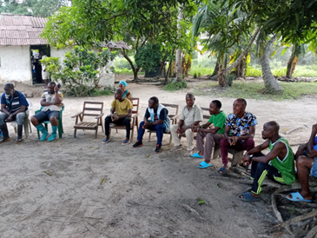
Consultation Meetings

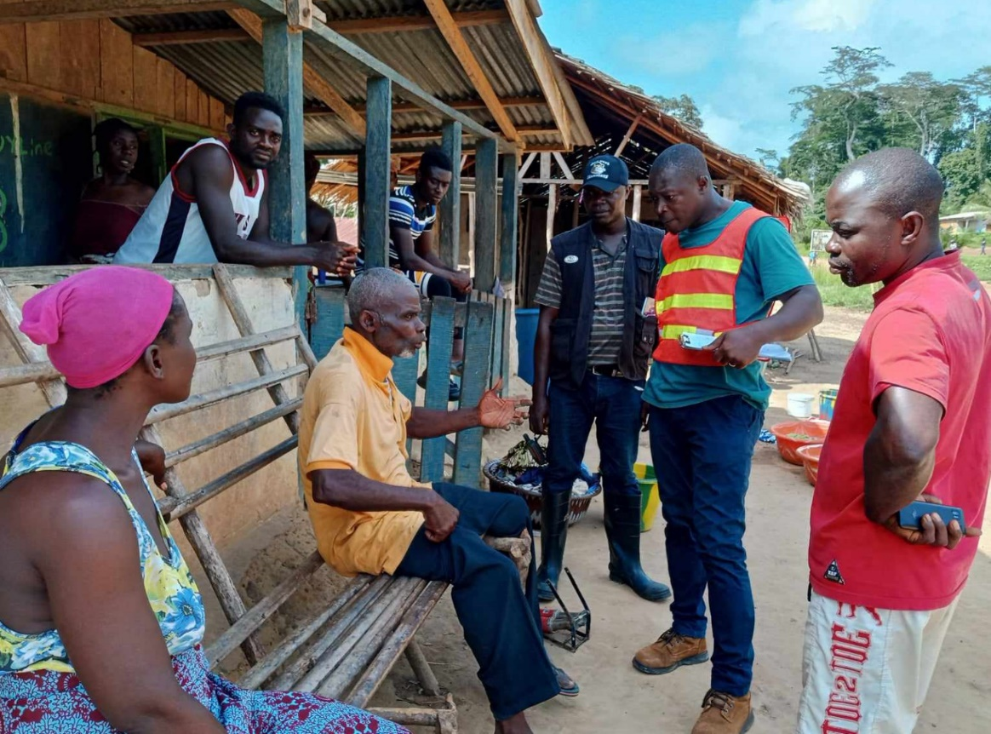
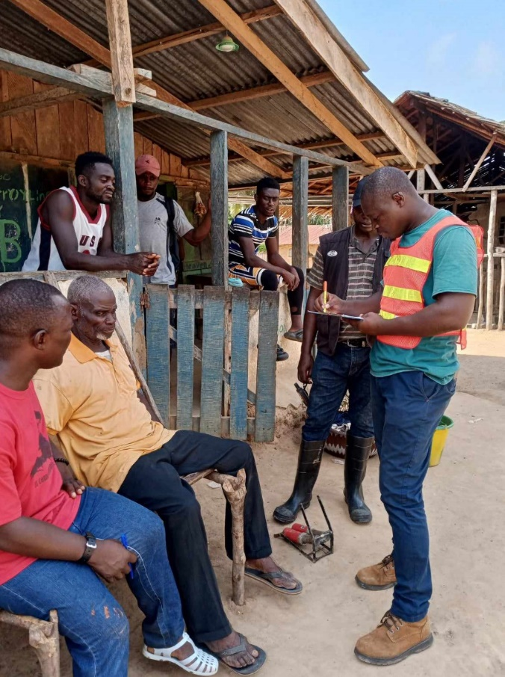
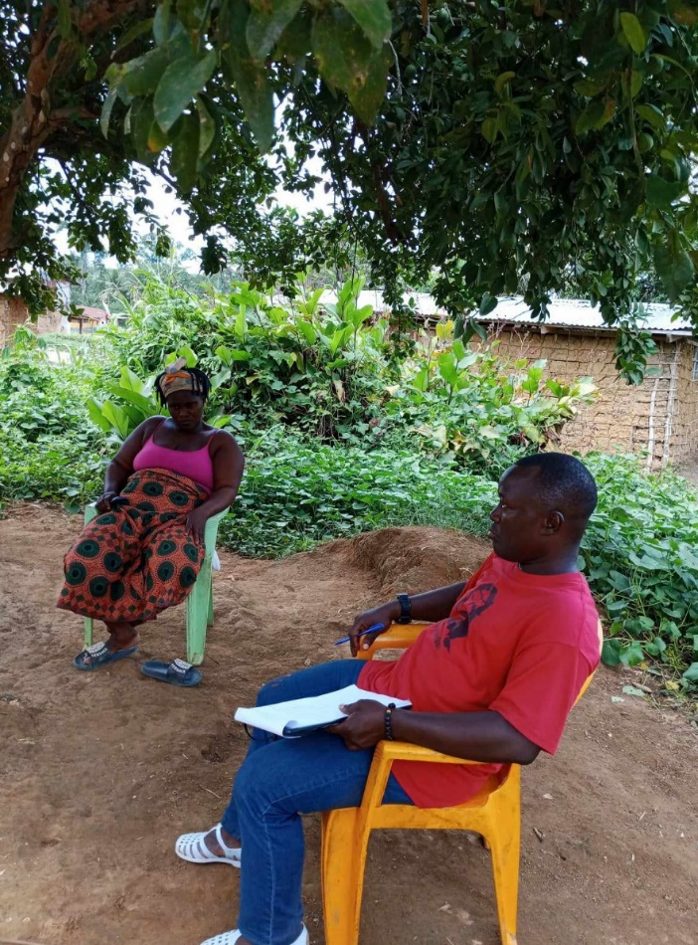
Some meetings held along the project corridor using FGD (Focus Group Discussion) method to help collect data

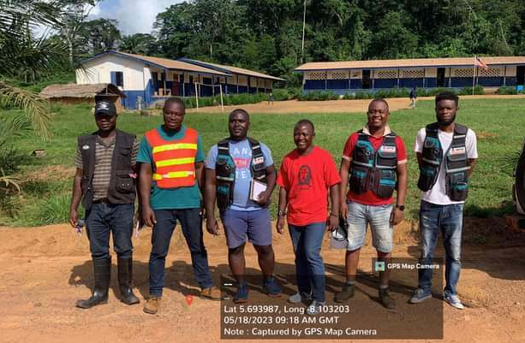
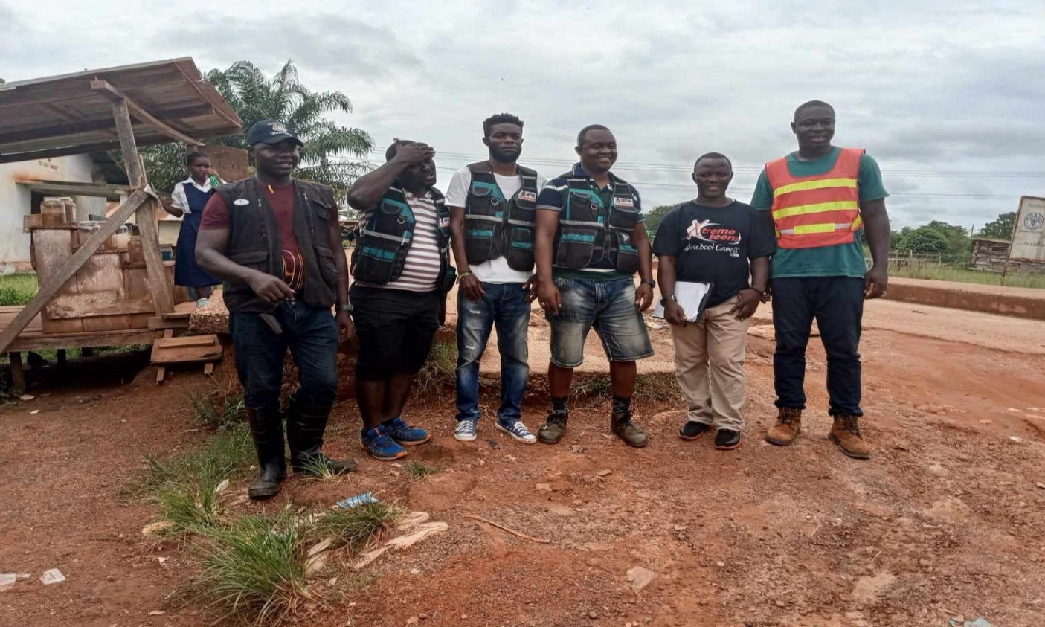
The beginning of the proposed Project Corridor, John Davies Town @ Km 0+000
End of proposed Project Corridor, Zwedru @ Km 52.7

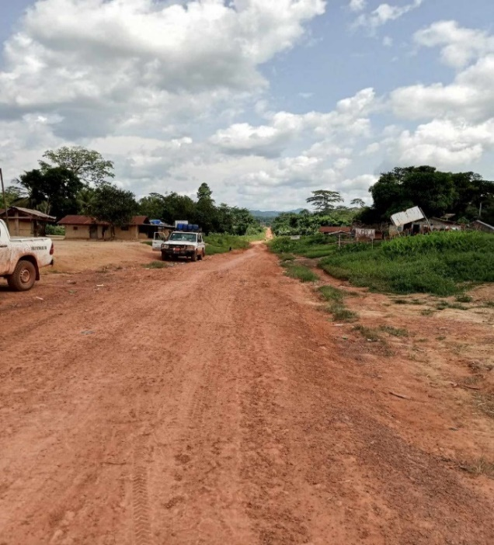
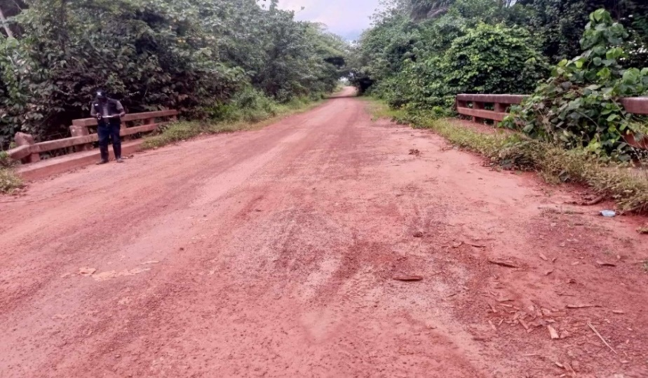
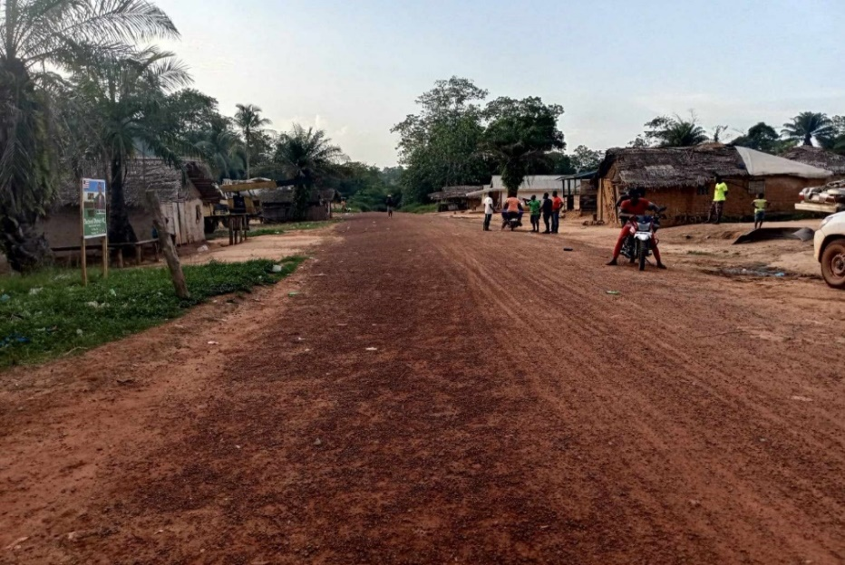
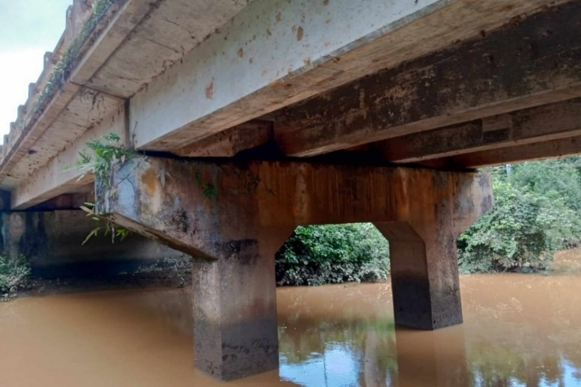
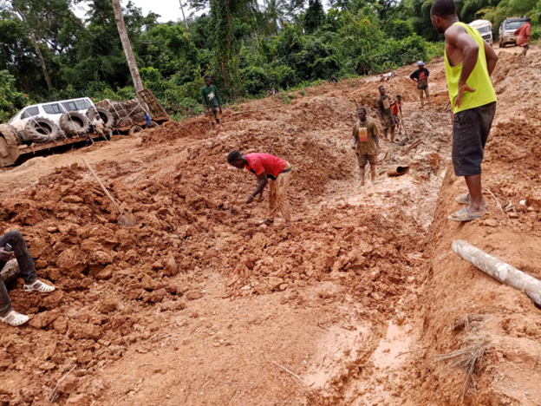
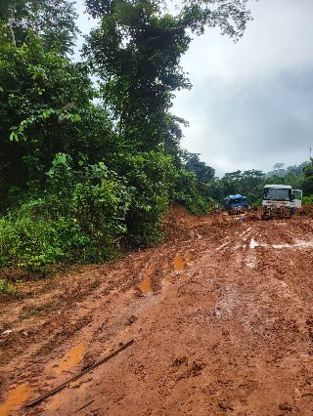
Dugbeh River Bridge
Some affected communities along the project corridor

RAP mandatory annex – Recap of PAPs
Code PAP* | First and last names of the PAP | Sex (M, F) and Age | Profession and principal activity of PAP | Tel. of the PAP and/or representative | PAP’s Picture | Image of the affected property/ies | GPS coordinates of the affected property/ies | Real compensation cost in local currency & dollars | Witness/Neighbor of the PAP  (Names and Tel.)
AAA000
Summary matrix of PAP
* Code must be alphanumeric to contemplate/indicate the location or site AND the number of PAP by location or site. Example: for a single site RAP in Bamako the coding could read BAM0001, BAM0002, etc. or for a two sites (Yopougon et Adjame) RAP in Abidjan the coding would read: YOP0001, YOP0002, etc. et ADJ0001, ADJ0002, etc.

Individual agreement form, between the Project Affected People (PAP) and the Developer
==============================
Republic of ……
==============================
- Basic data
- Project name: ……………………………………………………………………………………………...
- Sub-project/activity that triggers the resettlement: ……………………………………………………….
- Location of the affected asset (village, municipality, district, region): ……………..…………………...
- Site or Corridor where the affected asset is/are installed: ……………………………………………….

- Identity of the Project Affected Person (PAP)
- PAP’s code: ……………………………………………………………………………………………….
- Name & Surnames: ……………………………………………………………………………………….
- Age: ………………………………………………………………………………………………………..
- Sex: ………………………………………………………………………………………………………..
- Representative of Household or minor? if ticked, provide signed /authorization to represent.
- Physical address: ………………………………………………………………………………………….
- Tel. ………………………………………………………………………………………………………...
- Nature & ID no.: ………………………………………………………………………………………

- Nature/type and replacement cost of the affected asset

No. | Nature of affected asset | Characteristics/Quantity/Size of the affected asset |  | Tick | Nominal value ($) | Agreed compensation  (Amount in real value &/or in-kind)
 | Land
 | Built land
 | Residential building (primary residence)
 | Building in rent
 | Shop
 | Hangar
 | Fence
 | Grave/graveyard
 | Sacred/worship site
 | ….
 | Fallow
 | Livestock farm
 | Fish ponds
 | Plantations
 | Crops
 | …
 | Income-generating activities other than agriculture
 | ……
 | Total real amount due to the PAP (including in-kind compensation)

- Nature of the assistance provided to the PAP
No. | Nature of the assistance | Tick | Nominal value ($) | Agreed compensation  (Amount in real value &/or in-kind)
 | Temporary rent
 | Moving expenses
 | Capacity building
 | Vocational training
 | In-kind subsidy/inputs
 | …..
 | Other (specify)
Total real amount due to the PAP (including in-kind compensation)

Based on the assessments and negotiations carried out within the context of the resettlement for the works (development/construction) of the project, and by mutual agreement, the PAP receives the sum of [total amount in full spell], and/or [list the in-kind goods/benefits] as compensation.

Project Affected Person (PAP)  Signature & date  Name & Surname | Developer (Expropriating authority)  Signature & date  Name & Surname, Function
PAP’s Witness # 1  Signature & date  Name & Surname, Tel., ID no. | Signature/Seal of a Notary or Judicial Officer (if possible)
PAP’s Witness # 2

Signature & date
Name & Surname, Tel., ID no.

Replacement is provided in kind for: (i) primary and sole residence and (ii) subsistence food production farm. The payment of cash to the PAP is not recommended in these two cases.
Like the identification and assessment of asset and damages suffered as a result of the project, this agreement was signed without any constraint or threat of reprisals against the affected person, and with full knowledge of the implications and effects of the signatures affixed.

